Cheverton Award Recipient History
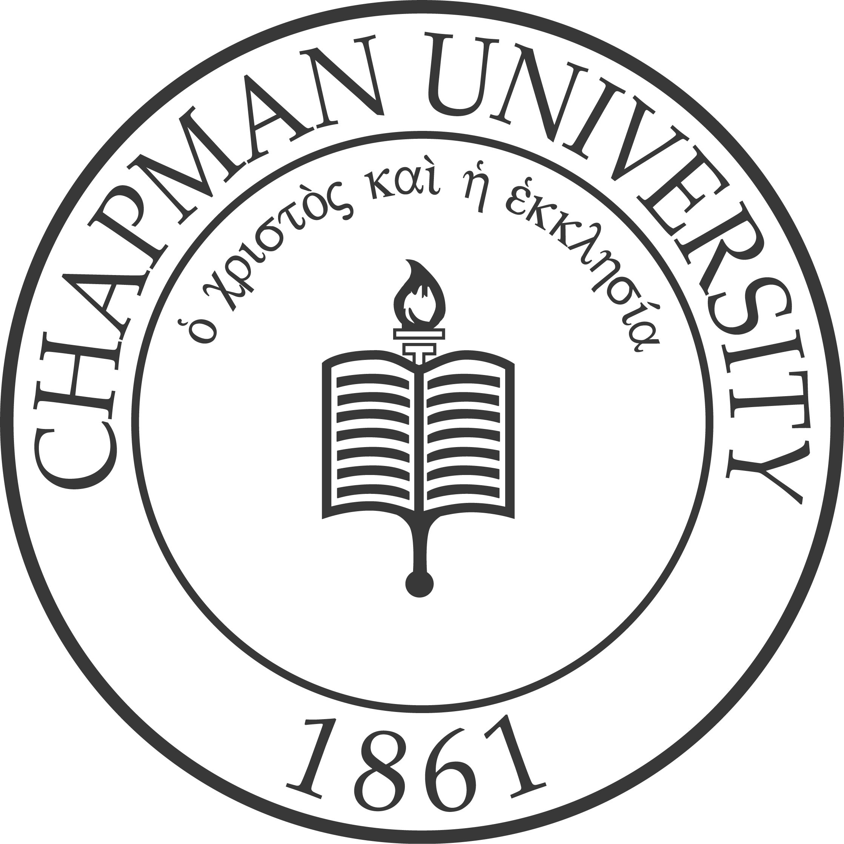

Chapman University

Year | Awardee | Major
2019 | Vidal Arroyo | Biochemistry and Molecular Biology
2018 | Paige N. Gulley | French & History
2017 | Taylor Lee Patti | Physics, Math, Spanish
2016 | Emily Frisch | Biological Sciences
2015 | Marissa Wong | Peace Studies
2014 | Elliot Joseph Cooley  Adam Zuhair Kalawi | Mathematics & Computer Science  Biochemistry/Molecular Biology
2013 | Priya Darshan Shah | History & Spanish
2012 | Harpreet Singh | Biochemistry & Biological Sciences
2011 | Mark James Johnston  Jessica Marie Pauletto | History & Political Science  Public Relations and Advertising
2010 | Parker Allen Bush | Economics
2009 | Yuri Choi | Business Administration & Psychology
2008 | Javeria A. Cartagena  Casey R. Wayland | Political Science  Film and Television
2007 | José Israel Pacheco | Mathematics
2006 | Ryan Van Ramshorst | Biological Sciences & Spanish
2005 | René Bennett | Political Science
2004 | Ian Louis Reitz | Film and TV & Political Science
2003 | Lindi Kay Duesenberg | English
2002 | Tauseef Qureshi | Biological Sciences
2001 | Nicole Benitah | Biological Sciences
2000 | Suzanne Crandall | Movement and Exercise & Biological Sciences
1999 | Matthew Barcelona | Chemistry
1998 | Travis Osborne | Psychology
1997 | Robert Diaz | Business Administration
1996 | Kristina Cordasco  Hieu Tran Phan | Biological Sciences, Economics  Philosophy, Religion
1995 | Rachel Fieber (Bednar) | English & French
1994 | Nader Baroukh | Legal Studies, Psychology, Human Resources Management
1993 | Jon D. Garcia | Political Science & Communications
1992 | Kristin M. Morris | Finance
1991 | Dana Daws | English
1990 | James Deaton | Finance
1989 | Christine A. Price | English, Preliminary/ Secondary Credential
1988 | David Nielsen  Stephanie D. Vance | Computer Info. Systems & Marketing  Political Science
1987 | Diana Cafaro | Chemistry/Biology
1986 | Susan Reagan | English
1985 | Elizabeth Brown | Philosophy/Religion/Accounting
1984 | Miguel Jacobowitz | Business Administration
1983 | Paul Carey | Communication Disorders
1982 | Ross Adams | Communication Disorders
1981 | Derrell Roberts | Government
1980 | Beata Chapman | Psychology
1979 | John Mark Lovelace  Mohammed Khalid Salih | Psychology  Biology
1978 | Alma Jo Clark | Biology
1977 | Virginia Sherman | English
1976 | Raul Briseno | Economics/Business
1975 | Colette Fleuridos Hayden | Religion
1974 | Carolyn Hamblin Malotte | Biology/Chemistry
1973 | Susan Parker | Political Science
1972 | Rita Brock | Religion
1971 | Paul Joseph Daniels  Machal Kay Hudak | Psychology  Home Economics
1970 | Anthony Louis Mason | Sociology
1969 | Kent T. Hoffman | Religion
1968 | Scott Lee MacAdam | Multiple Subjects
1967 | Carl Michael Reeske | Philosophy
1966 | Coralee Hoffmaster | Physical Education
1965 | Diane Louise Howel | English
1964 | Patricia Ann Wallace  Sandra White Gladson | English  English & History
1963 | Sharon Kay Maher | English
1962 | John Mark Messer | Sociology
1961 | Barbara Searle Ford | Special Education
1960 | Gayle Brewer | Philosophy
1959 | William Fanslow | English
1958 | Carroll Cotton
1957 | Dianne Burrell | Sociology
1956 | Paul E. Johnson | History
1955 | James Odell Laughrum
1954 | Dorothy Ann Lyerla | Music
1953 | George N. Reeves, Jr. | Education
1952 | Donald Earl Charles | Music
1951 | Daniel M. Immel | History
1950 | Greta Bilyeu | Physical Education/Credential
1949 | Mary House | Religion
1948 | Gloria Sing | Liberal Studies
1947 | Galal Kernahan | Philosophy
1946 | Ellen Atherton | Sociology
1945 | Ann Deskins | English, Religion
1944 | Merton Brown | Religion
1943 | Mary Parker | Music Education-Vocal
1942 | Lawrence Strimple | General Education
1941 | Charles DeVine | Sociology
1940 | Alice Jane Scholes | Sociology
1939 | Janet Worthy | Music Education-Vocal
1938 | Lois Strahl | English
1937 | Margaret Eichbauer | Sociology
1936 | Zelda McNamee | English
1935 | Ellsworth Lewis
1934 | G. Arthur Casaday | English
1933 | Irvin C. Chapman | History
1932 | Fanny-Lee Hancock | Religion
1931 | Orma J. Mewbourn
1930 | Herbert L. Minard | History

