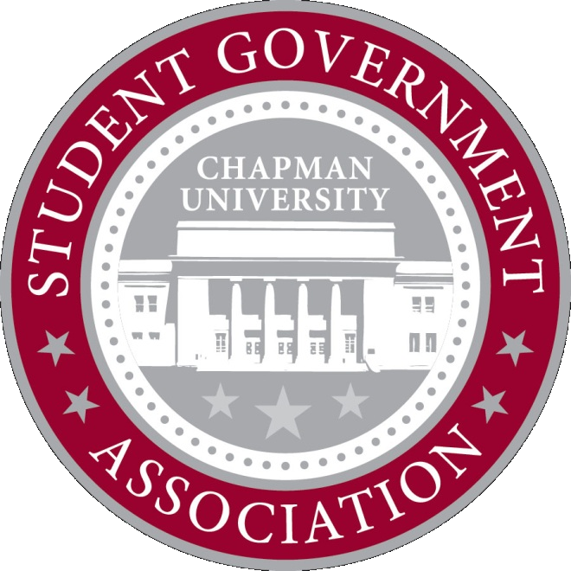
ALLOCATIONS
COMMITTEE
MINUTES

September 25, 2012
6:00 PM

- Attendance
  - Devon, Myke, Zach, Anthony, Sam, Kellyn
  - 0 absent

- Old Business
  - None

- New Business
  - Hazing Prevention Week – Delta Tau Delta
    - Requesting $3000
    - Great event, open to all students
    - Must send to full senate
    - Allocations
    - Approved for $3000
      - 4 in favor, 0 opposed
  - Men of Integrity/Women of Action
    - Need more info
    - Tabled
  - Disciples on Campus – Fall Retreat
    - Requesting $4373
    - Includes transportation and meals
    - Must be sent to full senate
    - Allocations recommendation: maybe fund in part, but it is not the responsibility of SGA to fund stay away retreats
    - Approved to send to full senate
      - 4 in favor, 0 opposed
  - National Society of Collegiate Scholars Induction Luncheon
    - Requesting $450
    - They are being funded in part by their dues/national org
    - Not sure we want to fund the whole amount
    - Approved $200
      - 4 in favor, 0 opposed

  - Asian Pacific Student Association – Mooncake Festival
    - Requesting $50 for Mooncakes
    - Approved $50
      - 4 in favor, 0 opposed
  - Korean Student Association – Meat and Greet
    - Requesting $50 for food for their event
    - They plan on spending in excess of $50 on outside food and paying for it out of pocket
    - Against Sodexo policy/our funding policy
    - Not approved
      - 0 in favor, 4 opposed

- Adjournment
  - 6:55 PM

