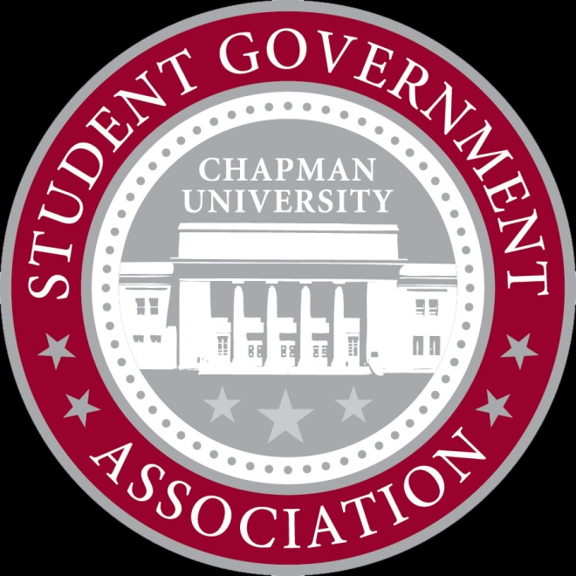
Allocations Committee Meeting

X___________________________
November 6, 2012
6:00 PM

- Attendance
  - Present: Devon, Myke, Zach, Kellyn, Sam, Anthony
  - Tardy:
- New Business
  - Chapman ASL Club
    - Requesting $3109.98 for comedian and food for event in March
    - Expected attendance is very low
    - Would like to see them maybe partner with UPB or other org to market and make a bigger event
    - Tabled for further info
      - 4 in favor, 0 opposed

  - AMA Saves Lives
    - Requesting $239.00 for supplies for tabling event
    - Will be encouraging students to become organ donors
    - Approved $239.00
      - 4 in favor, 0 opposed
  - Chapman Snow Club Sweatshirts
    - Requesting $675.00 for club sweatshirts
    - Approved $270.00 ($9.00 per sweatshirt)
      - 3 in favor, 1 opposed
  - Conference Scholarship – Nathan Flanagan-Frankl
    - Requesting $700.00 for travel and lodging
    - Leadership conference, it is a great opportunity
    - Approved $700.00
4 in favor, 0 opposed
  - KSA – Liberation in North Korea
    - Requesting $48.00 for dinner for documentary guest speakers
    - Approved $48.00
      - 4 in favor, 0 opposed
  - Calliope Literary Magazine
    - Requesting $7500.00 for extra issue in print
    - Must go to full senate
    - No allocations recommendation, will present both sides
    - Send to Full Senate
4 in favor, 0 opposed
  - Invisible Children SOCF
    - Requesting $4500.00 for Student Org Conference Scholarship
    - 30 students will be going at $281.25 each
    - Allocations recommends to fund in full
    - Send to full senate
4 in favor, 0 opposed

  - Meeting Dismissed 6:38

