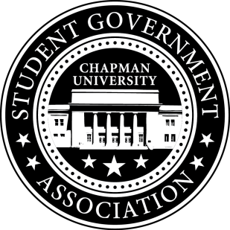
University and Academic Affairs Committee Minutes | September 29, 2017

- Call To Order: Meeting commenced @ 9:00AM
  - Present:
    - Ansley Wong
    - Courtney Wong
    - Alyssa Nowlen
    - Saba Amid
- New Business:
a. University and Academic Affairs Outreach
i. Open Forum in Committee Meetings – November 1st (Beginning Half)
ii. Feedback Poster – Student Union and Henley Basement
iii. Blackboard Pages
b. Committee Meeting Time
i. Wednesdays at 8pm-9PM Place: TBD
- Old Business:
- Study Space on Campus
  - Creating questions for the survey to get concrete data on study spaces on campus.
- Sustainability on Campus
  - Encourage students to bring their own cups to Starbucks
    - Senator Nowlen is getting the quota for the cups.
    - Event is week before Finals (Monday and Thursday 10am-12pm)
  - Looking into meeting with MacKenzie Crigger, Sustainability Manager.
- Senator Updates:
- Senator: Courtney Wong
  - Going to research the Recycle Mania Program
- Senator: Alyssa Nowlen
  - Met Dean Lyon and talked about open classrooms as potential study space
  - Met with Eric Cameron on Wednesday and discussed how SGA is trying to establish a good relationship with Sodexo.
- Senator: Saba Amid
  - Still thinking about what advocacies to pursue
- Senator: Ansley Wong
  - Attallah College Leadership Council – Met with the chairs and the Associate Dean to talk about the interview process.

V. Meeting Adjournment: Meeting concluded @ 9:45AM

