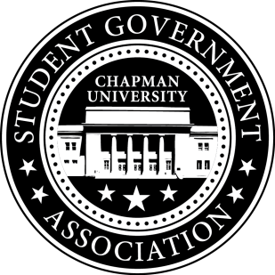
Community Outreach Committee Minutes | October 19, 2017

- Call To Order: Meeting commenced @ 7:03PM
  - Present:
    - Maytal Sarafian
    - Alysa Buckler
    - Molly Weber
b. Absent
- Old Business:
- Senator Updates:
- Senator: Maytal Sarafian
  - Plans to work with Health Center on increasing operating hours during weekdays and weekends
  - Helped review and edit Committee Operating Documents
- Senator: Alysa Buckler
  - Mentions bringing cameras to Lastinger and bike racks to Crean
  - Plans to follow-up with Blaze Pizza on Chapman Dog Day
  - Helped review and edit Committee Operating Documents
- Senator: Molly Weber
  - Senator Brunch
    - Plans to rename the event and organize the event that will entice students and faculty (i.e. grab food and chat with senators)
    - Plans to talk to UPB on Sodexo Catering
    - Plans to host this event on Thursday, November 9th from 11am-1pm
  - Helped review
- Senator: Lisa Kang
  - Treats in the Streets – 10/26
    - Spoke with DJ from City of Orange Recreation Services and plans to meet with him next Tuesday
    - Spoke with Jack on logistics
    - Asked Molly to bring candy and SGA resources
  - OHS Farm Improvement – 10/21
    - Reached out to Senators to volunteer
    - E-mailed Adam Duberstein the volunteer list
    - Plans to meet with volunteers after Senate meeting and review plans
  - Stop Sign Initiative
    - Connected Wil Harris with a point-in-contact at City of Orange via e-mail
  - Korean Language Courses Initiative
    - Met with Dr. Boitano
    - Received more signatures from constituent
    - Plans to reach out to students and form a committee
    - Plans to contact Cal State Fullerton and UCI
V. Meeting Adjournment: Meeting concluded @ 8:11 PM

