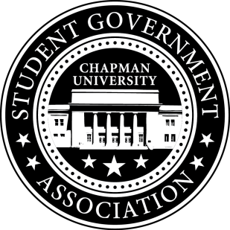
Community Outreach Committee Minutes | September 22, 2017

- Call To Order: Meeting commenced @ 7:05PM
  - Present:
    - Alysa Buckler
    - Molly Weber
b. Absent
i. n/a
- Old Business:
  - Merchant’s Day
i. Alyssa spoke with Laurenly Boutique, CocoRose, Green Tomato Grill and other vendors about possible partnerships Dog Day raffle tickets
ii. Lisa spoke with City of Orange and Blaze and invited them to Chapman Dog Day
- Senator Updates:
- Senator: Alysa Buckler
  - Worked on reaching out to different vendors for Chapman Dog Day
  - Spoke with Director of Elections on last year’s logistics
  - Sent Homecoming Volunteer sheet to Alpha Gamma Delta
- Senator: Lisa Kang
  - Met with Jack, VP of Community Relations to talk about Chapman Dog Day logistics
  - Spoke with Michael on volunteers for Socktober Homecoming - 10/7
  - Sent Homecoming Volunteer sheet to sorority chapters
  - Met with Curriculum Task Force and finalized petition form
V. Meeting Adjournment: Meeting concluded @ 12:30 PM

