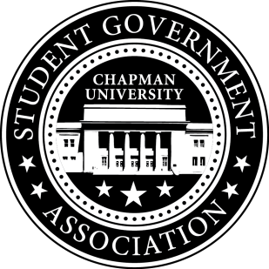
Academic Committee Minutes| April 15, 2016
- Call To Order: Meeting commenced @ 7PM
  - Present:
    - Priya Patel
    - Michelle Zhou
    - Jayetha Panakkadan
  - Tardy:
    - Skylar Goss
- Old Business:

- Senator Updates:
  - Senator: Michelle Zhou
    - Michelle has noticed that a majority of class time to ask the professor questions, prolonging the lab, and keeping other srudents from getting the help they need. Michelle suggests that Chem, Bio, etc. tutors attend labs and act as a sort of teacher’s assistant, to help students with lab questions. This way the Professor can be free to instruct the rest of the class. Hours spent assisting students during labs can count towards tutor’s 5 hour work week. Michelle suggests they are paid the same rate as hours spent in the TLT.
  - Senator: Priya Patel
    - Priya is going to meet with the Physical Space Task Force on April 26th to present her survey data about Student Study Space.
    - Priya got in touch with Kevin Ross, Associate Dean Librarian. They have a meeting Monday April 25th to share her data with him and see what can be done in the library to improve the issue of study space.
    - She is also going to work to publicize her survey and gain more student responses.
  - Senator: Skylar Goss
    - Skylar is ready to present his funding request to senate for charging stations in Beckman. He will be presenting at meeting on Friday.
  - Senator: Jayetha Panakkadan
    - Shmid app: Graphic design and comm sci classes are working on the structure of the app. Dr. Fahy will contact Jayetha when they are done and he needs suggestions for other components of the app.
  - Senator: Setareh Motamedi
    - Setareh has been drafting operating documents for the Academic Affairs Committee. They will be presented at meeting this Friday.
- Meeting Adjournment: Meeting concluded @ 7:45PM

