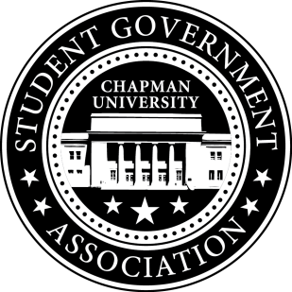
Academic Committee Minutes| Feb 26, 2016

- Call To Order: Meeting commenced @ 7:00 PM
  - Present: All
  - Late/Absent: None
- Old Business:
  - Coffee with CES
    - Facebook page has been made and the first meeting will take place in March
- Senator Updates:
  - Senator: Amanda Moore
    - All the new studying apps which have been introduced on Chapman’s campus are in violation with the the Academic Integrity Policy
    - Amanda will meet with Jaycie and seek new direction for the Academic Integrity Week she is planning.
  - Senator: Priya Patel
    - Priya has finished her survey regarding study space on campus
    - She will attend the Physical Space Task Force meeting in order to find out if creating more study space is feasible.
  - Senator: Skylar Goss
    - Skylar will meet with the Assistant Dean of the Business School next week to get approval to move forward with the charging station project.
  - Senator: Jayetha Panakkadan
    - Creation of the Schmid College smart phone app will get started soon.
    - Jayetha has contacted Dean Lyon’s secretary to set up an appointment with him regarding MKAT Scholarships.
    - Jayetha is working with Kelsey and Elise (Dean Price’s assistant) to see if we can have a permanent link that will be sent out in all of Dean Price’s emails so that SGA is more accessible and students can send any issues or comments they want though this. She is trying to find an easier and more accessible platform that students will actually use.
  - Senator: Setareh Motamedi
    - Setareh met with the Political Science Department Chair and discussed the issue of prerequisites in the political science department. Students are not taking the Political Research Methods requirement before taking other political science courses and instead taking the course when it no longer benefits them as much.
- Meeting Adjournment: Meeting concluded @ 8:00PM

