Econ/Eng/Phil 357 Topics in Humanomics
Hannah Arendt:
Philosopher of Freedom

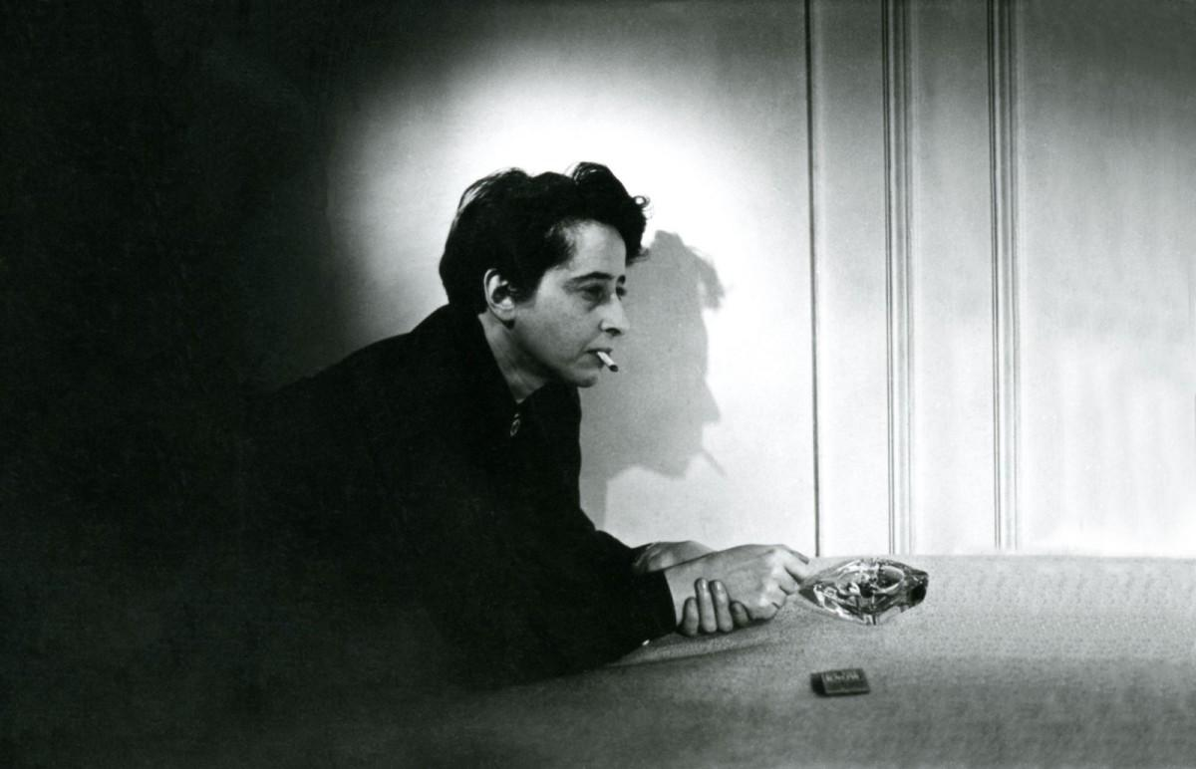

Professors Kyle Hampton and Katharine Gillespie Moses
Chapman University
Fall 2020

Hannah Arendt: Philosopher of Freedom
Econ/Eng/Phil 357
Fall 2020
MW 1pm-2:15 pm Wilkinson Hall 200
Office Hours: TBA
Contacts: Katharine Gillespie Moses kgillespie@chapman.edu
Kyle Hampton khampton@chapman.edu

COURSE DESCRIPTION
This course will introduce students to the life and thought of philosopher Hannah Arendt (1906-1975). Born in the then-German Empire to a Jewish family, Arendt lived through–and reflected upon–World Wars I and II, the rise of totalitarianism in Western and Eastern Europe, the discovery of the final solution, and the detonation of the first atomic bomb. She was nearly imprisoned by the Gestapo and was interred in a refugee camp in Vichy France before fleeing to America. After holding academic positions at Berkeley and the University of Chicago, she joined the faculty of the New School for Social Research in New York. In a number of influential books and essays, Arendt explores the role that power, violence, and evil play in both our everyday lives and the very structures of our inner thoughts.
Of particular contemporary interest is Arendt’s attempts in The Origins of Totalitarianism to identify the material and economic forces that motivated the rise of racism, fascism, and nationalism in the interwar period. In striking parallel to events in recent history, these movements were preceded by a period of increased globalization and economic interdependence across countries and the increasing divergence in living standards - across and within countries - that resulted.
Even as Arendt wrote vividly about the darkness that comes with political terror, she never lost faith in positive action as a way to express and perpetuate a “love of the world.” Through our engagement with an array of her philosophical writings, we will investigate what Arendt’s vision of politics might have to offer us today, not only as we reflect upon history but also as we confront the darkest aspects of the contemporary world and seek meaningful explanations for them and agential actions to combat them.
Through our reading of Arendt’s work, Eichmann in Jerusalem, we will examine how Arendt used journalism to convey one of her most famous philosophical concepts, the “banality of evil.” Examining two novels -- Michel Houellebecq’s Submission and Bernhard Schlink’s The Reader -- and two films - Terrence Malick’s 2019 film, A Hidden Life and the 1993 documentary, The Wonderful Horrible Life of Leni Riefensthal, whose subject was a favorite filmmaker of Joseph Goebbels -- we will explore the formal elements that works of literature and cinema use to dramatize and construct arguments about such important philosophical concepts as those that concerned Arendt. Viewing the biopic, Hannah Arendt, we will think about why Arendt’s life and work have come to be of great interest to thinkers and artists in the 21st century. Finally, reading selections from No Word Breaks Into The Dark—The Poetry of Hannah Arendt, we will examine the ways in which Arendt used poetry to express her worldview in ways that might resemble and/or differ from her philosophical and journalistic works.
We will always endeavor to think “without bannisters,” a phrase that Arendt coined to describe the act of engaging with ideas and events without ideological preconditions. The instructional methods include Socratic roundtable discussions of the texts, group presentations, two expository papers, and one creative piece that involves composing a piece of political propaganda relevant to contemporary concerns.
CATALOG COURSE DESCRIPTION

Must be taken for a letter grade. (Offered every semester.) 3 credits.

PROGRAM LEARNING OUTCOMES

Students will be able to critically analyze and communicate complex issues and ideas in a variety of genres and modes. They will work independently and collaboratively to explore issues and questions that have engaged historians, philosophers, artists, scientists, economists, and political theorists for over a century.

GE LEARNING OUTCOMES

AI/Artistic Inquiry: Students compose critical or creative works that embody or analyze conceptually an artistic form at a baccalaureate/pre-professional level.

“Before mass leaders seize the power to fit reality to their lies, their propaganda is marked by its extreme contempt for facts as such, for in their opinion fact depends entirely on the power of man who can fabricate it.” - Hannah Arendt
Arendt’s The Origins of Totalitarianism addresses at length the use of propaganda to achieve the goal of complete control of the citizenry. Specifically, propaganda is a tool wielded by those in power to sow doubt about all truth, such that a strong leader can impose her own version of reality.

This role for propaganda - as a tool for manipulating the truth for the purpose of political control - will unify many of the other themes in the course. For instance, we will be reading Open Borders, a comic book advocating for significantly increased immigration to the U.S. The use of the comic format for a book of this sort is unusual and will be examined within the historical context of agitprop comics of the past.
Students will also view the film, The Wonderful Horrible Life of Leni Riefenstahl, a biopic of the Nazi filmmaker that explores the so-called “fascist aesthetic” and the ways it was employed to muster support for the policies of the Third Reich. Students will also be asked to read several critical essays by George Orwell on the topic of art as propaganda.
This historical use of propaganda will be contrasted with its more recent uses in social media. The 2016 and 2020 elections will be considered through the lens of Arendt’s writings generally with special consideration given to the role of memes, fake news, and other forms of propaganda.
Students will be asked to apply their newfound understanding of the form by creating propaganda art pieces of their own. Along with this creation, students will also be tasked with decribing the rhetorical tools they used to persuade their audience.

SI/Social Inquiry: Students identify, frame and analyze social and/or historical structures and institutions in the world today.

This course attempts to identify the socio-economic forces that drive the rise of authoritarian political movements. The Origins of Totalitarianism identifies as key drivers the rise of global trade and economic interdependence, imperialism and colonialism, and the dislocations created by refugee crises and immigration. Dehumanization of minority populations is especially important and Arendt has much to say about its role driving the rise of autocratic regimes.
VI/Values/Ethics Inquiry: Students articulate how values and ethics inform human understanding, structures, and behavior.

The course pivots slightly in the second half - from an examination of the socio-economic forces that lead to a rise in totalitarianism to the struggles of those trapped within its workings. Arendt’s Eichmann in Jerusalem introduces the world to the term, “the banality of evil.” How are people corrupted by these totalitarian political systems and to what extent can we expect conscience to survive?
The novels, The Reader by Bernhard Schlink and Submission by Michel Houellebecq, explore the inner conflict to maintain one’s individuality in the face of overwhelming social and political pressure to conform. The films, A Hidden Life by Terrence Malick, The Wonderful, Horrible Life of Leni Riefenstahl by Ray Muller, and Jo Jo Rabbit by Taika Waititi each address the challenge of conscience.

PREQUISITES:
Disposition to inquire and be challenged.

(Offered fall semester) 3 credits.

COURSE LEARNING OUTCOMES
Upon completion of the course, students will be able to:
- Identify Hannah Arendt’s concerns as an important philosopher of the 20th century.
- Describe the historical and economic contexts in which Arendt wrote and which inspired her ideas.
- Discuss the complexities that attend upon the key concepts in Arendt’s work, including totalitarianism, evil, the active life, the public sphere, political and ethical responsibility, etc.
- Identify key features of propaganda and the rhetorical tools used by the powerful to manipulate information and exploit the human propensity to empathy
- Articulate reasons for Arendt’s relevance to issues in the 21st century
- Describe the economic conditions - historical and present day - that give rise to populist support for totalitarian economic and political systems..
- Read, discuss, and understand advanced philosophical concepts and works.
- Read, discuss, and understand the formal elements that works of literature and film use to dramatize and structure arguments about philosophical concepts.
- Read, discuss, and understand the ways in which poetic and philosophical modes of communication may resemble and/or differ from one another.
- Examine the importance of humanist inquiry to a university education.

REQUIRED TEXTS TO PURCHASE (Students are expected to bring hard copies of assigned books, along with a notebook and pen, to each discussion; electronic copies of text are not acceptable).

- Hannah Arendt The Origins of Totalitarianism, 3rd ed (1973)
- Hannah Arendt Eichmann in Jerusalem (1963)
- Hannah Arendt Between Past and Future (1954)
- George Orwell All Art is Propganda (2009)
- Bryan Caplan, Zach Weinersmith Open Borders (2019)
- Hannah Arendt The Life of the Mind (1977)
- Bernhard Schlink The Reader (1995)
- Michel Houellebecq Submission (2015)

Assigned movies will be available on major streaming services like Youtube and Amazon.

- The Wonderful Horrible Life of Leni Reifenstahl (1993)
- A Hidden Life (2019)
- JoJo Rabbit (2019)
- Hannah Arendt (2012)

ESSENTIAL FACILITY:
Seminar setting.

INSTRUCTIONAL METHODS:
This course uses a combination of hands-on learning in Socratic roundtable discussions of readings, in-class presentations, two expository papers, and a final project.

EVALUATION:
1. Attendance and participation in class discussions (20%).
2. First expository Essay (20%)
3. Second expository Essay (25%).
4. Creative final project (25%). Students will choose a medium through which to produce a piece of propaganda on a relevant contemporary subject.
5. Oral final exam (10%)

ATTENDANCE POLICY
Because of the interactive nature of the class, attendance is an essential component. Excessive tardies constitute absences; six absences may result in failure (Undergraduate Catalog 2019-2020, “Academic Policies and Procedures”). Missed in-class work cannot be made up.

STUDENTS WITH DISABILITIES
In compliance with ADA guidelines, students who have any condition, either permanent or temporary, that might affect their ability to perform in this class are encouraged to contact the Office of Disability Services. If you will need to utilize your approved accommodations in this class, please follow the proper notification procedure for informing your professor(s). This notification process must occur more than a week before any accommodation can be utilized. Please contact Disability Services at (714) 516-4520 or (www.chapman.edu/students/student-health-services/disability-services) if you have questions regarding this procedure, or for information and to make an appointment to discuss and/or request potential accommodations based on documentation of your disability. Once formal approval of your need for an accommodation has been granted, you are encouraged to talk with your professor(s) about your accommodation options. The granting of any accommodation will not be retroactive and cannot jeopardize the academic standards or integrity of the course.

CHAPMAN UNIVERSITY ACADEMIC INTEGRITY POLICY
Chapman University is a community of scholars, which emphasizes the mutual responsibility of all members to seek knowledge honestly and in good faith. Students are responsible for doing their own work, and academic dishonesty of any kind will not be tolerated anywhere in the university.

CHAPMAN UNIVERSITY’S EQUITY AND DIVERSITY POLICY
Chapman University is committed to ensuring equality and valuing diversity. Students and professors are reminded to show respect at all times as outlined in Chapman’s Harassment and Discrimination Policy. Please see the full description of this policy at

http://www.chapman.edu/faculty-staff/human-resources/eoo.aspx.

Any violations of this policy should be discussed with the professor, the dean of students and/or otherwise reported in accordance with this policy.

TENTATIVE SCHEDULE

Week One
M: Introduction.

W: The Life of the Mind: Introduction.

Week Two
M: LABOR DAY; NO CLASS.

W: The Life of the Mind: Part One, chap. 3, sections 17 (“The answer of Socrates”) and 18 (“The two-in-one”).

Week Three
M: The Origins of Totalitarianism: Part Three, Preface and Chapter One, “A Classless
Society.” Propaganda, Identity and Meaning.

The Wonderful Horrible Life of Leni Riefensthal

W: The Origins of Totalitarianism: Part Three, Chapter Two, “The Totalitarian
Movement.”

Week Four
MW: Origins of Totalitarianism: Part Two: Chapter Five “The Decline of the Nation-State and the End of the Rights of Man”

Open Borders

Week Five
MW: First third of Submission.

Eichmann in Jerusalem: chap. 1 and chap. 2.

Week Six
MW: Second third of Submission.

Eichmann in Jerusalem: chap. 3 and chap. 6.

Week Seven
MW: Final third of Submission.

Eichmann in Jerusalem: chap. 7 and chap. 8

First essay due.

Week Eight
M: LIBRARY VISIT.

W: Eichmann in Jerusalem: chap.13, chap.15, and Postscript

Week Nine
MW: The Reader, first half

A Hidden Life

Week Ten
MW: The Reader, second half

JoJo Rabbit

Week Eleven
M: Between Past and Future, chap. 3, “What is authority?”

W: Between Past and Future, chap, 4, “What is freedom?”

Second essay due

Week Twelve
MW: Hannah Arendt

Week Thirteen
M: Between Past and Future, chap. 5, “The Crisis in Education.”

W: Between Past and Future, chap. 7, “Truth in Politics.”

Week Fourteen - THANKSGIVING HOLIDAY - NO CLASS

Week Fifteen
MW: Selections from No Word Breaks Into The Dark—The Poetry of Hannah Arendt.

Propaganda Projects Due.

Final Exam

