<https://www.chapman.edu/campus-services/campus-controller/financial-services/fiscal-policy/index.aspx>

**3.2 Purchasing Procedures**

**Competitive Bidding:**

Procurement at Chapman University is based on open market competition. Purchases or transactions of higher dollar (***$10,000 or greater***) amounts as outlined in the charts below are subject to a competitive bid process. In cases where competition cannot be obtained, your purchase requisitions should include a completed **Sole/Single Source Supplier Justification Form**. [The form is available at Purchasing’s website](https://www.chapman.edu/campus-services/campus-controller/financial-services/purchasing/guidelines/sole-single-source-form.pdf). Please contact the Purchasing department for further assistance.

Please note that “splitting purchases” are not to be artificially divided or fragmented in order to qualify or meet lesser requirements of lower dollar purchases or transactions.

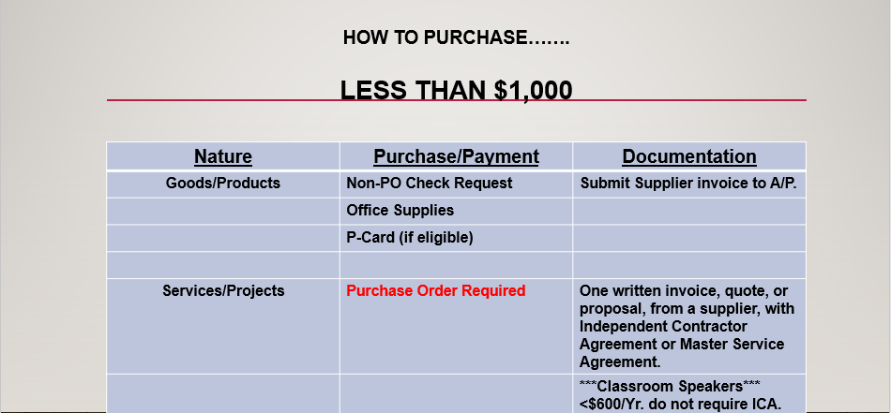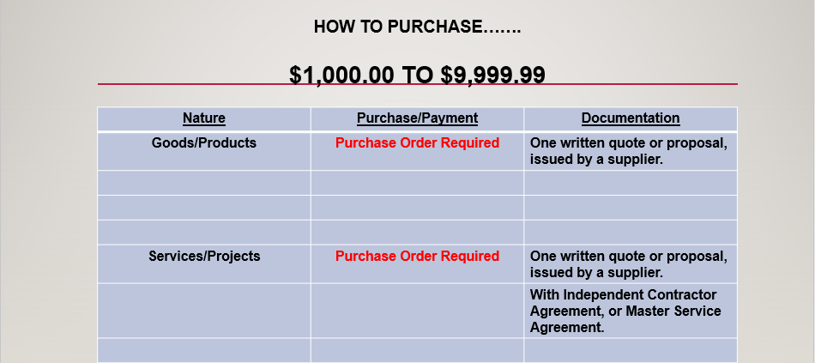

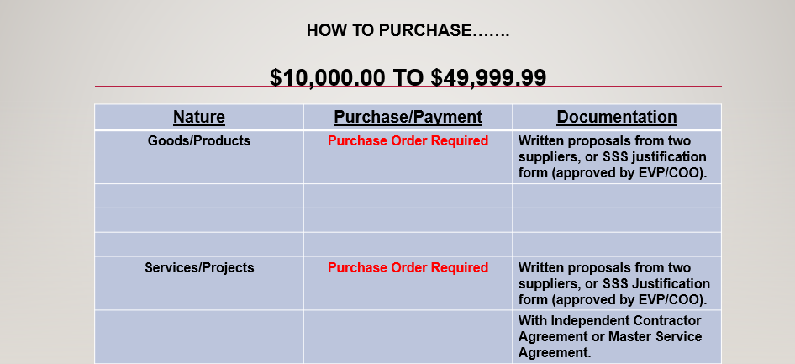 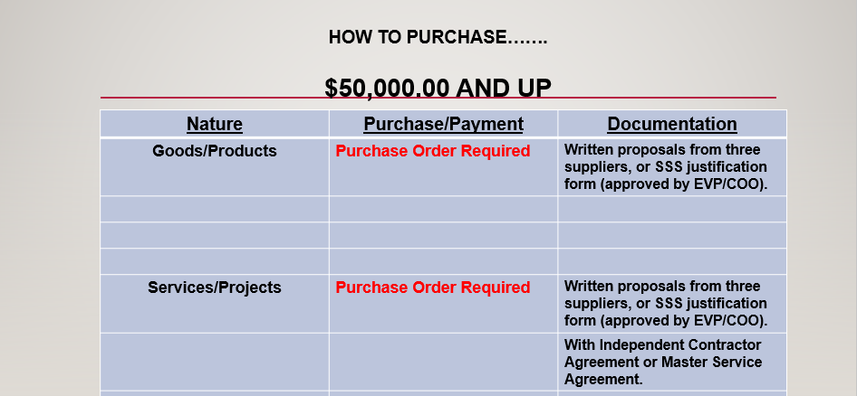

***\*NOTE: Sole/Single Source Suppliers Justification*** [***forms***](https://www.chapman.edu/campus-services/campus-controller/financial-services/purchasing/guidelines/sole-single-source-form.pdf) ***require approval of the EVP/COO.\****

***Sole Source*** *exists when a single seller controls the supply of products or services in a defined market. These situations are usually the product of market conditions such as technology leadership, patent protection, limited or exclusive franchise distributorships, mergers, and acquisitions, etc.*

***Single Source****selections are usually driven by “objective business” decisions; such as leveraged volume purchase contracts, standardization programs/systems, parts/service provided by an original equipment manufacturer, consistency of quality or batch control, or “just-in-time” delivery requirements, etc.*

*Note: Sole/Single Source selection based purely on personal preference or subjective rationale will not be sanctioned.*

**Preferred Suppliers:**

Please review and reach out to Chapman University’s “[preferred suppliers](https://www.chapman.edu/campus-services/campus-controller/financial-services/purchasing/guidelines/index.aspx)” whenever feasible. These suppliers have been previously vetted and utilized efficiently. You can check out Purchasing’s [website](https://www.chapman.edu/campus-services/campus-controller/financial-services/purchasing/guidelines/index.aspx), or contact the Purchasing department for a complete list of the preferred suppliers.

**Formal Bidding:**

For purchases or transactions with threshold of $50,000 and above, a formal bidding process is required to obtain the most beneficial outcome for Chapman University. If any of the [preferred suppliers](https://www.chapman.edu/campus-services/campus-controller/financial-services/purchasing/guidelines/index.aspx) is interested, please include them accordingly. Please make sure the following steps are observed adequately:

* ***Contact Legal Affairs for*** [***Request for Proposal***](https://www.chapman.edu/campus-services/legal-affairs/forms/index.aspx) ***template.***
* ***Send out the same invitation to all potential suppliers.***
* ***The Statement of Work (SOW) must be clearly stated.***
* ***An expiration date for submission should be included.***
* ***All bids must be submitted in written form and sealed.***
* ***The bids may be forwarded to*** [***CUBids@chapman.edu***](mailto:CUBids@chapman.edu)***.***
* ***Bids should be opened and reviewed at the same time.***
* ***Invite CU personnel from other departments to assist.***
* ***If feasible, invite at least three CU personnel for review.***
* ***Reach out to Financial Services for further assistance.***
* ***It is unethical to use suppliers’ bids as bargaining tool.***
* ***Please contact Legal Affairs for help when necessary.***
* ***You must be ready/prepared to justify to selected bid.***
* ***At the end, please inform bidders of the final decision.***
* ***Submit PeopleSoft’s PR with all pertinent documents.***

**Independent Consultant/Contractor Agreement [ICA]:**

The ICA is a legal agreement that defines scope of services, compensation, insurance requirements, and terms of condition, between Chapman University and a supplier (or service provider). The ICA should be reviewed by Legal Affairs and Risk Management. The ICA is not valid unless it has been signed by the EVP/COO.

Refer to section [1.2.4 Professional Services](https://www.chapman.edu/campus-services/campus-controller/financial-services/fiscal-policy/index.aspx) above. And, contact Legal Affairs directly for [ICA template](https://www.chapman.edu/campus-services/legal-affairs/forms/index.aspx) or any pertinent questions and/or concerns.

**Master Service Agreements [MSA]:**

The MSA is like the ICA described above. While the ICA is more specific to a defined professional service, and/or statement of work, the MSA is more general/universal in nature and often provides longer lifespan coverage. The MSA should be reviewed by Legal Affairs and Risk Management. It is not valid unless signed by the EVP/COO.

MSA, amendments and renewals must be properly vetted by a committee to include a representative from the department (using the supplier) and Financial Services.

While the university has made every effort to create a policy and related procedures to provide oversight control, accountability and transparency, certain circumstances may create an “exception”.  When this occurs, the reason for the exception and/or any mitigating circumstances must be documented and, in some cases (e.g. major projects, renovations, construction of new buildings) will be made by the EVP/COO or Board of Trustees.