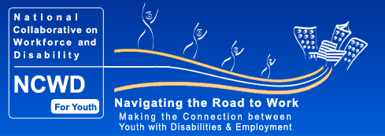
Work-based Learning
http://www.ncwd-youth.info/work-based-learning
Work-based learning is a supervised program sponsored by an education or training organization that links knowledge gained at the worksite with a planned program of study. Experiences range in intensity, structure and scope and include activities as diverse as site visits, job shadowing, paid and unpaid internships, structured on-the-job training, and the more formal work status as apprentice or employee.
Work-based learning helps youth to:
- Gain basic workplace skills (including teamwork, communication, problem solving; customer service and social etiquette skills);
- Knowledge of specific occupational skills; and,
- An understanding of different industries to make informed career choices.
Work-based learning takes many forms and serves many purposes and its worth is recognized throughout the world. The Organization for Economic Co-Operation and Development (OECD) has documented what various countries do in their education and job training programs to achieve the goal of smooth transition from initial education to working life.
While work experiences are beneficial to all youth, they are particularly valuable for youth with disabilities. One of the most important findings from the research shows that work experiences for youth with disabilities during high school (paid or unpaid) helps them acquire jobs at higher wages after they graduate. Also, students who participate in occupational education and special education in integrated settings are more likely to be competitively employed than students who have not participated in such activities. (Blackorby & Wagner, 1996; Colley & Jamison, 1998; Luecking & Fabian, 2000; Rogan, 1997)
Unfortunately, many young people with disabilities do not have the opportunity to participate in structured high-quality programs designed to help them make informed choices about what careers they may want to pursue. (Luecking & Fabian, 2000) Youth with disabilities continue to actively struggle to achieve success in the labor market. They are frequently channeled into inadequate education for work programs because of low expectations and/or discriminatory assumptions about disability. (Fairweather & Shaver, 1990; Rojewski, 1996)

Paid Work Experience
The following information was taken from the” New Ways to Work” Paid Work Experience Fact Sheet.
Paid Work Experience is a career preparation activity in which students are at a worksite doing real work for pay. They are held to the same expectations as all employees. The workplace supervisor conducts evaluations based on workplace expectations and performance. These experiences range from regular, paid employment to subsidized employment and learning-rich work experience.
Work experiences are designed to promote: • Exposure of the student to careers and jobs; • Development of pre-employment and work maturity skills; and • Building occupational knowledge and technical skills.
Key Legal, Safety & Health Issues
• The employer or the school/funder responsible for student wages is also responsible for all taxes, liability and workers’ compensation coverage.
• The student should be oriented to all safety and health issues.
• The California Department of Education sponsors Work Experience Education, which has specific program components, definitions and regulations regarding work-based learning activity conducted through the program.
For more information review the factsheet titled "Work Experience Education." (CA Education Code Section 51760)

Subsidized Work Experience

Subsidized Work Experience In some programs, the student’s wages are subsidized (i.e., not paid by the workplace, but by the program through an outside funding source, usually a state- or federally funded program). In these cases, the program is the actual employer, subsidizes all wages and is responsible for taxes and workers’ compensation insurance. Students must be paid at least the California minimum wage for all hours worked.
Resources: (to locate a resource visit stc-clearinghouse.com or nww.org)
- The Work-Learning Process: What Every Worksite Supervisor Should Know– Strumpf Associates
- Worksite Handbook– Mayor’s Youth Employment & Education Program
- California Law, Education and Labor Code http://www.leginfo.ca.gov/calaw.html
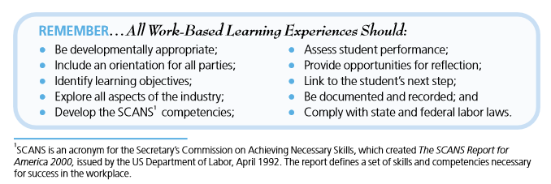
http://www.newwaystowork.org/qwbl/tools/caltoolkit/factsheets/paidworkexperience.pdf

