Viewing Attachments when you approve an AP Voucher

- From your Worklist or approval email link – select the voucher to approve

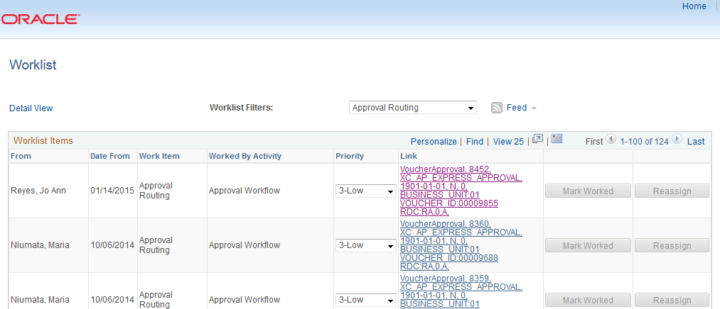

- Click on the highlighted Attachments hyperlink to go to the Voucher Attachments window

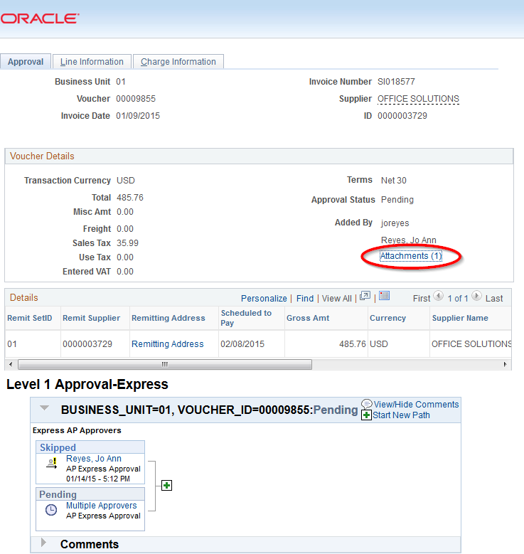
- The system will take you to the Voucher Attachments window. Click on the highlighted file name hyperlink to view the invoice.
