DELEGATING APPROVER AUTHORITY
Approvers/Reviewers can elect to have someone else receive the approval notices and process approvals/reviews. This would be an option during vacations and other “out of office” temporary periods. Note: the Alternate User/Delegate must have the appropriate security roles to approve transactions.
Navigation: Main Menu – My System Profile
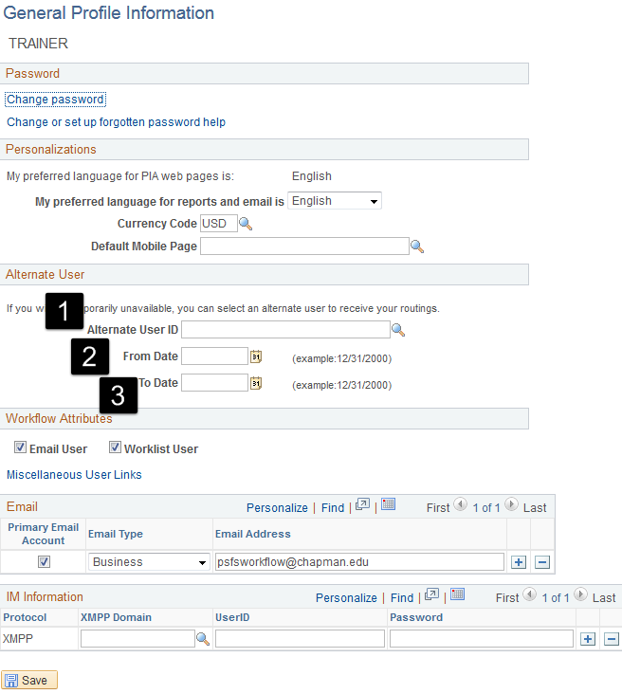

- Add the User ID for the delegate
- Add the date the delegation authority begins
- Add the date the delegation authority ends.

