

QUICK REFERENCE GUIDE
WORKFLOW PROCESS – PURCHASE ORDERS/VOUCHERS

There Are Two Ways To Access Documents Requiring Approval:
- Email Link to Approval Page OR
- Log in to PeopleSoft and Access Worklist

Email Link
When a purchase order has been sourced and approval is required, an email is generated by the system to the reviewer/approver. Click on the link within the email text to go directly to the purchase order/voucher approval page.

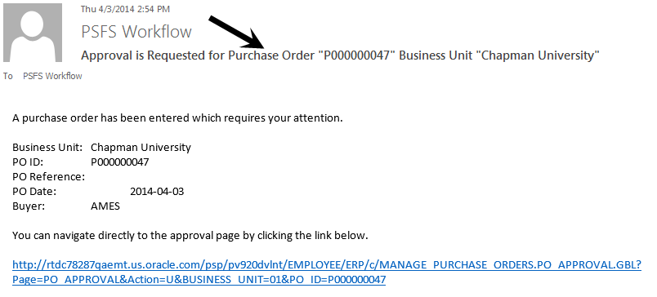

If you are not logged into PeopleSoft, you will be presented with the login screen.
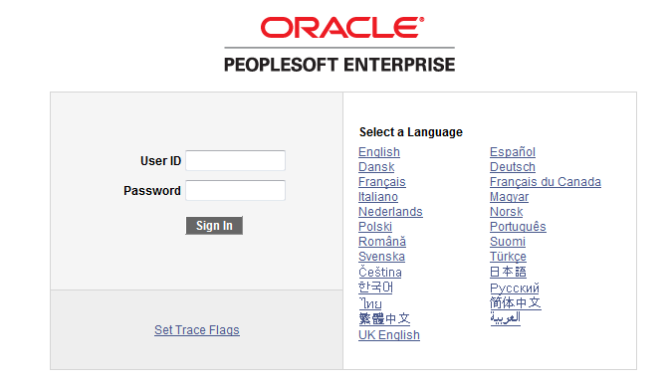

Your PeopleSoft login is the same as your Chapman University email/computer login. You will be directed to the approval page.

Log in to PeopleSoft and Access Worklist

Log in to PeopleSoft by launching a web browser such as Internet Explorer or Firefox. Your PeopleSoft login is the same as your Chapman University email/computer login.

In the top menu bar on the right hand side of the screen is a link to Worklist. Click on Worklist.

A list of documents requiring your approval populates the screen.

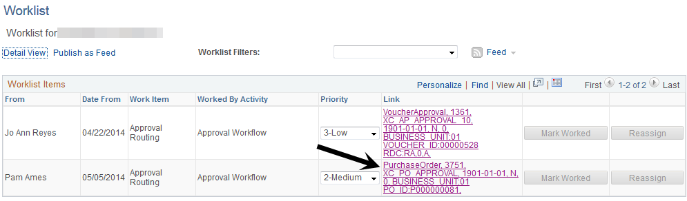

Click on the link to the Purchase Order/Voucher you want to approve.

Approval Process

- After successful login – you will be in the P.O. acquiring your approval. There are two sections to this screen – the Purchase Order/Voucher Approval details section and the Approvers section.

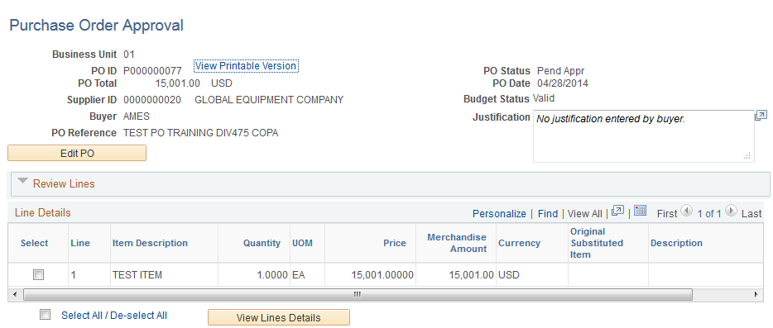
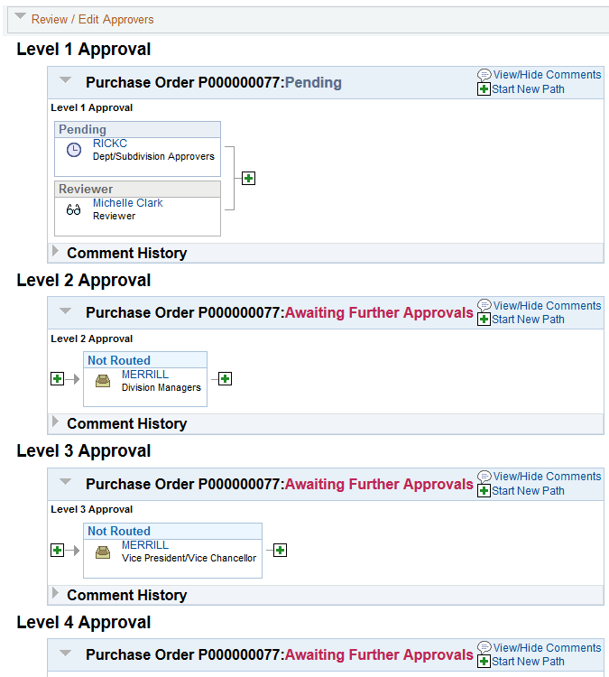
- Three actions can be taken at this approval level: Approve – Hold – Deny. Scroll to the bottom of the screen and click on the appropriate button. If you place the PO on Hold or Deny you must provide comments. NOTE: Placing a PO in Deny results in cancellation of PO.

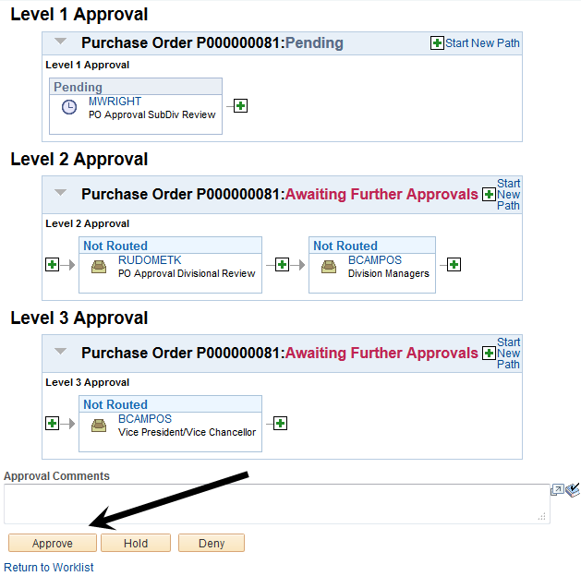

- Once Approve or Deny action is taken, the item will be removed from your Worklist. Holds will remain on your Worklist.

