Accommodations via Booking.com and Airbnb for Work are now connected with our Concur Travel portal. Both options are clearly identified with their respective logos in Concur.
Booking.com 2
Searching and viewing details 2
Booking 3
Confirmation and changing a reservation 5
Airbnb 6
Searching and viewing details 8
Booking 10
Confirmation 11
Changing a reservation 12
Support Contacts 13

Booking.com

Searching and viewing details
From the Concur home page, enter dates to search for a hotel
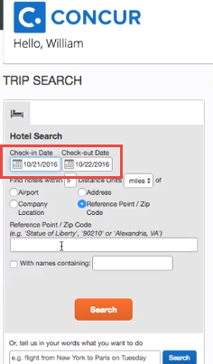
Click on View Rooms to see pricing options
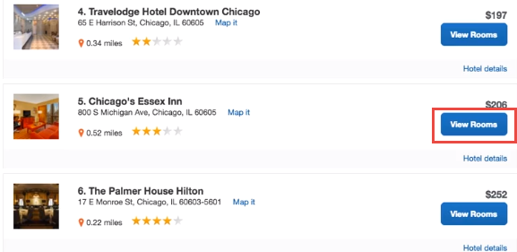

Note that the rates below are from Booking.com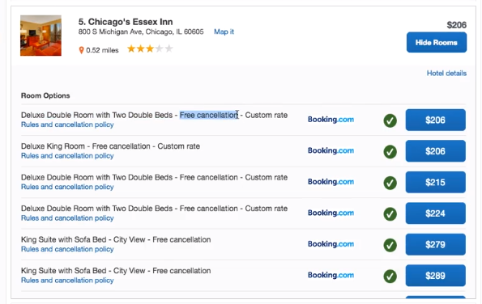

Booking
Select the room desired and review the rate details and cancellation policy. Reserve the Hotel and Continue
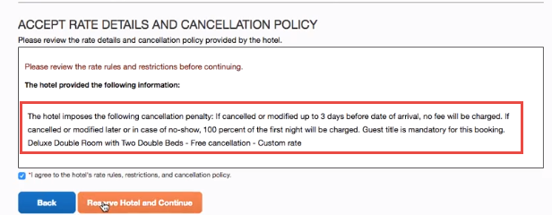

Enter the name of your trip
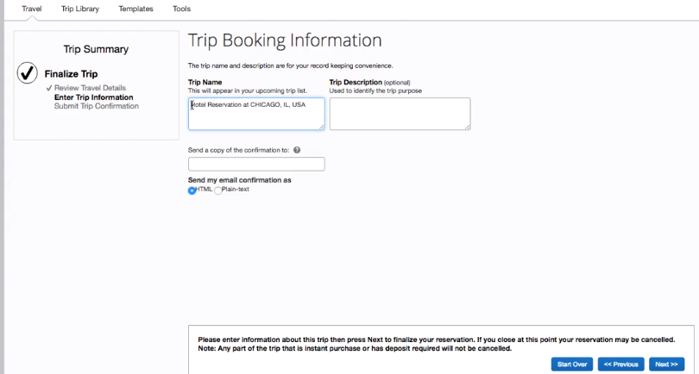

Review the reservation and click on ‘Confirm Booking’ to complete
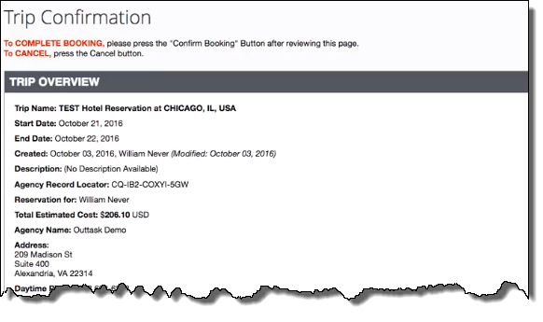
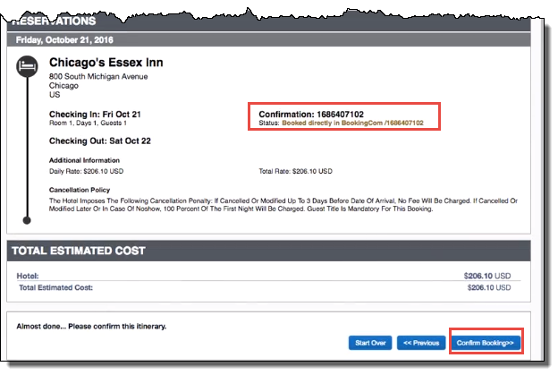

Confirmation and changing a reservation
Your reservation is confirmed and is available for review. You can print, email your itinerary to plans@tripit.com (if signed up) or cancel your trip from here.
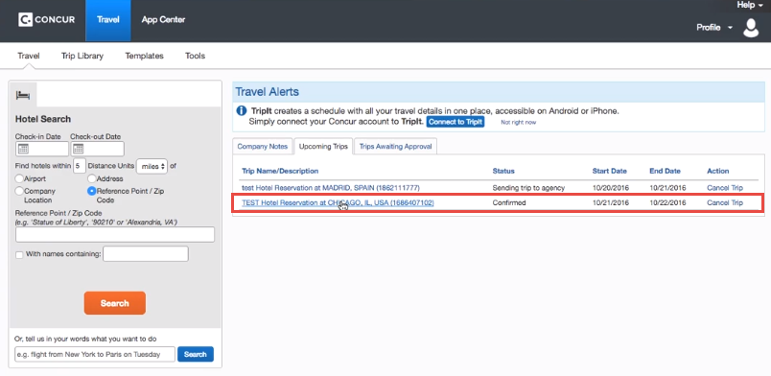

Click on the trip name to see the reservation summary and additional options under I want to…

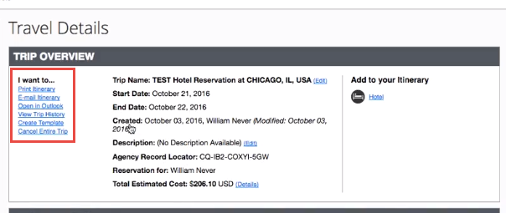
Airbnb
Airbnb now available in Concur Travel
- Airbnb listings will now be available in Concur hotel search
- Users will be directed to Airbnb for final booking
- Itineraries can be reviewed in Concur Travel and users will receive e-receipts
- Add your Airbnb can be linked to My Travel Network for e-receipts
- Form of Payment - Travelers will need to enter credit card information in Concur. Credit cards stored in Concur will not be shared with Airbnb
E-receipts – are sent to Concur to attach to their expense report
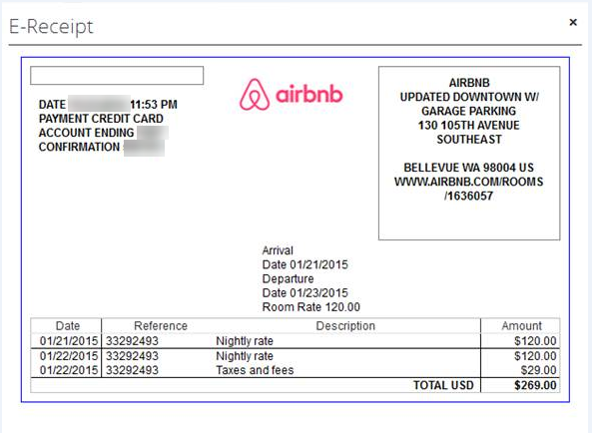

Searching and viewing details
Sample search results displaying hotel & Airbnb
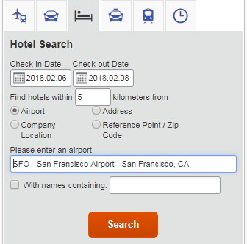
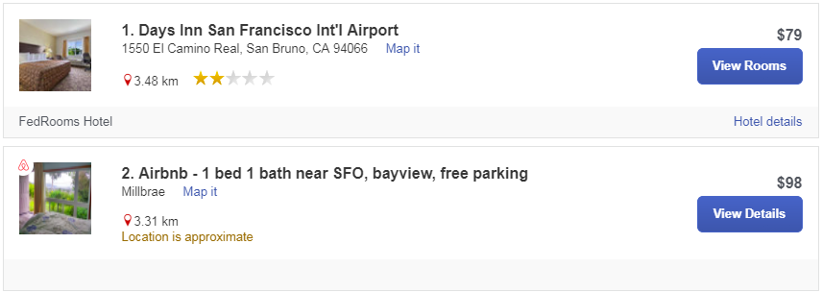
Users can filter results for Airbnb
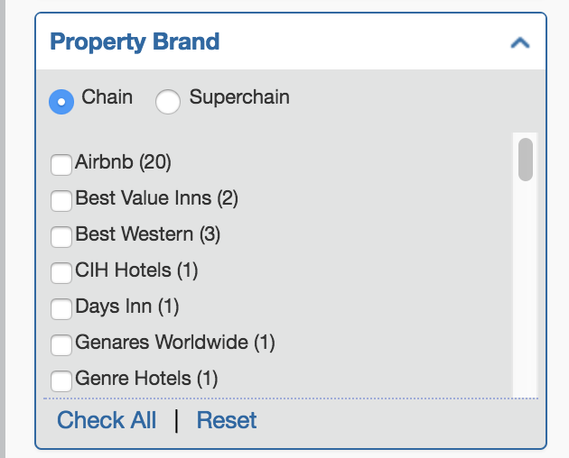

View additional details and rules/cancellation policy
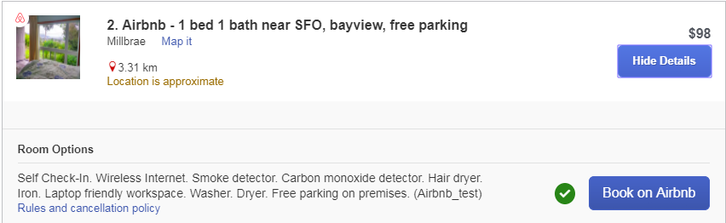
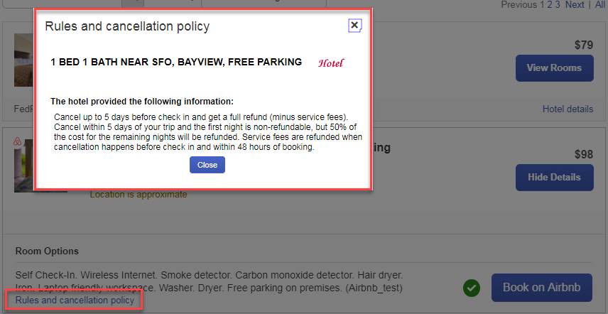

Booking
After the user click on Book on Airbnb, you are redirected to the Airbnb website where you complete the booking. Once the booking is confirmed, you will not be returned to the Concur site.
If the user already has an Airbnb account, you can sign in once you are redirected to the site.
Airbnb will send the users a confirmation email and details will be added to an existing itinerary if dates overlap or a new itinerary will be created.
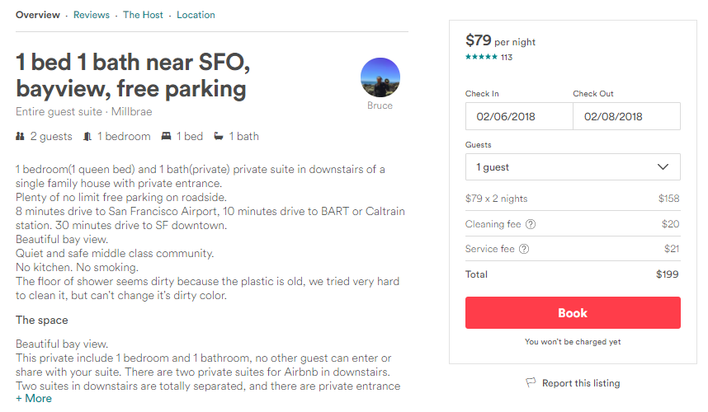

Confirmation
Airbnb will send the users a confirmation email and details will be added to an existing itinerary if dates overlap or a new itinerary will be created.
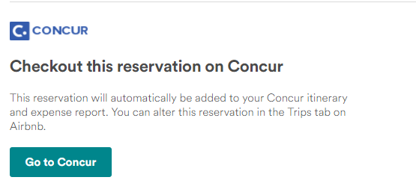

Here is how the booking appears in Concur
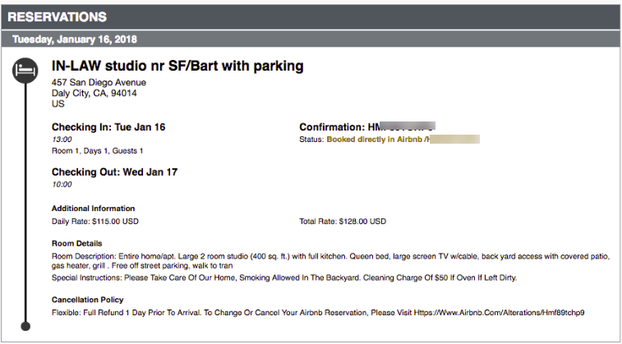

Changing a reservation
While the Airbnb booking appears on the user's itinerary in Concur Travel, modifications and cancellations must be completed directly on the Airbnb website. To do this, the user clicks Change reservation on the Airbnb confirmation email
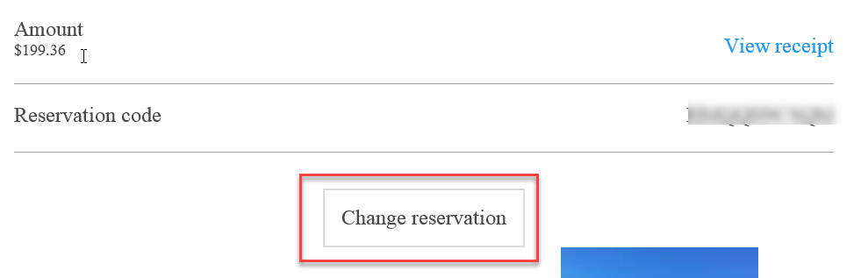
The user is directed to the Airbnb and given these options:
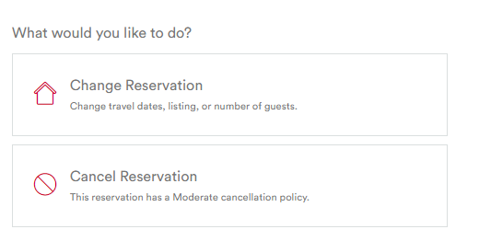
As an alternative, all Airbnb reservations/receipts are stored – in chronological order – in the Airbnb profile under Trips. The user can click a trip name to access more details and can then change or cancel the reservation.
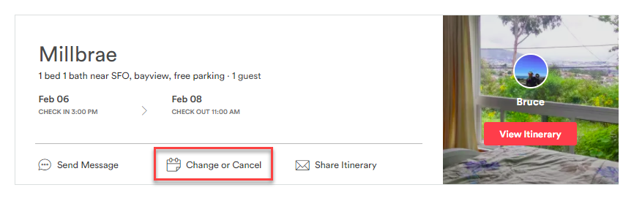

Support Contacts
There will be a priority customer service number located at the bottom of all business travel bookings. This should be used if an error occurs while on the Airbnb site. Issues that occur while in Concur Travel should be reported via the standard process.

