

REFERENCE GUIDE - BUDGET REPORTS IN PEOPLESOFT

Report Summaries: 1
Navigation Details: 3
REPORTS: 4
Budget to Actuals with Encumbrances 4
Run Control 4
Template/Parameters 5
As of Date 5
Run 7
Process Scheduler 8
Process Monitor 8
Process Details/Message Log 9
View Reports 11
GL Transaction Details 18
Budget Comparison 20
12 Month Budget Reports 22
Monthly Budget to Actuals 24
Budget Change Reports – Tracking Budget Transfers 27
Purchasing Reports – Location Table Query 29
PO Listing Details 30
Requisition and PO Budgetary Activity Report 34
Supplier Lookup Report 37
Account Code Listing 39
Fund/Department/Program Listing 41
AP Transaction by Supplier 43
Tips for Successful Report Generation 45
Viewing Reports from Main Menu 46
Viewing Process Monitor from Main Menu 48
Suggested Run Control ID – Naming Convention 49

Report Summaries:

The following budget reports are currently available in PeopleSoft. NOTE: Budgets and actuals data FOR FY 2010-11 through 2014-15 has been loaded to PeopleSoft.
- Budget to Actuals with Encumbrances
This report provides all the non-compensation categories (and compensation if your security allows this data). The non-compensation categories are those that are “budget checked” in the purchase requisition and travel and expenses review. Once a purchase/travel authorization is approved the funds are “encumbered” and appear on the report. When payment has been made (either purchase or expense report) the funds move to the “actuals” column. The data for this report comes from the KK Ledger (Commitment Control). Two templates are available.
  - Budget to Actuals with Encumbrances by Department
  - Budget to Actuals with Encumbrances by Program

- Budget to Actuals with Encumbrances – NOP
This report provides budget to actual with encumbrance data for non-fund 100. This report will require specific inputs for the Template and Ledger Group depending on the fund. Users who do not have all-accounts security (non-comp only or student only compensation) will see limited data depending on the budget setup for ledgers. All NOP reports are reporting on GL Actuals which is different than the Fund 100 Budget to Actuals with Encumbrance report which is reporting on KK Actuals. The report contains 4 templates, you will need to select the template and the Ledger Group based on the fund associated with the program or project.
- Fund 105
- Restricted
- Capital Project
- Grants Project

- GL Transaction Details
This report reflects actual expenses posted to the General Ledger. The Budget to Actuals with Encumbrances provides both “pending” and “actual” data so these two reports may not match.

- Budget Comparison Reports
This report compares monthly of expenditures in a selected fiscal year with the same month in the prior fiscal year. This report also provide YTD data as of the month selected. To review the YTD comparison of one budget year to another – select month 12. Data from this report is from the GL (General Ledger). Nine templates are available. RXC templates list budget category totals only, a summary report. RXD templates list account and budget category totals, a more detailed report.
- Monthly By Department (2 templates) | - Monthly by Program
- Monthly by Division (2 templates) | - Monthly by Officer (2 templates)
- 12 Month Budget Reports
This report displays the annual budget in the assigned monthly amounts. Three templates are available.
  - 12 Month Budget by Department
  - 12 Month Budget by Program
  - 12 Month Budget by Account

- Monthly Budget to Actuals
This report provides Budget and Actuals data over a 12 month budget period. There are two templates available for this report.
- XC_BP03_1 Provides Department/Program/Account details
- XC_BP03_2 Provides Department/Account details

- Budget Change Reports
This report allows for tracking of budget transfers. There are two templates, one to review all budget transfers for a fiscal year, the other is used to identify specific transfers.
- Budget Change Detail
- Budget Change Detail by Reference

- Purchasing Reports
There are two reports in the Purchasing Folder. The Location Table Query opens the Location Codes table used for product delivery ordered through the purchase requisitions. The physical addresses are associated with the Location Codes in Requisition processing. The PO Listing Details report provides detailed PO information by line item. It includes PO Header data, Supplier, PO & Requisition number, line descriptions, account numbers, merchandise amount by line, AP vouchers applied against PO by line and liquidated amount by line to calculate the encumbrance balance by line. One template is available.
- XC_PO02_Q1 PO Listing Details

- Requisition and PO Budgetary Activity Report
This report is used to run a PO listing by chartfield (department/project/program). The Report provides the PO amount, liquidated amount, remaining amount and vouchered amount. This is an excellent summary report.

- Supplier Lookup
Report provides full supplier ID#, supplier name, short supplier name and address details. Using this report is an alternative to searching for suppliers in the Purchase Requisition process.

- Account Code Listing
This report provides a list of PeopleSoft Accounts and the corresponding IFAS Object Codes. This is also available as a PDF.

- PeopleSoft Fund-Department-Program Listing
This report provides all the chartfield data (fund, department, program, operating unit, project number, etc.) This is also available as a PDF.

Navigation Details:

Your assigned security roles determine the amount of information you can retrieve from the reports. Most budget reports will be found with the following navigation. If the navigation is different, it will be referenced at the top of each report section.
NAVIGATION: MAIN MENU > CHAPMAN CUSTOMIZATION > REPORTS > BUDGET
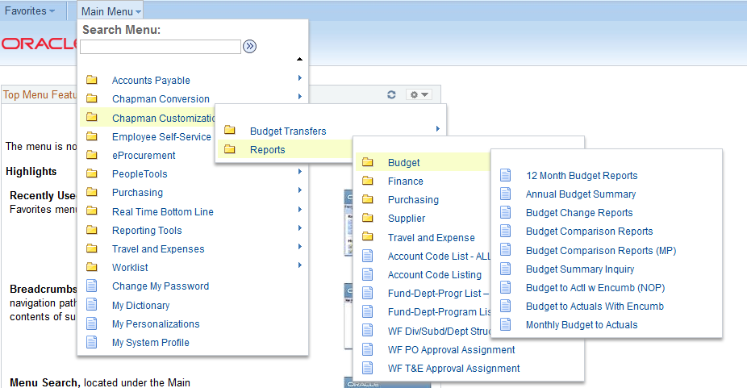

REPORTS:

Budget to Actuals with Encumbrances

- Select Budget to Actuals with Encumbrances. You will be routed to the search page and prompted to enter a Run Control ID. This screen will appear when you select any of the Budget Reports.

Run Control
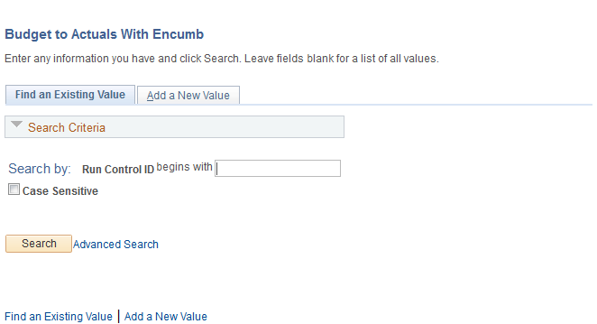
- A Run Control ID is created by the user. A Run Control ID should be named to assist you in identifying the report. Report parameters can be saved to a Run Control ID for future processing. Here’s a few tips in establishing run controls:
  - Run Controls cannot contain spaces – use “underscore” if a space is needed
  - Run Controls can be up to 30 characters including numbers.
  - Create separate Run Controls for each report template ID. This will allow you to launch several reports without waiting for one to finish.
  - Include type of report in Run Control i.e. BUD_ACT_ENCUM_KIM1

- Click on Add a New Value and create a Run Control ID and click Add.
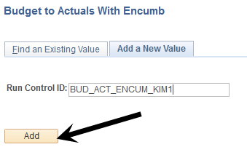
You will be routed to the Report Parameters screen.

Template/Parameters
- Select the template you want to run (Department vs. Program) by clicking the magnifying glass and selecting the template. Your Run Control name should reflect the template type.

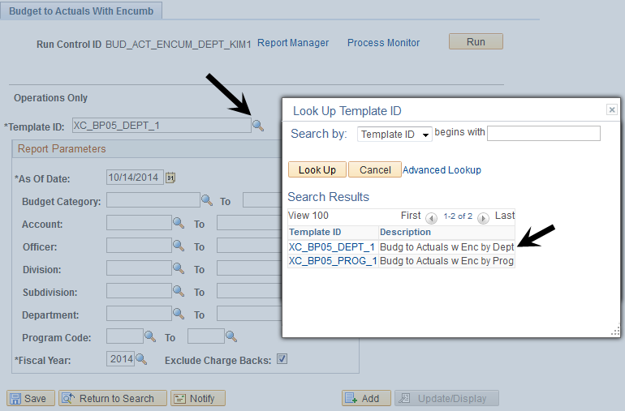

As of Date
- The *As of Date field is a key element on this report. To view the entire fiscal year, you should select the last day of the fiscal year (05/31/2015). This ensures the report collects all data for the fiscal year that is contributing to the current available funds. NOTE: If the fiscal year has ended and you want any changes occurring AFTER the end of the year – allow the As of Date to default to the current date.
- The *As of date can be “retroactive”. If you select a prior date the report will provide budget, actuals with encumbrances based on that date.
- When selecting a different fiscal year, the *As of Date should be in line with the fiscal year selected.
- To view available funds for Purchase Orders and Travel Expenses (the Non-Compensation categories), enter the Budget Category 5100 to 5995 or select from the drop down menu.

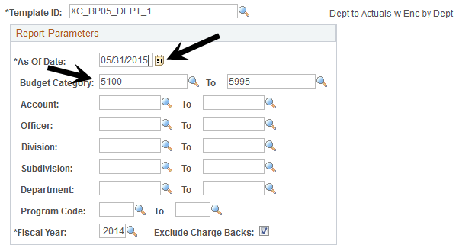

Screen shot of Budget Category menu:
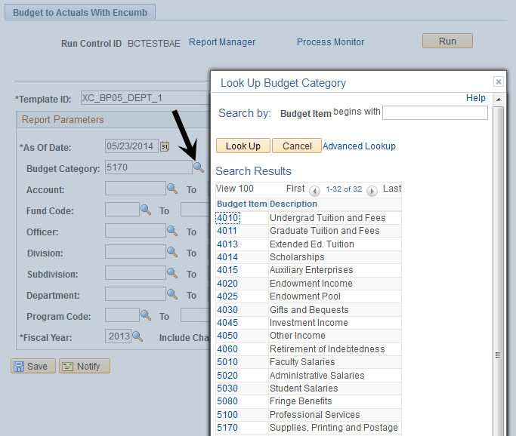

You can further define your report by selecting other parameters (Account, Fiscal Year etc.). Parameters should be selected from top to bottom. For example: If you select “Division” the “Departments” and “Program” selections are limited to the one in that division.
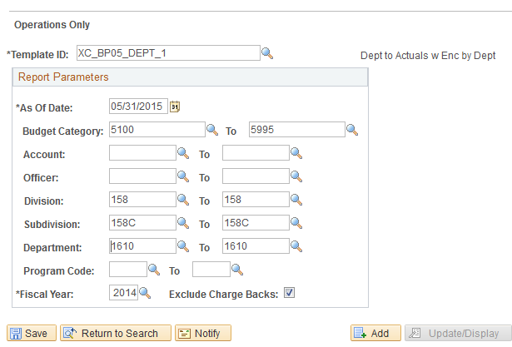

If this is a report you will be running throughout the year, click Save to retain these parameters as part of the Run Control ID. NOTE: Parameters will be saved once you click Run.

Run
- Click Run to begin report generation.
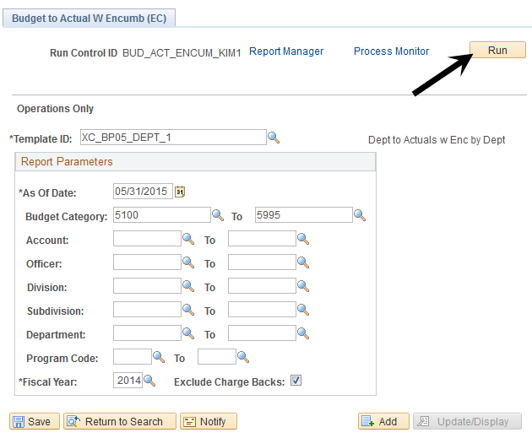

Process Scheduler
The Process Scheduler will appear. It is not necessary to change any fields. The report is “auto selected”. Click OK.

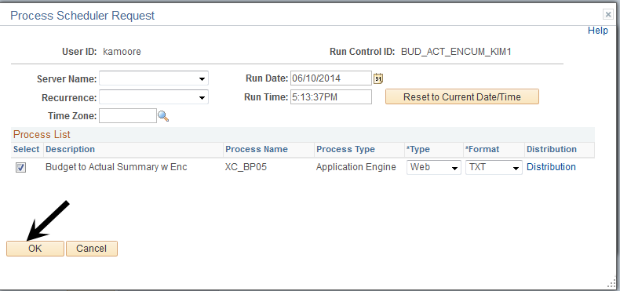

Process Monitor
- System returns to the Parameters page. Notice a “Process Instance” number has been assigned. This is confirmation the report is now running. Note the number so you can retrieve it by number if necessary. Click on the Process Monitor link to view the status of the report.

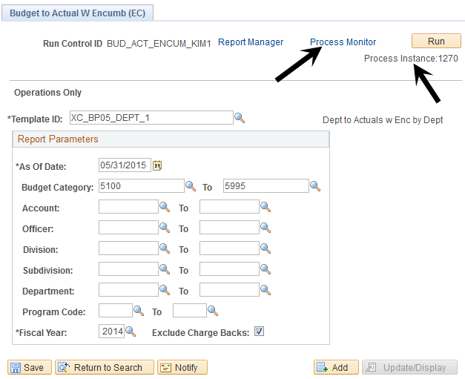

You will be routed to the Process Monitor List. Your report will reflect a Run Status of “Queued” and Distribution Status of N/A. Click the Refresh button to update the Run Status.
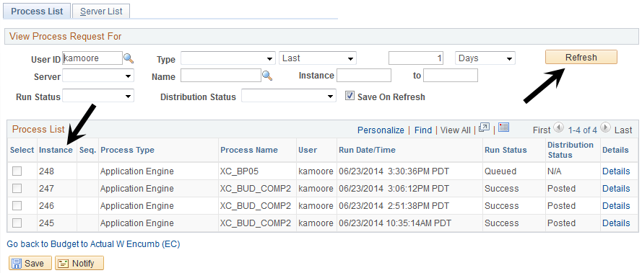

The report is ready when Run Status = Success and Distribution Status = Posted.
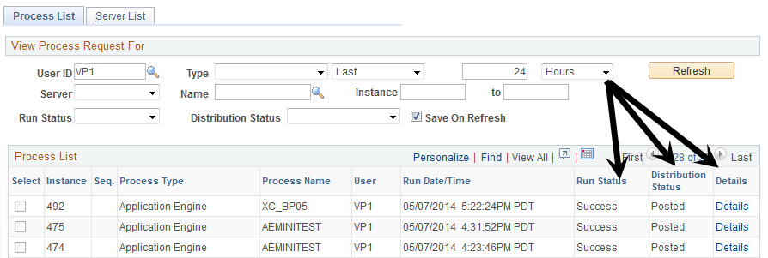

Process Details/Message Log
Click on Details. The Process Detail screen appear. Click on the Message Log link.
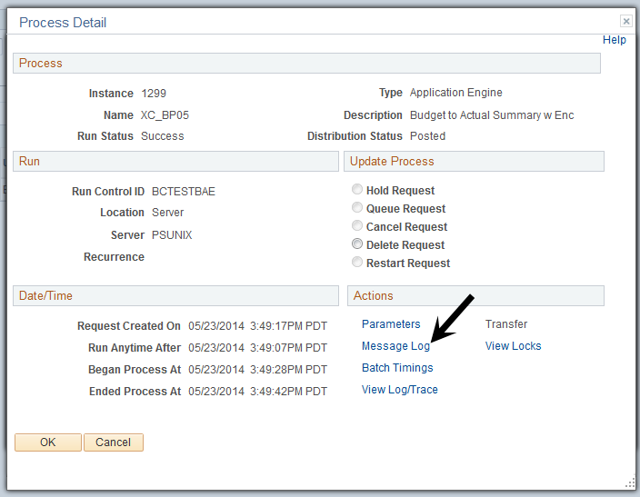
The Message Log appears. Review the Message Text to confirm the report ran successfully. Click Return. Click OK to exit the Process Detail page and return to the Process List

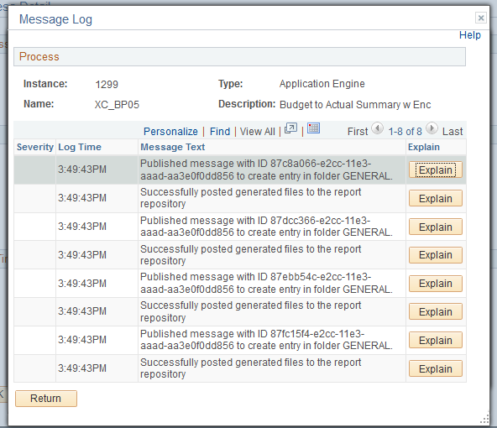

NOTE: This step is optional – if the Run Status is “No Success” the Message Log and View Log Trace may assist in determining the problem. In many cases it is an invalid run control.

View Reports
- Click on the link to the report at the bottom of the screen to return to the Process List page.

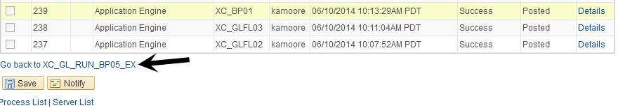

- To view Reports - click on the Report Manager link.

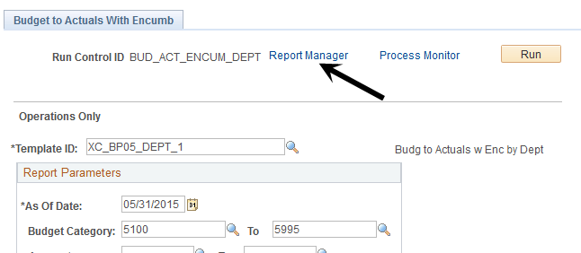

Click on the Administration tab to view available reports.
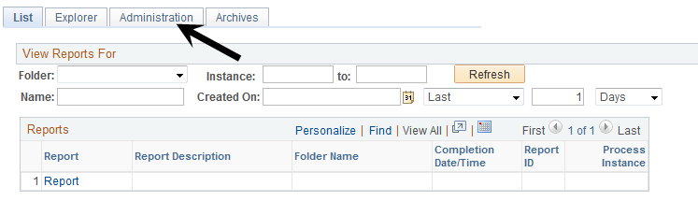

All reports are provided in three formats.
- PDF
- HTML
- Excel

Click on the Description of the report you want to open.
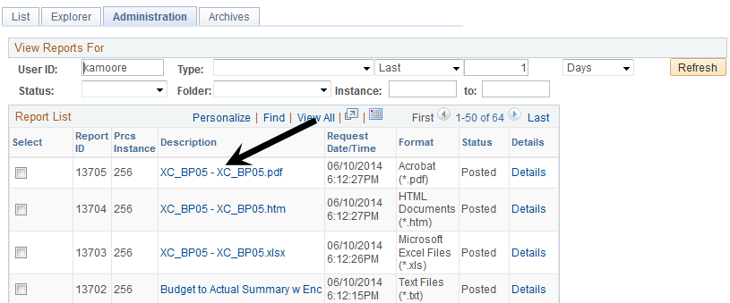

Here is a sample of the PDF version.
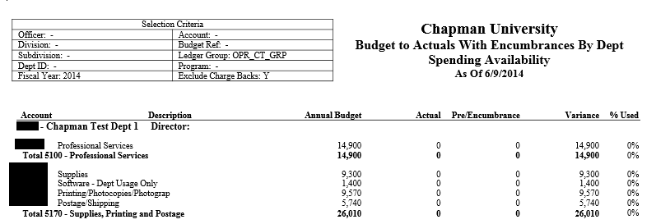

To export to Excel click on the link for the .xlsx report. Click on the Name of the report and a window will open confirming the selection.

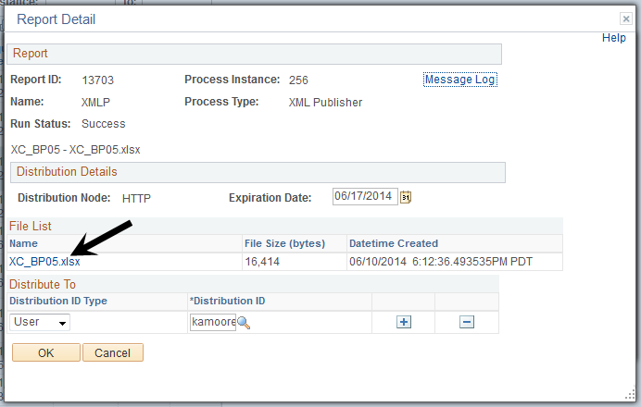

Click OK and the report will open in Excel.

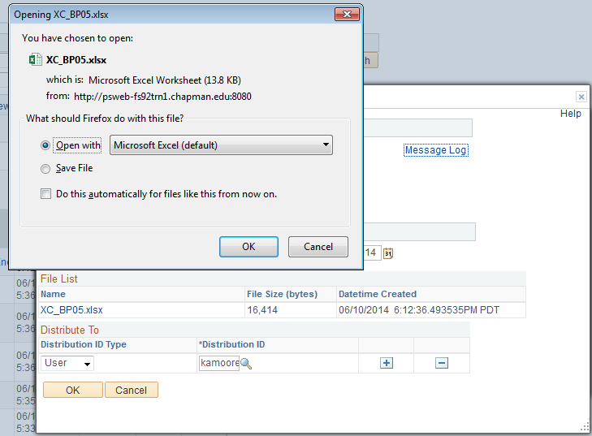

The export to Excel is very user friendly and is easy to manipulate the data.

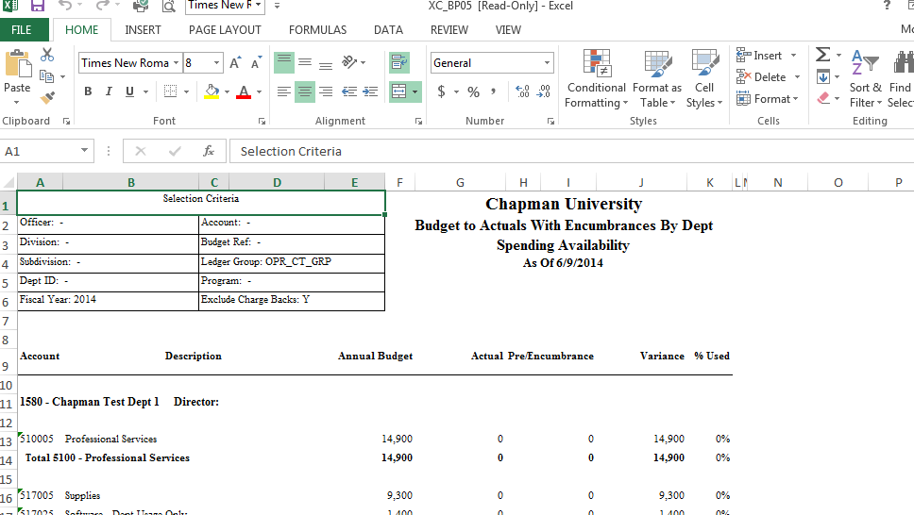

Budget to Actuals With Encumbrances – NOP

- It is recommended to establish a Run Control ID for each template.
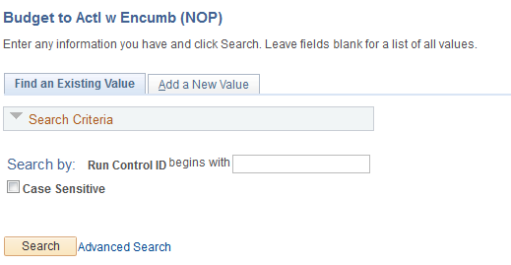

- The report contains 4 templates, you will need to select the template and the Ledger Group based on the fund associated with the program or project. See below.
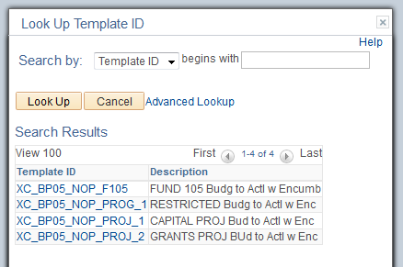

Ledger Group selection
- FUND 105 = NON_CT_GRP Ledger Group
- RESTRICTED = NON_CT_GRP Ledger Group
- CAPITAL PROJECTS = PRJ_CT_GRP Ledger Group
- GRANT PROJECTS = PRJ_CT_GRP Ledger Group

- Set the Fiscal Year and “As of Date” end date. The start date is currently hardcoded. Establish the remaining parameters. The Ledger Group is required.
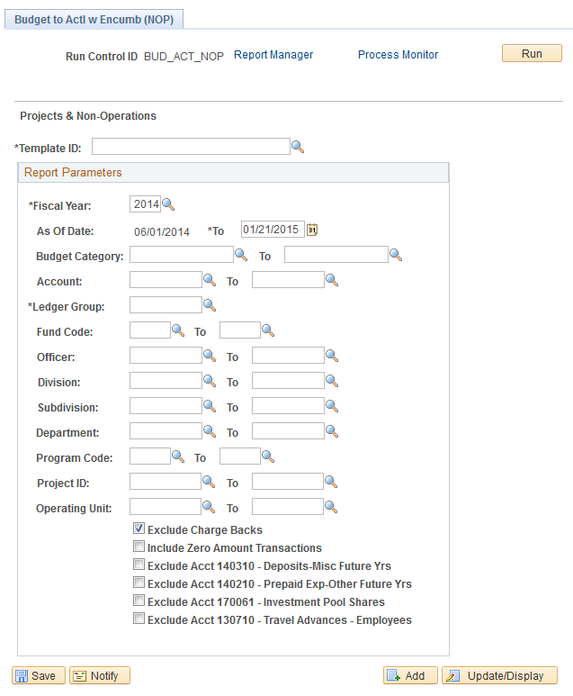

- Follow steps 5 – 8 in the Budget to Actuals with Encumbrances to finish the report.

Report Sample

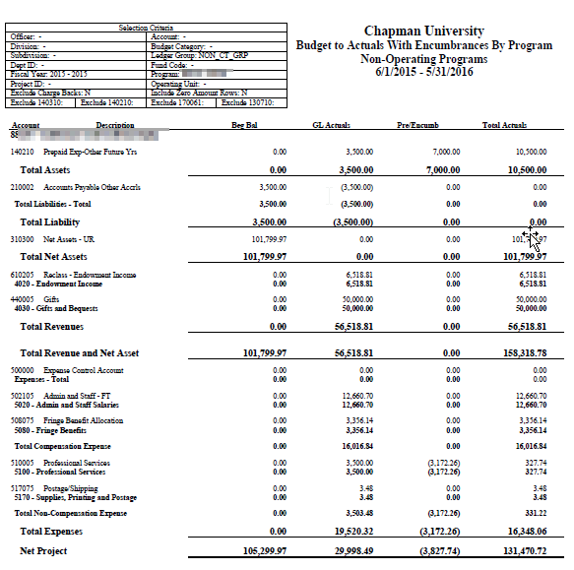

GL Transaction Details

NAVIGATION: CHAPMAN CUSTOMIZATIONS > REPORTS > FINANCE > GL TRANSACTION DETAILS
- There are two reports, one will generate a PDF, Excel and HTML file. The GL Transaction Detail Excel generates only an Excel file.
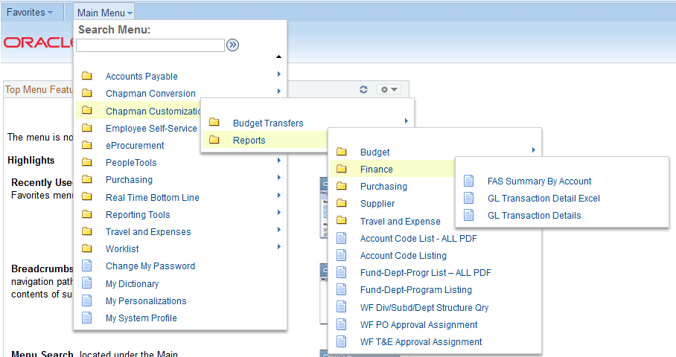
- Establish a Run Control ID for this report.
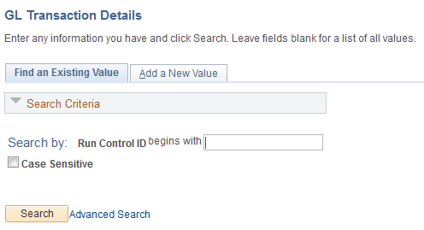
- There is one template for this report – GL Transaction Details by Program – XC_GLTR01_1.
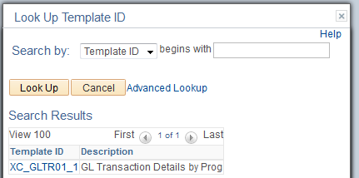
- The parameters allow you to select “From/To” dates as well as the scope of data (division vs. department vs. program etc.).
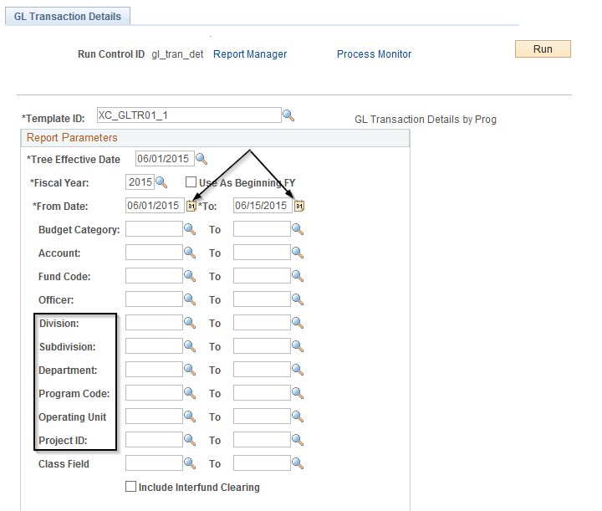
- Follow steps 5 – 8 in the Budget to Actuals with Encumbrances to finish the report.

Here is a sample report.
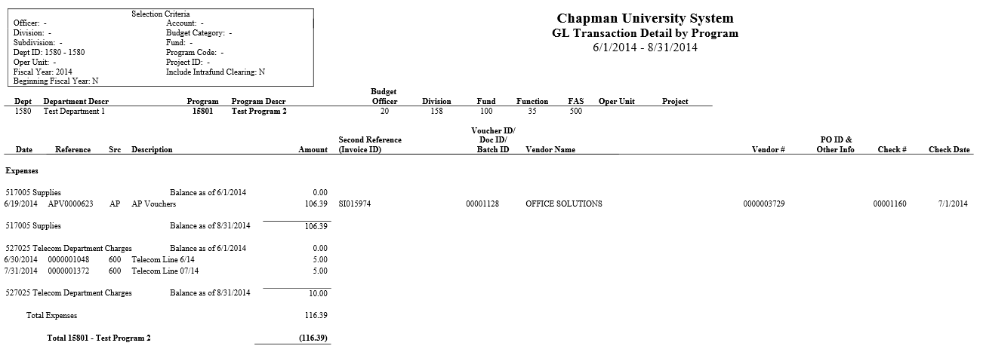

Budget Comparison

- It is recommended to establish a Run Control for each template.
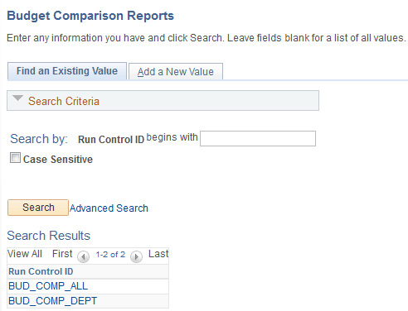

2. After selecting/creating a Run Control you’ll be directed to the Report Parameters page. Select the template of the report you want to run.
  - The Month Budget Comparison Reports provide data for month selected compared to same month in prior year and year-to-date for both years. Enter the data to define the report. There are multiple templates (Dept., Div, Officer, etc.) to assist you in developing the report.
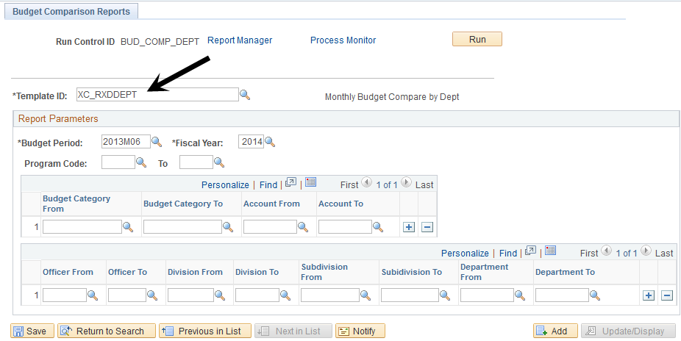

      - Follow steps 5 through 8 of Budget to Actuals to Encumbrances to run and view the reports.

Report Sample
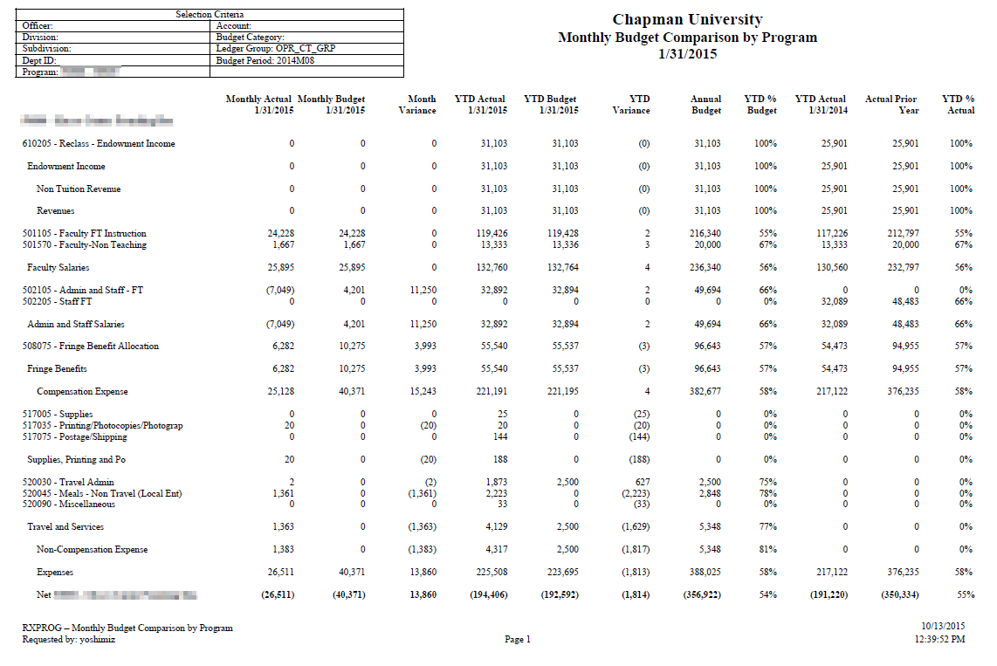

12 Month Budget Reports

- It is recommended to establish a Run Control for each template.
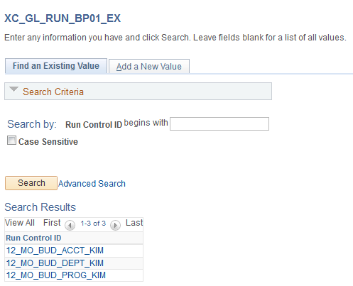

- After selecting/creating a Run Control you’ll be directed to the Report Parameters page. Select the template by clicking on the magnifying glass. This report reflects the new form and can be run for other funds. The report can also be further defined by increasing the selection criteria (see 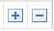 ) Define the data you want in the report and click Save.
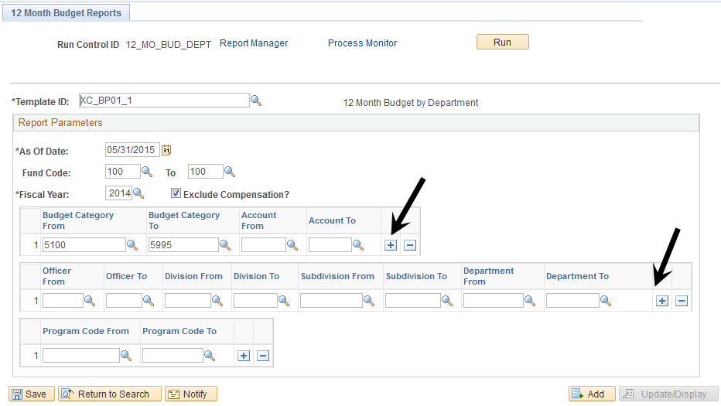

- Follow steps 5 through 8 of Budget to Actuals to Encumbrances to run and view the reports.

Report Sample
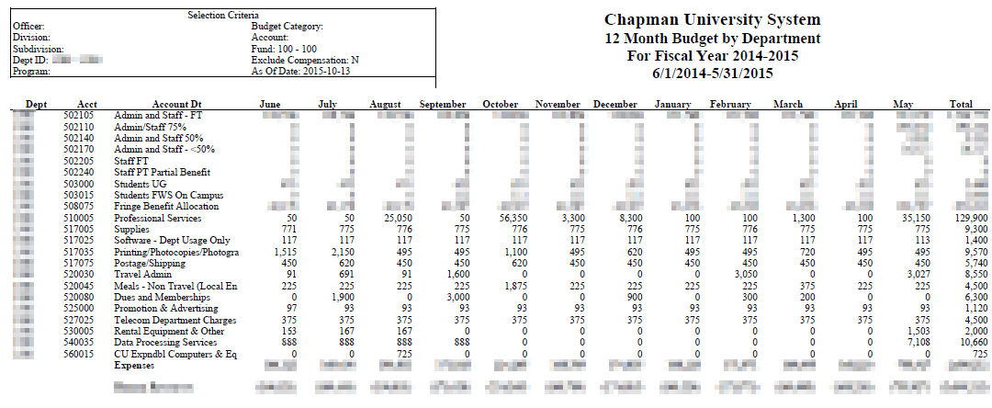

Monthly Budget to Actuals

- It is recommended to establish a Run Control for each template.
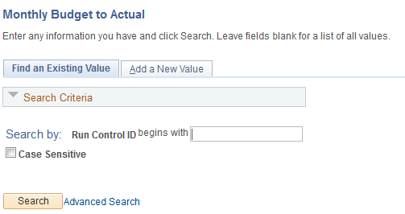

- Select the template you want to use.

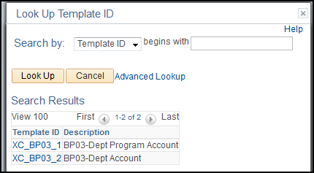
- On the Parameters screen Select Budget Category/Account and Division vs. Department etc. based on data desired. The Department/Program/Account report provides details for all programs within the Department based on the parameters selected. This is the more detailed of the two templates.

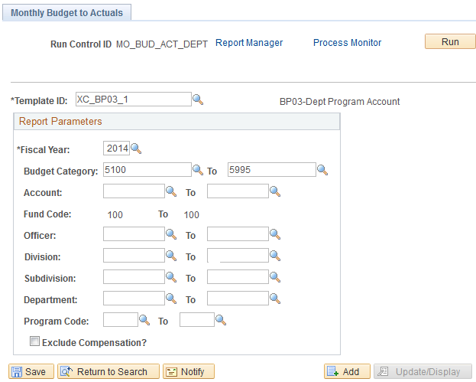

- The Department/Account report provides the summary data for the Department’s programs.
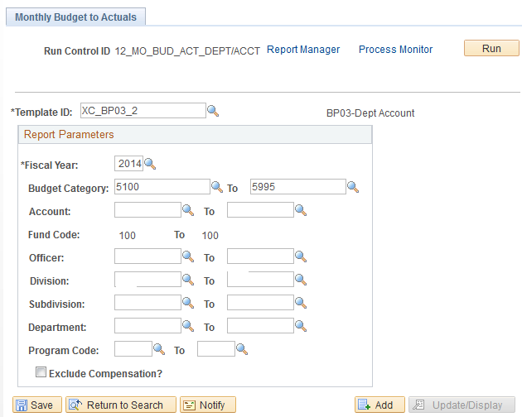

- Follow steps 5 through 8 of Budget to Actuals to Encumbrances to run and view the reports.

This is a sample report. Both templates create reports that look the same – totals are on the far right. The difference is the level of detail.

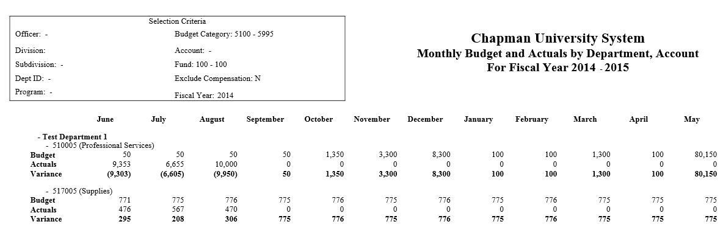

Budget Change Reports – Tracking Budget Transfers

- It is recommended to establish a Run Control for each template.
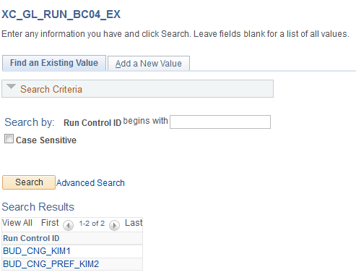

- After selecting/creating a Run Control you’ll be directed to the Report Parameters page. Select the template of the report you want to run.
  - The Budget Change Detail report provides all of the budget transfer activity that occurs for the Fund/Department/Program.
  - The Budget Change Detail by Reference allows you to see details for a specific budget transfer
- Enter the *As Of Date to include dates of transfers. After the end of the Fiscal Year you may need this to extend past the FY end date to capture any changes after year end.
- Enter remaining parameters to define the report.
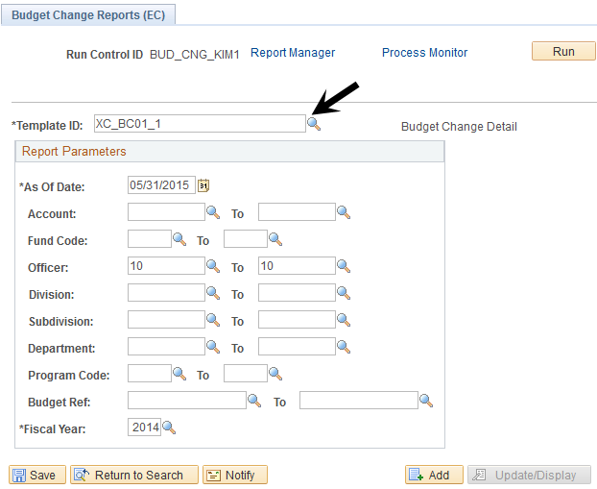

- Follow steps 5 through 8 of Budget to Actuals to Encumbrances to run and view the reports.

Report Sample By Budget Ref
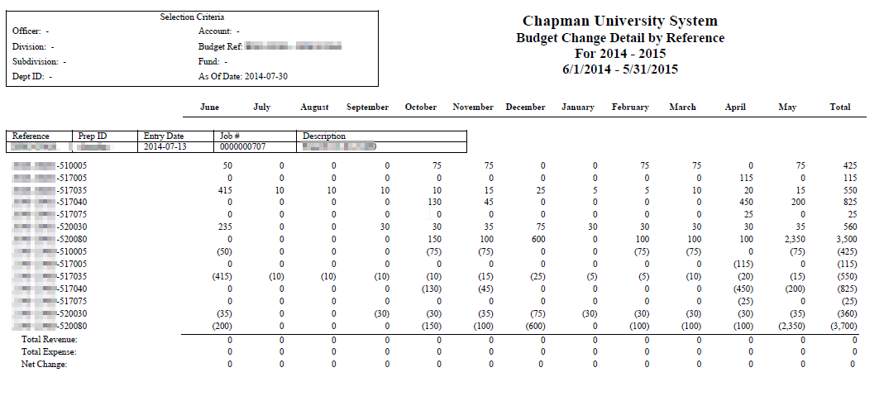

Purchasing Reports – Location Table Query

NAVIGATION: CHAPMAN CUSTOMIZATIONS > REPORTS > PURCHASING
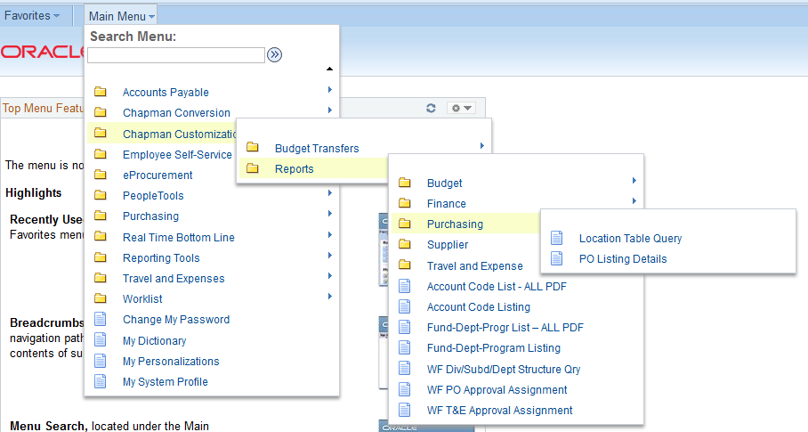

Location Table Query

This query opens the Location Codes table used for product delivery ordered through the purchase requisitions. The physical addresses are associated with the Location Codes in Requisition processing. The Location Code is populated in the Purchase Requisition and designates which address to use for shipment. To add an alternate location (other than Central Receiving) contact Purchasing.
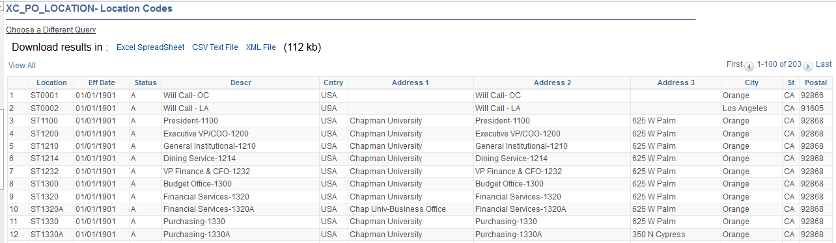

PO Listing Details

      - Establish a Run Control ID for the report.
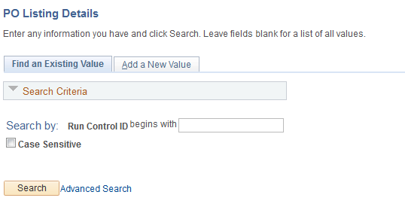

      - Select the Template ID and enter the Business Unit (01- Chapman). Enter ONE of the following criteria:
  - PO Number
  - Supplier ID
  - Department
  - Program
  - Project

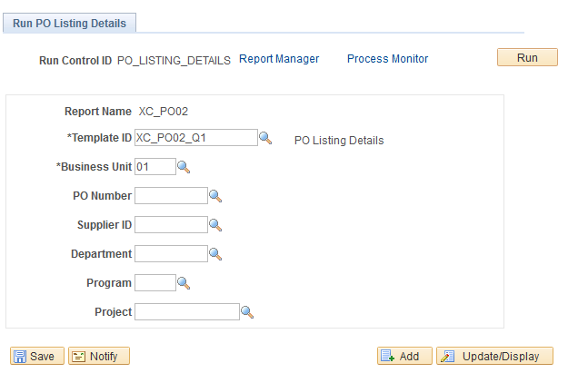

3. Click the Run button to open the Process Scheduler Request box. Unlike other reports you MUST SELECT A FORMAT – either PDF, XLS or Web. The format defaults to Text so must be changed.
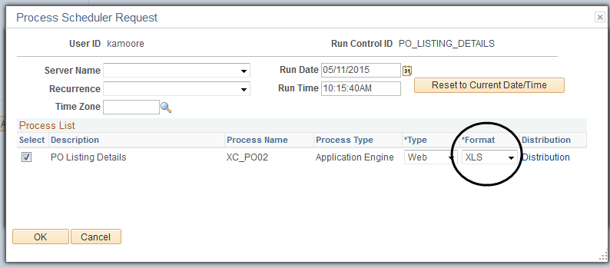

- Follow steps 5 through 8 of Budget to Actuals to Encumbrances to run and view the reports.

Here is a sample of the report.

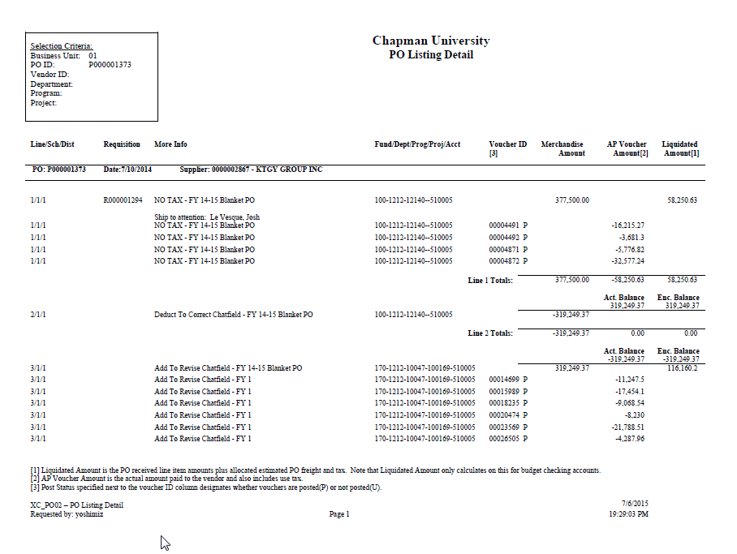
- AP PO invoices are budget checked against the PO Encumbrance balance (see “a”). The balance is calculated by adding estimated Freight/Tax/Misc. (see “b”) and amount of prior receipts. This is referred to as the “Liquidated Amount” in PeopleSoft.
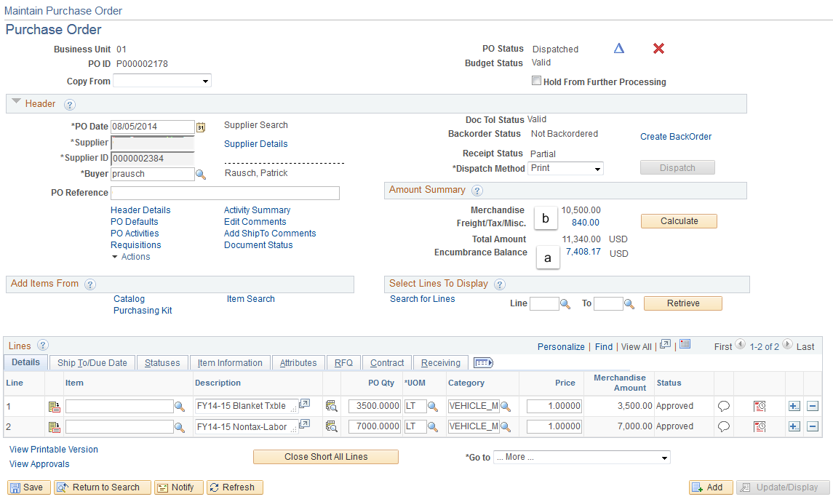

- The PO Listing report reflects the amount of the PO (Merchandise Amount), actual AP Voucher Amount paid to vendor (2) and the Liquidated Amount (1) which is the PO received plus estimated tax and shipping. The AP Voucher ID (3) indicates a P if posted or U if not posted to the KK and GL ledgers.

Requisition and PO Budgetary Activity Report

NAVIGATION: MAIN MENU > PURCHASING > PURCHASE ORDERS > REPORTS > REQ AND PO BUDGETARY ACTIVITY
- Establish a Run Control ID for this report.
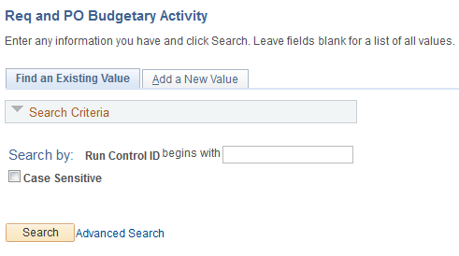
2. Set the parameters as follows:
a. Business Unit – 01 for Chapman University
b. Budget Date From: Enter 06/01/2014 to capture the entire fiscal year
c. Budget Date To: Enter 05-31/2015 to capture the entire fiscal year.
d. Remaining Amount: To see POs with remaining funds select “>” and leave the 0.000. To see all POs issued – leave the Remaining Amount field blank.

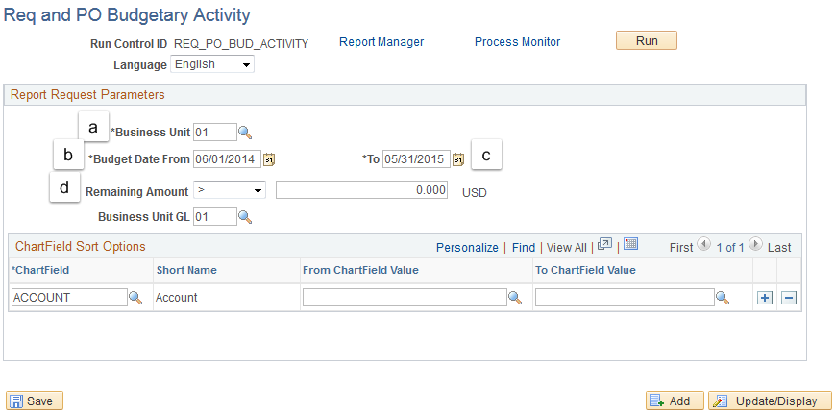

3. The second section of this page is the Chartfield Sort Options. Click the magnifying glass to review the menu and make a selection.
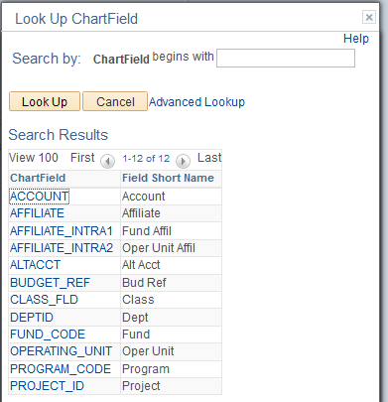

- The Chartfield Value fields (From and To) must be completed. It is critical to complete the “To” field to narrow the data.
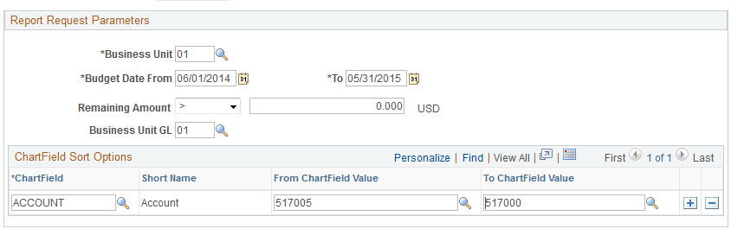
- Click the RUN button.
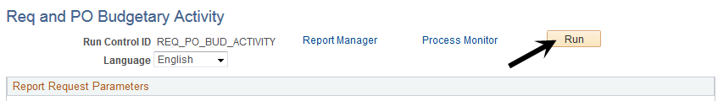

- In the Process Scheduler Request box click the Procurement Budgetary Activity box. Click OK to begin the report generation.
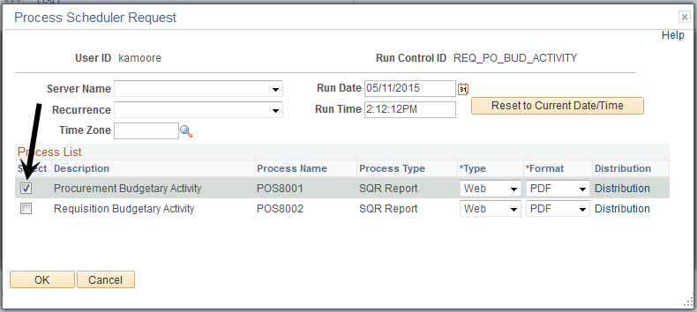

- Follow steps 6 through 8 of Budget to Actuals to Encumbrances to run and view the reports.

- Here is a sample report. This is only available as a PDF.

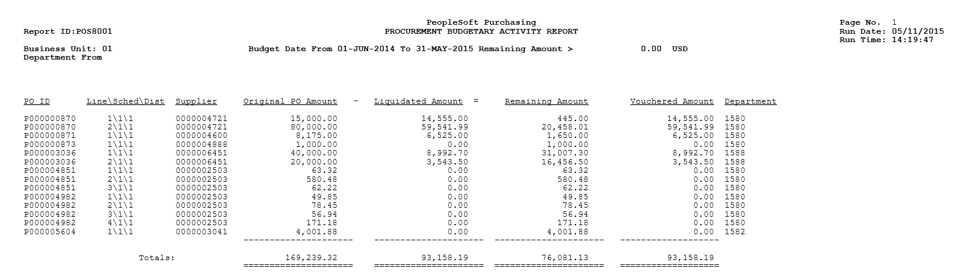

Supplier Lookup Report

Navigation: Chapman Customizations > Reports > Supplier > Supplier Lookup
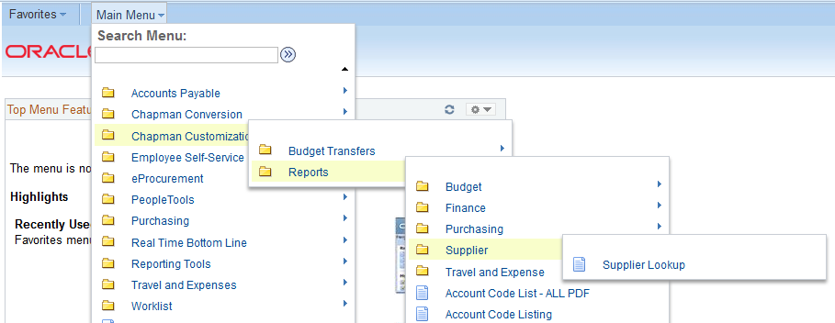

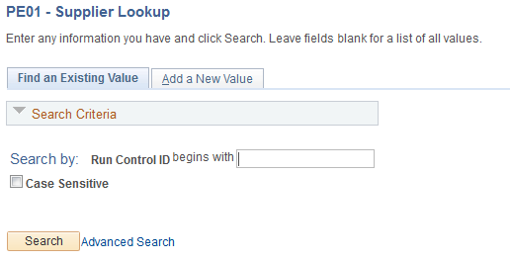

Search for suppliers using partial supplier ID# or name. This report provides full supplier ID#, name and addresses. Enter either a partial supplier ID with the % (wildcard) or partial name with the %.
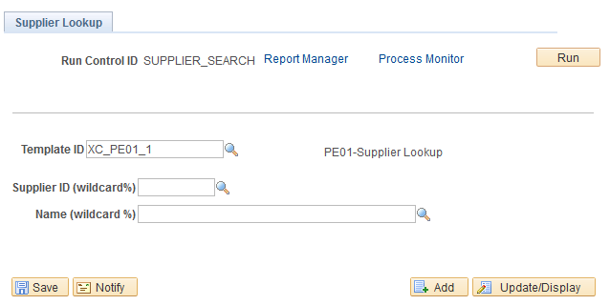

Sample Report
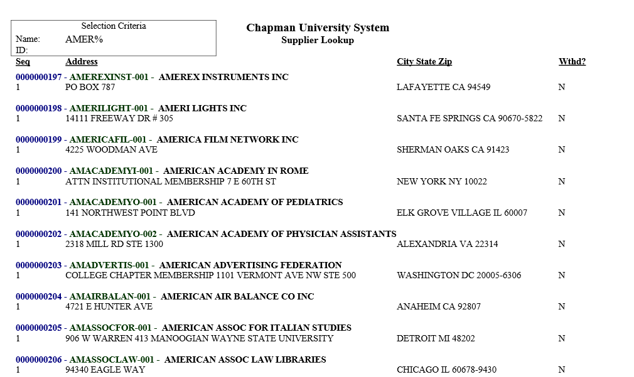

Account Code Listing

This report will allow you to search on the PeopleSoft Account numbers and view a list of the correlating IFAS Object Codes.

- Establish a Run Control
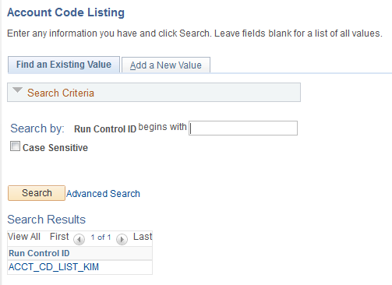
- Enter the Account number range or Budget Category range. To generate the entire report do not select any parameters.
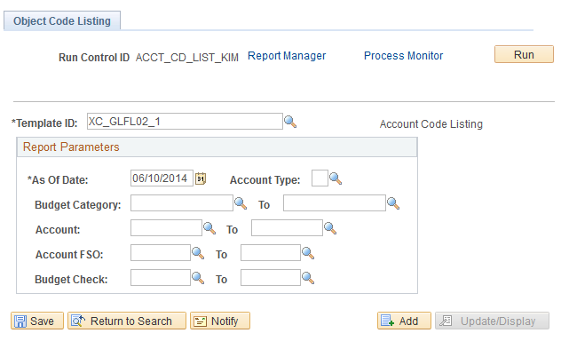

- Follow steps 5 through 8 of Budget to Actuals to Encumbrances to run and view the reports.

Sample Account Code Listing.

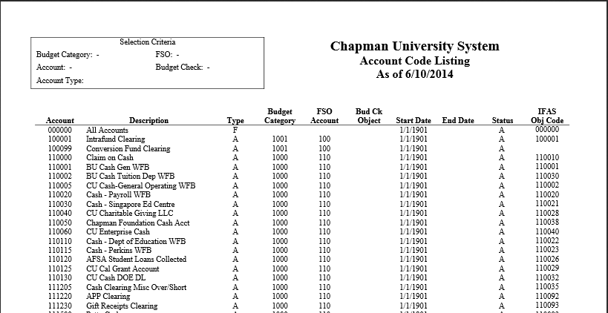

NOTE: This report is run nightly and published in the menu in a PDF version for all values – Main Menu/Chapman Customizations/Reports/Account Code Listing – ALL PDF

Fund/Department/Program Listing

This report will provide a list of all funds, departments and programs within your division.

- Establish a Run Control
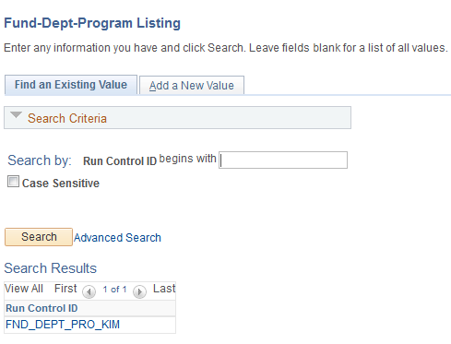

- Enter the parameters to define report or leave blank to generate all funds/departments and programs.
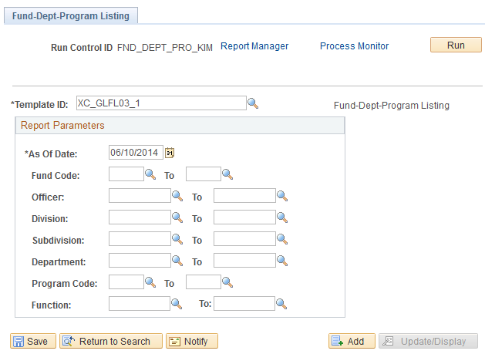

- Follow steps 5 through 8 of Budget to Actuals to Encumbrances to run and view the reports.

Sample Department -Program listing.
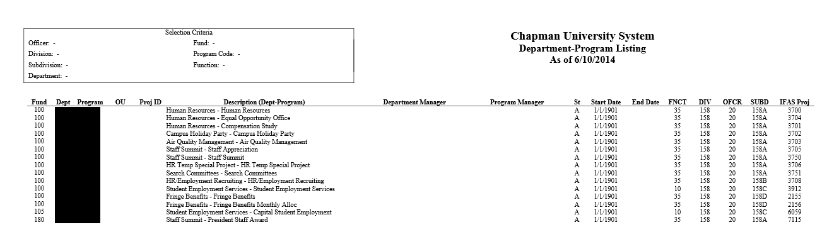

NOTE: This report is run nightly and published in the menu in a PDF version for all values – Main Menu/Chapman Customizations/Reports/Fund-Dept-Prog List – ALL PDF

AP Transaction by Supplier

This report will provide a list of all AP activity by date range for a vendor, invoice number or specific chartfields.

- Establish a Run Control
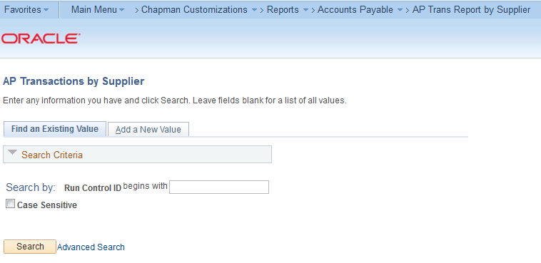

- Enter from/to date, supplier number or invoice number. Or enter parameters such as department or program range. Running the report with only the date from/to is not recommended.

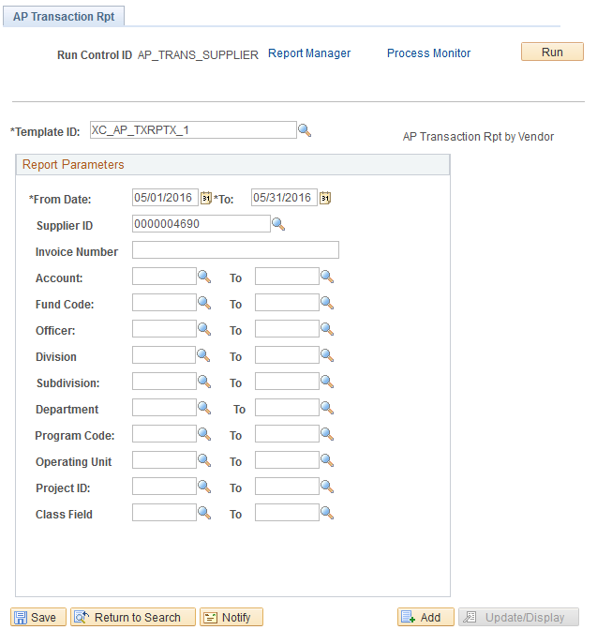

Sample AP Transaction Report
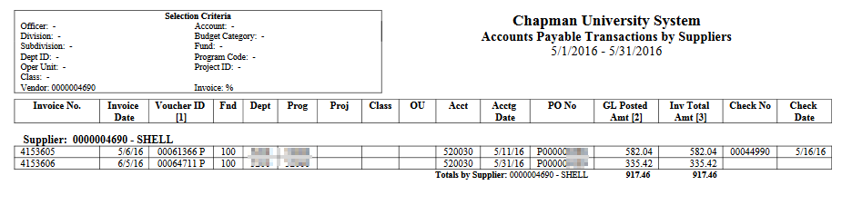

Tips for Successful Report Generation

- All reports are available for Fund 100 chartfields. Select reports can be run for other Fund IDs (projects, grants etc.) such as GL transaction detail and the Budget to Actuals with Encumbrances NOP.

- Multiple reports can be generated simultaneously, HOWEVER, you cannot use the same Run Control, it must be a new/different Run Control.

- Once a Run Control is created it cannot be deleted. You can change the parameters for the Run Control and save it with new parameters, however there is not a process in place to delete Run Controls.

- Reports are purged after 7 days. To retain a report past 7 days: After you click Run, the Process Scheduler Request window opens – click Distribution.
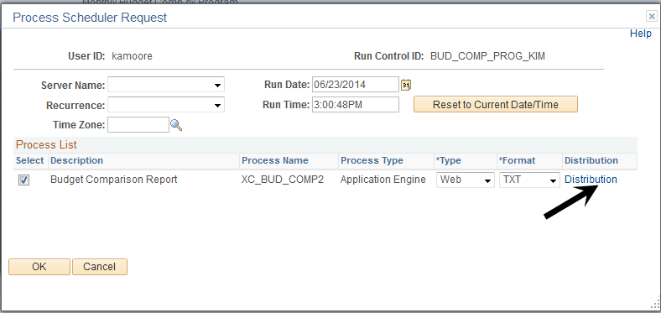
The Distribution window opens, change the number of Retention Days and click OK.
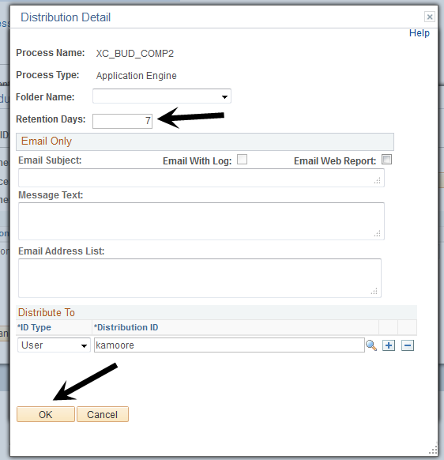

Viewing Reports from Main Menu

Access the Report Manager from the Main Menu to view reports from the last seven days.

Navigation: Main Menu > Reporting Tools > Report Manager
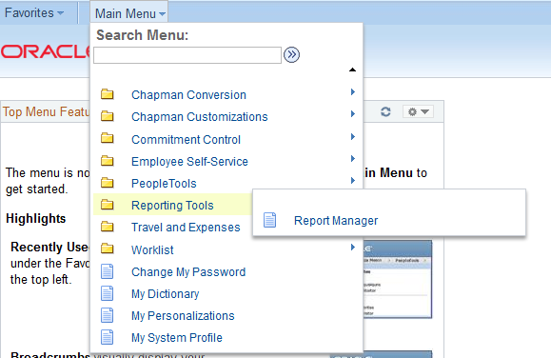

Click on Report Manager and the third tab “Administration”. The system defaults to the “Last 1 Days”.

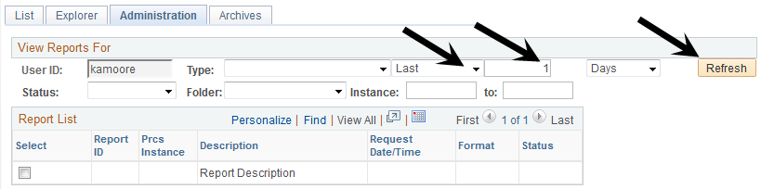

Update the number of days to retrieve reports and click Refresh.
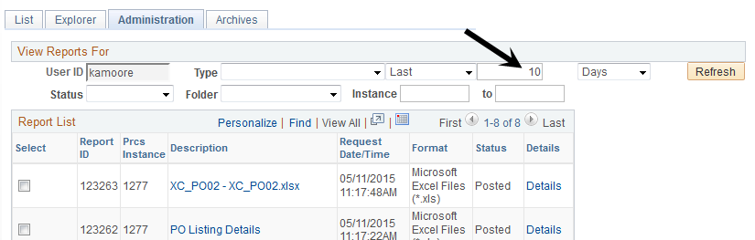

You can also click the arrow by Last and select Date Range and enter the dates. REMEMBER: The system only retains reports for 7 days unless you changed the Retention Date.

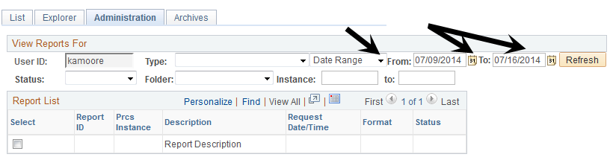

Viewing Process Monitor from Main Menu

To access the Process Monitor screen (to update Run Status etc.) follow this navigation:
Navigation: Main Menu > PeopleTools > Process Scheduler > Process Monitor

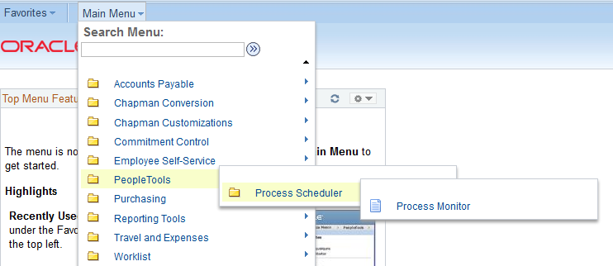

Once you click on Process Monitor the screen appears. You can click “Refresh” to update the Run and Distribution Statuses.
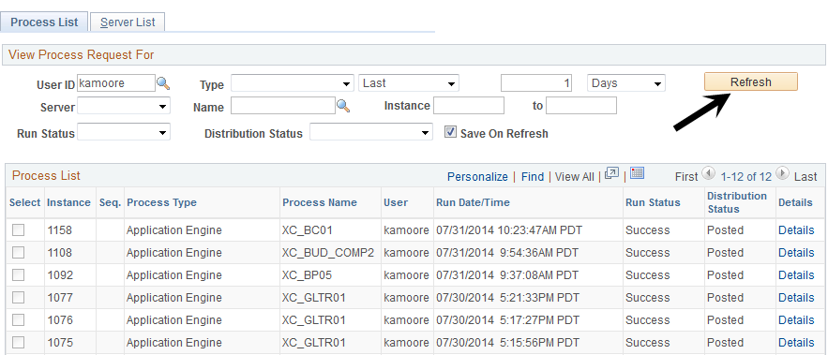

Suggested Run Control ID – Naming Convention

Budget To Actuals With Encumbrances
- Bud_to_Act_Enc_by_Dept

12 Month Budget Reports
- 12_mo_bud_prog
- 12_mo_bud_dept
- 12_mo_bud_acct

Budget Comparisons Reports
- Dept_(fill in main)
- Dept_(alternate)
- Mo_Compar_Dept_(main)
- Mo_Compar_Dept_(alternate)
- Program_(fill in main)
- Program_(alternate)
- Mo_Compar_Prog_(main)
- Mo_Compar_Prog_(alternate)

Budget Change Detail Reports
- Bud_Chg_Detail
- Bud_Chg_by_ref

Account Listing
- Account_Listing

Fund-Dept-Program Listing
- Dept_Prog_Listing

