

BUDGET SUMMARY INQUIRY WITH DRILLDOWN

Budget Summary Inquiry with Drilldown 2
Input Guidelines 2
Sample Input Pages by Type 3
Budget Summary Inquiry Input Page – Fund 100 example 3
Budget Summary Inquiry Page – Fund 100 example 4
Drill Down to Details Hyperlink 5
Budget Summary Input Page – Fund 105 6
Budget Summary Inquiry Page – Fund 105 7
Budget Summary Inquiry Input Page – Restricted 8
Budget Summary Inquiry Page – Restricted 9
Budget Summary Inquiry Input Page – Grants and Capital Projects example 10
Budget Summary Page – Grants and Capital Projects example 11
Budget Checking Accounts List by Type 12
Budget Check Account List – Fund 100 – OPR_CT_GRP & Fund 105 NON_CT_GRP 12
Budget Check Account List – Restricted/Capital 13
Budget Check Account List – Grants PRJ_CT_GRP 14

Budget Summary Inquiry with Drilldown
This page provides the available budget balance. Budgets are tracked using control accounts and budget balance inquiry is available on the control account, not the detail account where expenses are posted.
- Operations fund 100 is tracked by department
- All others funds are tracked by either by project or program
- Please note that users who do not have all-accounts security (non-comp only or student only compensation) will see limited data depending on the budget setup for ledgers.
The chart below shows required inputs to see the available budget and the control account used to load & track budgets.

Navigation: Main Menu > Chapman Customization > Reports > Budget > Budget Summary Inquiry

Input Guidelines
With sample chartfields
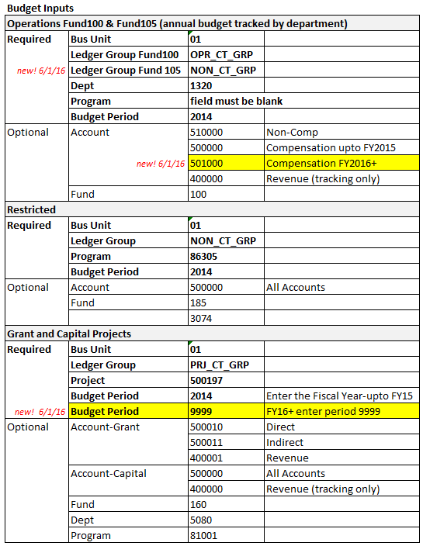

Sample Input Pages by Type

Budget Summary Inquiry Input Page – Fund 100 example
- Enter the required fields and click on the Search button
- The system will show the search results
- For Fund 100 select Account 510000 to see the non-comp spending available budget

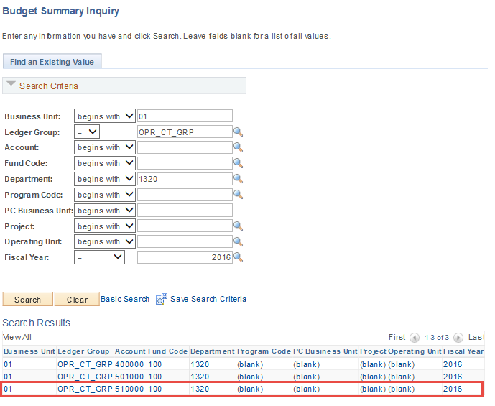

Budget Summary Inquiry Page – Fund 100 example
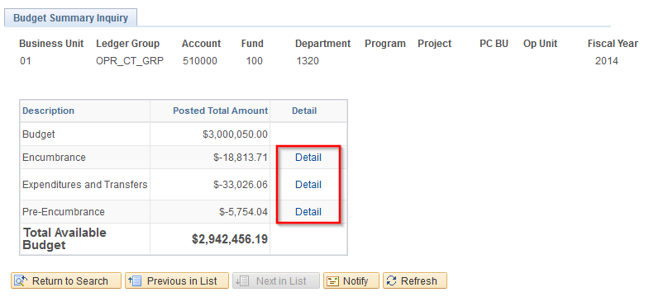
This page displays the annual budget for department 1320 and breaks down the expense by Encumbrance, Expense, Pre-Encumbrance and shows the Available Budget Balance. Click on the Details hyperlink to view transaction details.

Drill Down to Details Hyperlink

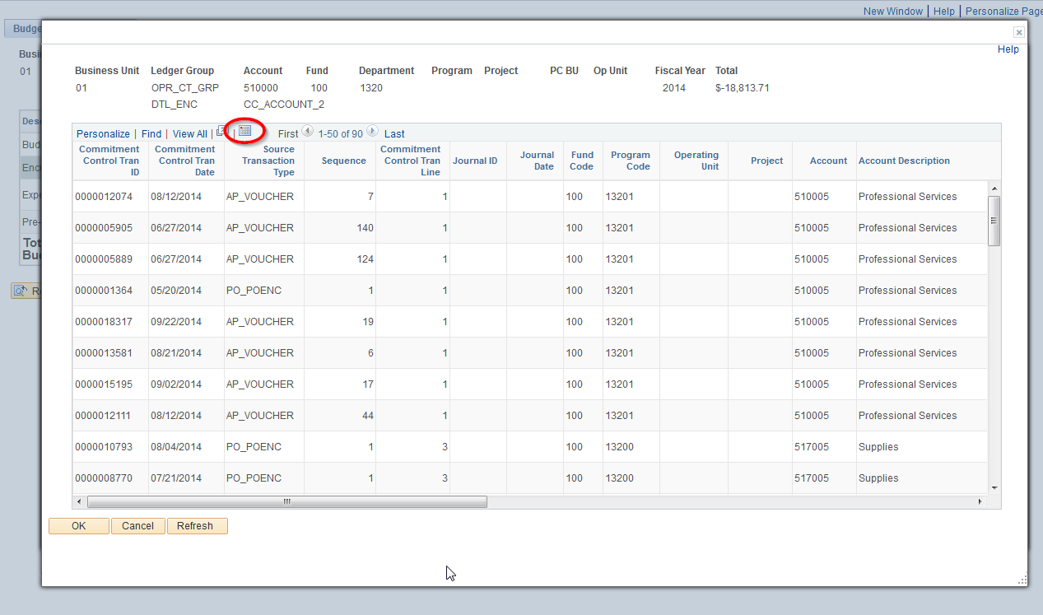
A new window will open with a listing of the detail transactions. Click on the Download icon to export the data to Excel. You can scroll to the right to see additional details.
For reconciling and clearing encumbrances, it may be helpful to sort the Excel download by PO number on column T, then by Travel Authorization number on column S to identify the open encumbrance balances.

The Source Transaction Type field will be used to identify document types. Below is a brief explanation of the document types that clear encumbrances.

PO_ENC (purchase orders) are cleared by corresponding AP_VOUCHER (accounts payable voucher) transactions. The AP_VOUCHER rows will list the related PO number on the far right so you can see the related PO and Vouchers that clear.

EX_TRVAUTH (travel authorizations) are cleared by corresponding EX_SHEET (expense reports) transactions. The EX_SHEET rows will list the related Travel Authorization number on the far right so you can see the related Travel Authorization and Expense Reports that clear.

Budget Summary Input Page – Fund 105
New 6/1/16!
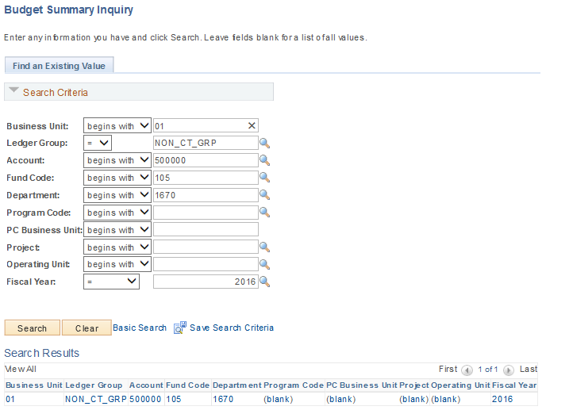

Effective 6/1/2015, fund 105 budgets will be entered in detail and controlled by department. The inquiry page used to show the available budget is only available by department. Similar to the OPR_CT fund 100 budget.

Budget Summary Inquiry Page – Fund 105
New 6/1/16!
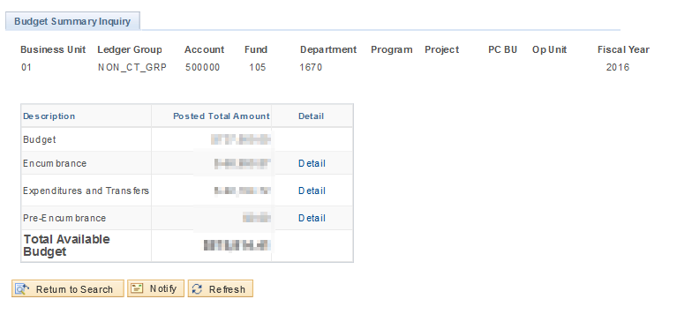

This page displays the total budget by department and breaks down the expense by Encumbrance, Expense, Pre-Encumbrance and shows the Available Budget Balance. Click on the Details hyperlink to view transaction details.

Budget Summary Inquiry Input Page – Restricted
- Enter the required fields and click on the Search button
- The system will show the search results
- For Restricted Funds, select Account 500000 to see the non-comp available budget for spending

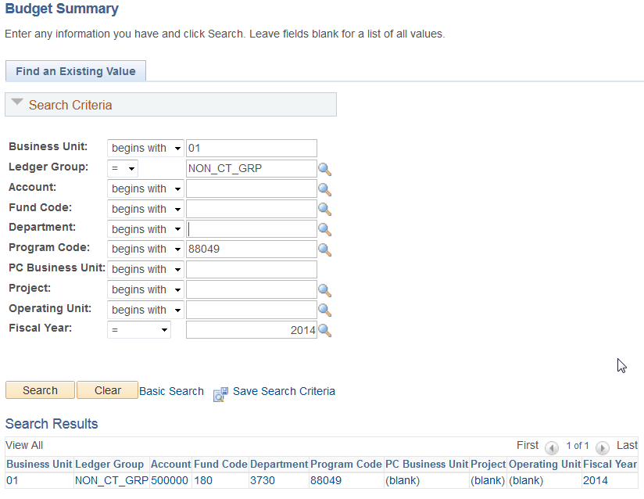

Budget Summary Inquiry Page – Restricted

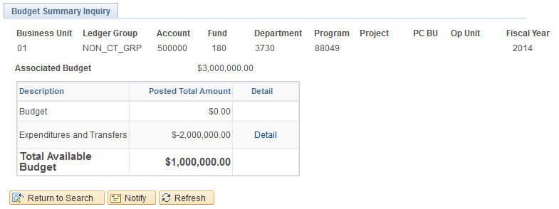

This page displays the annual associated budget (restricted) or budget (fund105) and breaks down the expense by Encumbrance, Expense, Pre-Encumbrance and shows the Available Budget Balance. Click on the Details hyperlink to view transaction details.

Budget Summary Inquiry Input Page – Grants and Capital Projects example
- Enter the required fields and click on the Search button
- The system will show the search results
- For Grants, select Account 500010 to see direct available budget, select 500011 to see indirect available budget, for Capital select account 500000
- New 6/1/16! Effective 6/1/2016, period 9999 has been setup to allow rolling budgets for all capital projects.
- To view years prior to FY2016 please enter the specific fiscal year

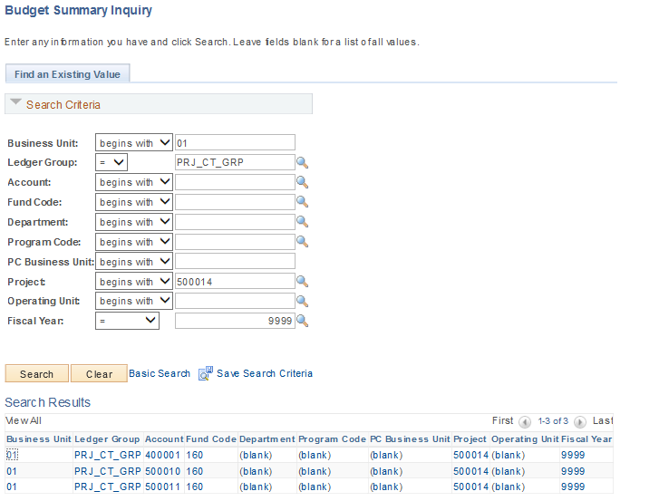

Budget Summary Page – Grants and Capital Projects example
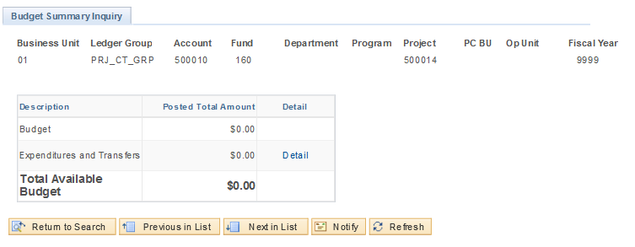
This page displays the annual budget for project 500014 and breaks down the expense by Encumbrance, Expense, Pre-Encumbrance and shows the Available Budget Balance. Click on the Details hyperlink to view transaction details.

Budget Checking Accounts List by Type
Budget checking accounts varies by the ledger group. Below are the list of budget checking control accounts by ledger type

Budget Check Account List – Fund 100 – OPR_CT_GRP & Fund 105 NON_CT_GRP
New 6/1/16! Fund 105
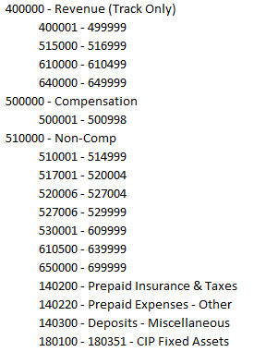

Budget Check Account List – Restricted/Capital
- Restricted NON_CT_GRP
- Capital Projects PRJ_CT_GRP (excludes Grants)

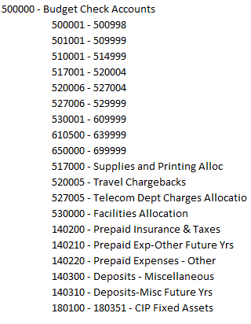

Budget Check Account List – Grants PRJ_CT_GRP
