
The Security Pagelet report is available to run by user, division, or subdivision.

Users are assigned chartfield (CF) security for Accounts, Programs and Projects. Below are the types of values and definitions.

Accounts
ALL_ACCOUNTS –all accounts including all compensation & non-comp
NON_COMP – non-compensation accounts
STU_ONLY – student compensation accounts
FAC_COMP – faculty compensation accounts
COMP_ONLY – all compensation accounts
(Compensation amounts are posted in summary without individual names)

Project
PJ_###### - specific project number
PJ_NONE – no project access
PJ_GRANTS – all grants projects
PJ_CAP – all capital projects
PJ_ALL – all projects

Program_Code
PG_##### - specific program number
D#### - all programs under department ####
DV_### - all programs under division ###
SD_#### - all programs under subdivision ####
OFCR_## - all programs under officer ##
VPVC_## - all programs under VPVC ##
PG_PJ_CAP – all programs required to view capital projects
PG_PJ_GRNT – all programs required to view grants projects

Notes:
Example values | UserID | Division | Subdivision
To see 1 userid | jchapman | % | %
To see all users in a Division | % | 123 | %
To see all users in a SubDivision | % | % | 123A

If you would like to see the list of programs under one of the program groups, please run the
Fund-Dept-Program Listing report for that group (Main Menu/Chapman Customizations/Reports/Fund-Dept-Progr-Listing)

To see complete accurate information for Restricted programs, Grants and Capital, ALL_ACCOUNTS access is required. Without this access reporting details can be incomplete.

The criteria for this report is Active status in HR and peoplesoft account is not locked out. Please submit a service desk ticket requesting to lock out the employee if they are terminated.
Adding Pagelets to your Peoplesoft Finance Homepage
- Select Content
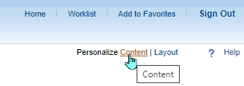

- Check the report & Save
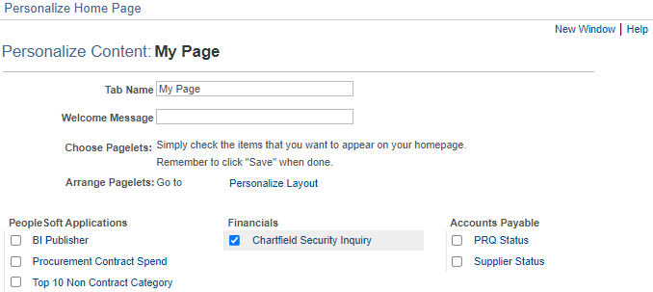

- Select Layout to change the arrangement on the homepage
