PO Listing Detail Report
This report provides detailed PO information by line item. The report includes the following information:
- PO header information, Supplier, PO & Requisition number, line descriptions, account numbers
- Merchandise amount by line
- AP vouchers applied against a PO by line
- Liquidated amount by line to calculate the encumbrance balance by line

If you are not familiar with running reports, please refer to the REFERENCE GUIDE – Budget Reports, available at this link - https://mywindow.chapman.edu/teams/PeopleSoft/Training/Report%20Training/Forms/AllItems.aspx
This document will explain how to setup a run control, review the process monitor and retrieve the report output from the Report Manger link.

Navigation: Main Menu/Chapman Customization/Reports/Purchasing/PO Listing Details
- Create a Run Control ID or Find an Existing Value
- Select the Template ID
- Enter the Business Unit – Required Field
- Enter one of the following:
  - PO Number, Supplier ID, Department, Program, Project
- After you click Run, On the Process Scheduler Request window, please specify Type = Web, Format = PDF, XLS or Web. No other combinations are supported at this time.

A summarized PO report is also available.
Navigation: Main Menu/Purchasing/Purchase Order/Reports/Req and PO Budgetary Activity Report
This report can be run by department, program or project

Purchase Order Budget Checking vs. Actuals
- Accounts Payable PO invoices are budget checked against the PO Encumbrance Balance (A). The Encumbrance Balance is calculated by Receipt Amount plus estimated Freight/Tax/Misc (B) amount allocated towards the Receipt Amount. This amount in Peoplesoft is called the Liquidated amount, see Figure 1.
- The Liquidated Amount does not always equal the actual invoice amount paid by Accounts Payable because the vendor is invoicing actual freight amount plus any miscellaneous handling charges. The actual invoice amount will post to the Actuals KK and GL ledgers.
- When the PO is finalized, the budget will be reduced by the actual invoice AP Voucher Amount (Amount D), see Figure 2
- The PO Detail report will show the liquidated amount and the AP actuals amount
  - The liquidated amount is used to calculate the Encumbrance Balance, see Figure 2
    - [C-Merchandise amount] – [E-Liquidated Amount] = [A-Encumbrance Balance]
  - The AP Voucher Amount is the amount posting to KK and GL Actuals Ledgers (D), see Figure 2

Figure 1:
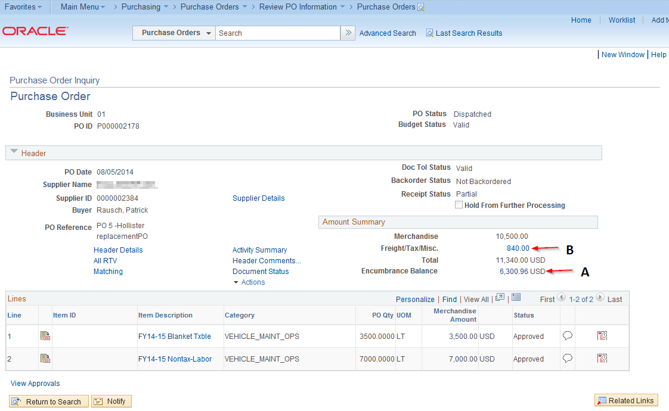

Figure 2:
