

Purchase Order Inquiry
Training Guide

PeopleSoft Financials

Chapman University
2014

Table of Contents – PO Activity Summary
PO Inquiry Pages 3
Purchase Orders 3
Activity Summary 3
PO Review Information - Purchase Order Overview 3
PO Review Information – Purchase Order Page Navigation 3
Supplier Details 4
Activity Summary 4
Header Comments 4
Document Status 4
View Approvals 4
The Line Details Icon 4
The Schedule Icon 4
PO Activity Summary Overview 5
PO Activity Summary Page Navigation 5
Receipts Details and Drill Down 7
Receipts Details and Drill Down – Blanket PO Example 9
Invoice Details and Drill Down 10
Other Options to Inquire on Requisitions and Purchase Orders 12
Requisition Inquiry using the Add/Update page, Find an Existing Value, Document Status 12
Purchase Order Inquiry using the PO Inquiry page, Find an Existing Value, Document Status 12

PO Inquiry Pages

This training document shows the direct navigation to the main inquiry pages. However, throughout the system, there are links to the same pages from other source documents such as the original PO or financials ledger drill down.

Purchase Orders – This page is used to view PO general information and provides links to the Header Comments (including attachments), Document Status and Activity Summary and other links which are currently not in use
Activity Summary – This page is used to view summary and details of related financial transactions applied towards a PO and displays remaining PO balances.

PO Review Information - Purchase Order Overview
The Review PO Information - Purchase Order pages are used to view general PO information and also provides links to other components to further drill down into PO details.

PO Review Information – Purchase Order Page Navigation
Navigation Main Menu > Purchasing > Purchase Orders > Review PO Information > Purchase Order
- Enter the Business Unit and Purchase Order number
- Click the Search button
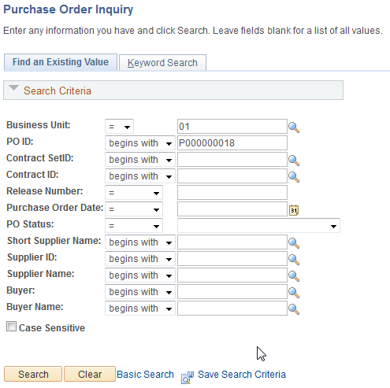

The system will display the PO Inquiry screen. Some of the useful links have been highlighted
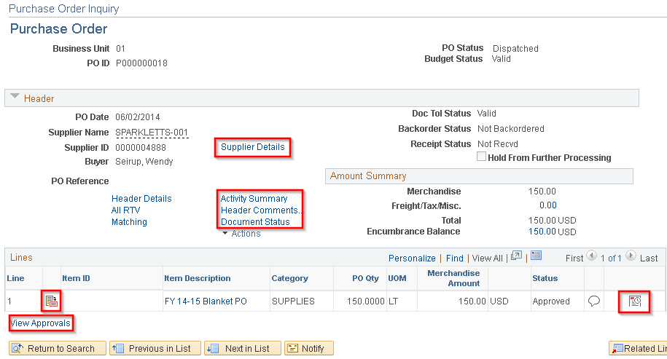

Supplier Details – This link will display the supplier address and phone number
Activity Summary – This link will take display the summary and details of related financial transactions applied towards a PO and displays remaining PO balances. Activity summary section of the training document for more details
Header Comments – This link will display the comments from the original PR and will give you access to any attachments.
Document Status – This link will show you the PR related to the PO. There is also a link to the accounting entries on the Related Info tab to see the chart fields for this PO
View Approvals – This link displays the approval workflow for the PO.
The Line Details Icon - This icon provides details for the PO line
The Schedule Icon - This icon takes you to the Schedules page. From the Schedules page, click on the Distributions/Chart fields icon to see the chart fields for this PO.

PO Activity Summary Overview

The Purchase Order Activity Summary pages are used to view the receiving, invoicing, and matching activities that were performed on the selected purchase orders to date. The Activity Summary page displays the total purchase order merchandise amount, and the merchandise received, vouchered, and matched.

PO Activity Summary Page Navigation
Navigation Main Menu > Purchasing > Purchase Orders > Review PO Information > Activity Summary
- Enter the Business Unit and Purchase Order number
- Click the Search button
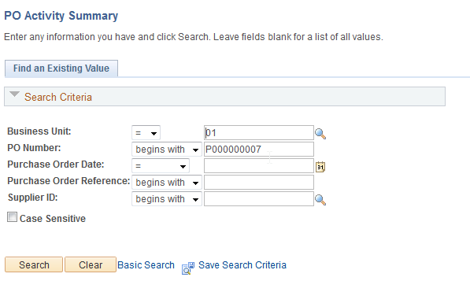

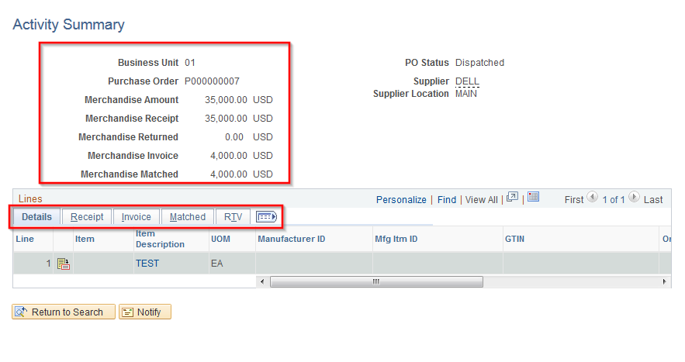

You can see the Total PO Amounts by PO Merchandise Amount, Receipts, Returned, Invoiced and Matched.
Click on the Tabs to see details information and drill to source documents:
Details – PO details by line
Receipt – Receipts
Invoice – AP Invoices
Matched – AP Matching activities
RTV – Return to Vendor

Receipts Details and Drill Down

- To see Receipts details click on the Receipts tab
- Click on the Receipt Icon to drill to Receipt information

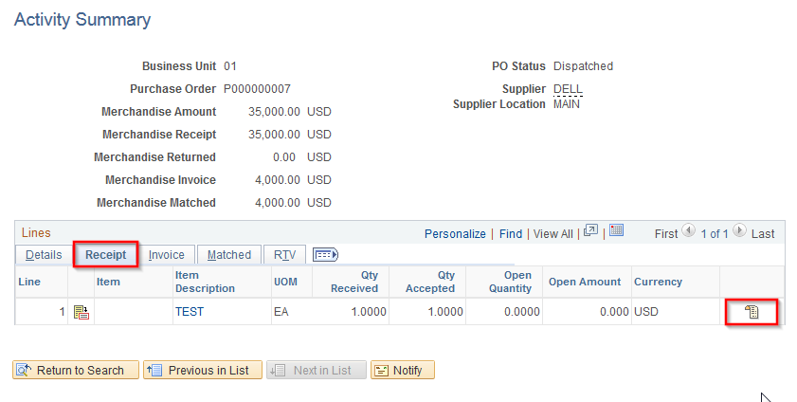

- Click on Receipt No hyperlink to drill to the Receipts screen 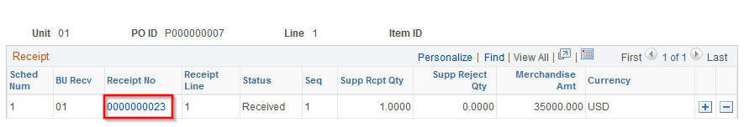

- This screen provides details on the receiving document
- The Header Details hyperlink will show you the Receiving Date

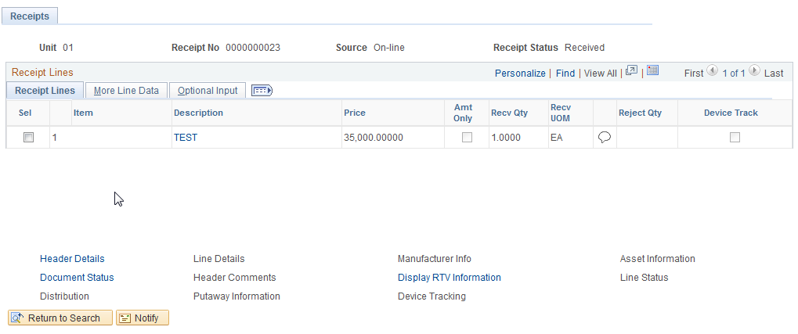

Receipts Details and Drill Down – Blanket PO Example

- For Blanket PO’s you can see the Open Amount that hasn’t been received
- Click on the Receipt Icon to drill to Receipt information

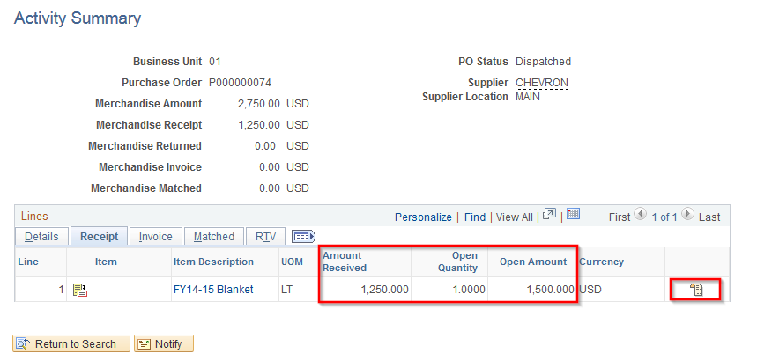

- Receipt Information
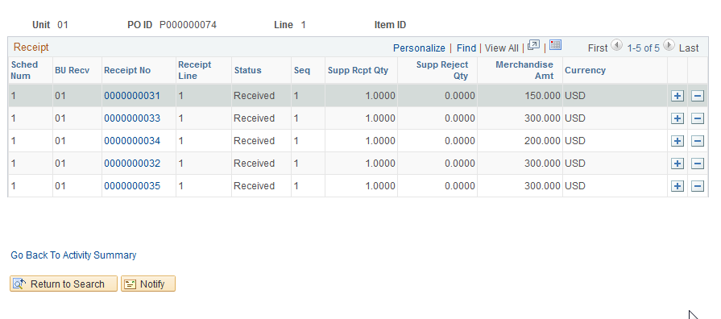

Invoice Details and Drill Down

- To see AP voucher details click on the Invoice tab and scroll to the right.
- Click on the Invoice Icon to drill to AP Invoice information

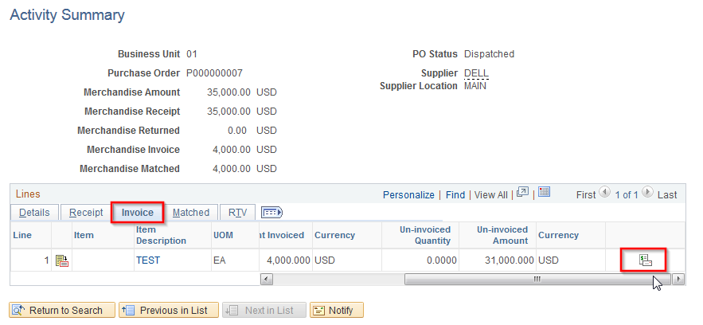

- Click on the Voucher number hyperlink to drill to the Voucher Inquiry screen
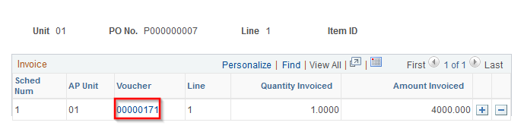

- Click on the Actions drop down to view additional details such as Accounting Entries or Payment Information

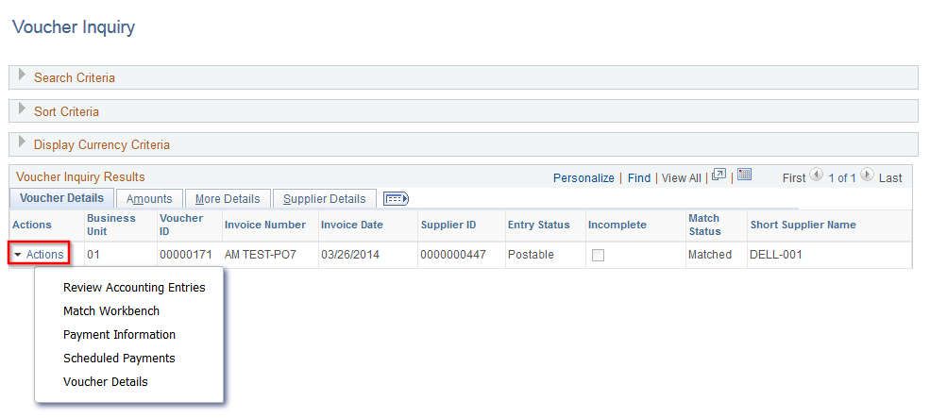

Other Options to Inquire on Requisitions and Purchase Orders
PeopleSoft provides multiple ways to navigate and inquire on documents through menus and pages and also through hyperlinks within a page.

Requisition Inquiry using the Add/Update page, Find an Existing Value, Document Status
- Navigation: Main Menu > Purchasing > Requisitions > Add/Update Requisitions
- Click on Find an Existing Value Tab and locate the requisition
- Once you are in the requisition detail, click on the Document Status link to inquire and drill down on related details.
