This report is used to run a PO listing by chart field (department, project or program). PO’s are listed in summary showing the following information
PO amount – this is the total PO dollar amount
Liquidated amount – this is the AP/PO line amount + allocated misc. charges (freight/tax) based on the PO header estimated tax and freight
Remaining amount – PO amount less Liquidated amount
Vouchered amount – This shows the actual amount paid by AP which can be +/- than the liquidated amount, which is a allocation based on freight and tax estimates. This amount will be used when determining the final encumbrance relief if the PO is cancelled and the final amounts posted to actuals.

Navigation: Main Menu > Purchasing > Purchase Order > Reports > Req and PO Budgetary Activity
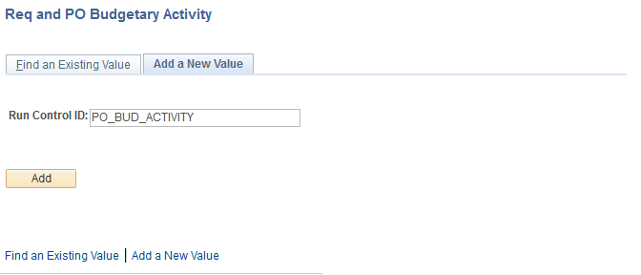
Enter a Run Control ID and click.

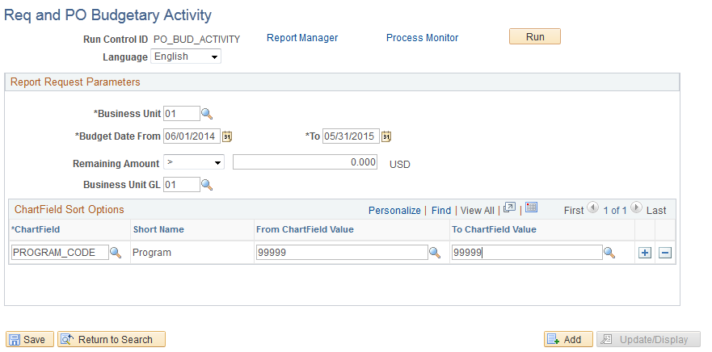
Business Unit: 01
Budget Date From: Enter the desired date or 6/1/2014 to capture the entire year.
Budget Date To: Enter the desired date or 5/31/2015 to capture the entire year
Remaining Amount: Change the Operand to > and leave the balance at 0.00. To see all POs
issued within the requested period, use blank.

Chartfield Sort Options
Chartfield: Click the next to the field to display the following search box and select the desired chartfield name.
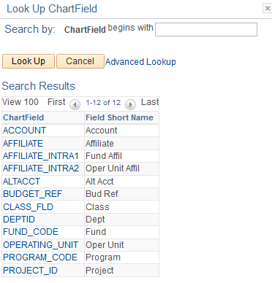
From Chartfield Value: Enter the beginning value of the selected chartfield.
To Chartfield Value: Enter the ending value of the selected chartfield. This field must have a value or you might get more data than desired.

Click .

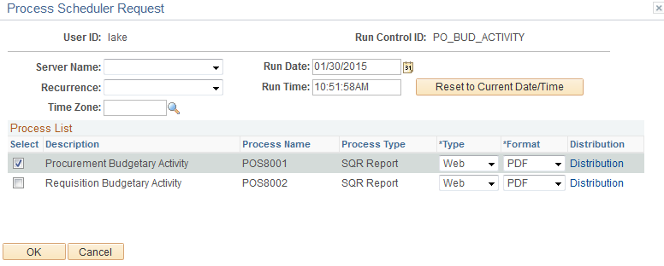
Check the next to and click . You will automatically be returned to the Run Control screen.

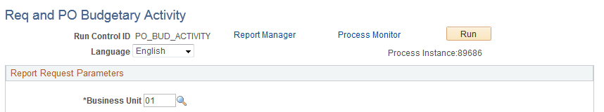
Click .

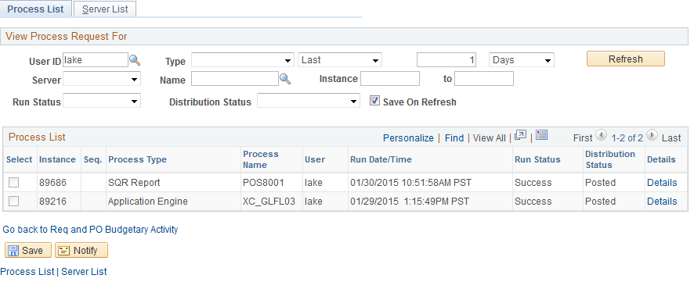
Click. When the is and the is , click.

Click .

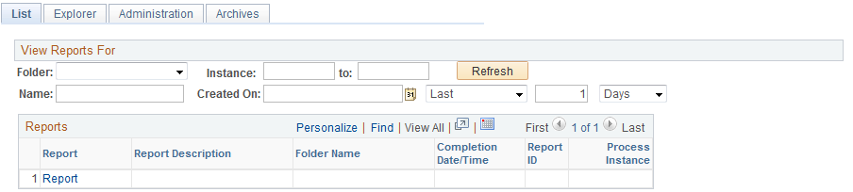
Click the tab.

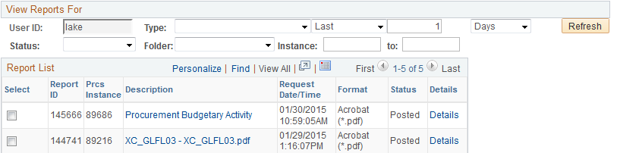
This report is only available as a .pdf file.

Sample output
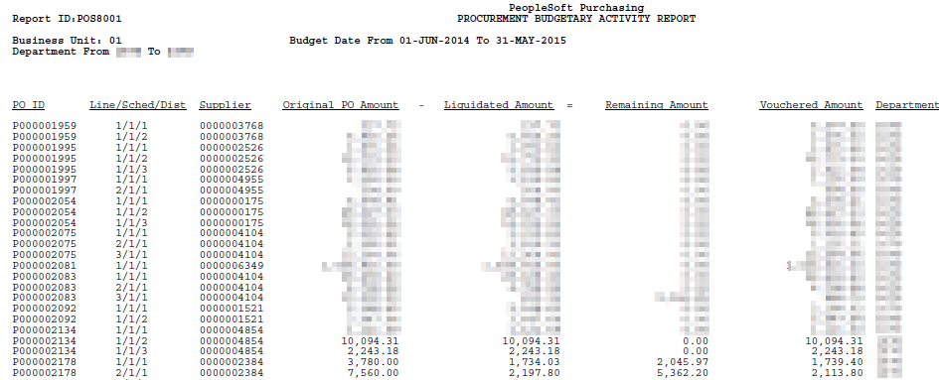

The report calculates the remaining amount on the PO and also shows the vouchered amount including actual misc. charges and tax accruals.

