There are 2 new Grants reports:
- Budget to Actuals with Encumbrance by Project – ITD (Inception To Date)
- Budget to Actuals with Encumbrance by Project – FY

Navigate to the new Grant reports.  NOTE: For each report you must create a separate run control. | 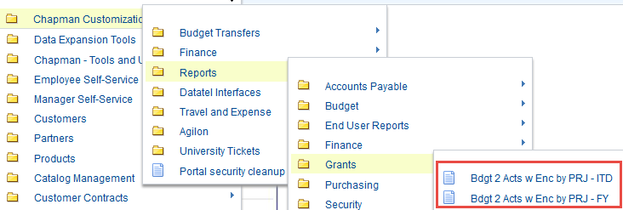
Add a new run control for each report, click Add  (For the other report you might create the run control with a name of GRANTS_FY) | 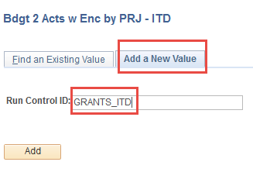
Select the template ID. Click on Update Parameters | 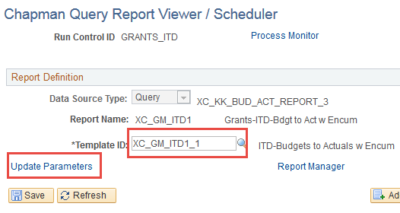
Enter the desired information, click OK | 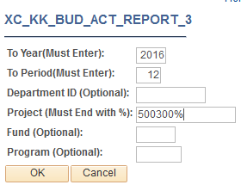
The run control will populate with the data just entered. Click on the View Report hyperlink to see the data.  You will only be able to see data for the projects you have access to as defined by security. | 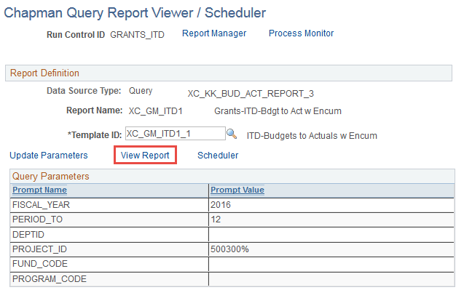
The report will be displayed in a PDF format | 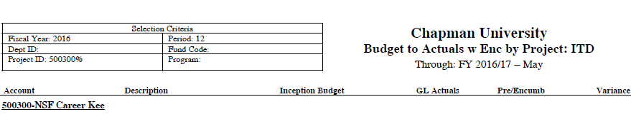
To run the report for another project, click on the Update Parameters link to enter the new data.  Enter the new data and click OK. Then click on View Report. | 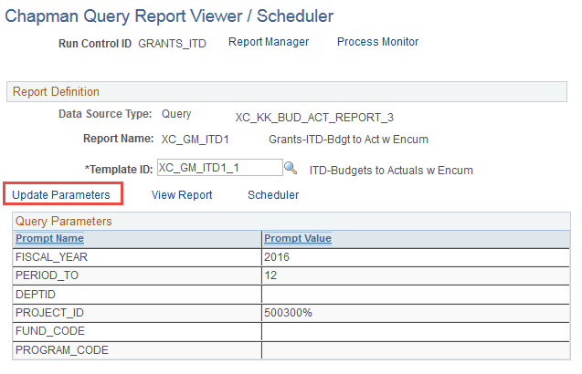
There is an option to schedule the report to run on a recurring basis and also send it to multiple users.  Click on the Scheduler link | 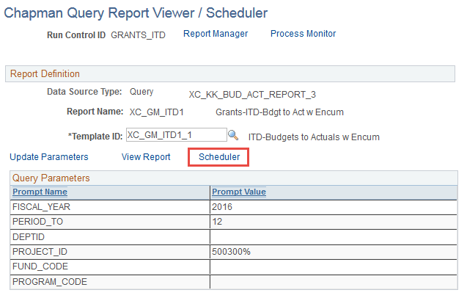
Recurrence: Select a recurrence  Type: Change to Email to email the report  Format: Change to PDF  Distribution Hyperlink: If you want to send the report to others, click on the link | 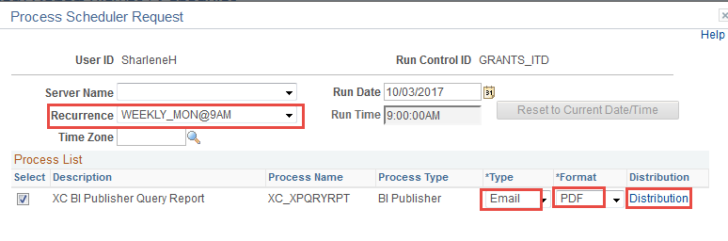
Enter a subject and click on the plus/minus buttons to add/remove users, click OK  Click OK again to launch the process.  This process will email the report on a scheduled basis. | 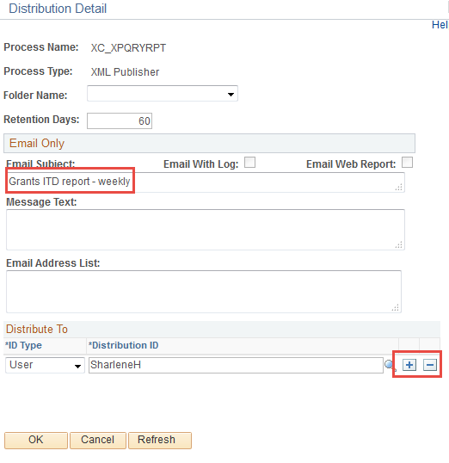
Note: Please remember to create a new run control for each of these Grants reports. If you re-use the same run control for both the ITD and FY reports you may run into problems.

