GL Transaction Detail Report – Output for Multiple Years

The GL Transaction Detail Report can display multiple fiscal year data.
- The Fiscal Year on the run control year must be the earliest Fiscal Year
- The check box Use As Beginning FY must be checked.
Below is a sample run control showing the correct input & incorrect input. The correct input will display 2 years data, the incorrect input will display FY17 data only.

Correct Run Control Example
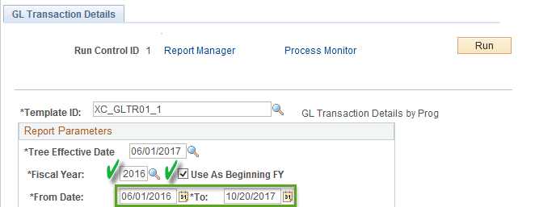

Incorrect Run Control Example – output will only display FY17 data
