

REFERENCE GUIDE
5 YEAR ACTUALS COMPARISON REPORTS IN PEOPLESOFT

TABLE OF CONTENTS

Contents
Available Reports: 1
NAVIGATION: 1
Run Control: 1
Parameters & Budget Period: 3
Other Uses for These Reports: 4
Run Formats: 4
Reminder -- Tips for Successful Report Generation 4

5 YEAR ACTUALS COMPARISON REPORTS

Available Reports:
The following new reports are now available in PeopleSoft:
- 5 Year Comparison of Actuals by Division – Summary By Budget Category
- 5 Year Comparison of Actuals by Officer – Summary By Account
A summary by account version of the Division report and a summary by budget category of the Officer report are in queue for development. Meantime, these reports can be utilized for both, as well as lower level detail by program, department or subdivision when parameters dictate.
These reports have been created to be flexible enough to provide the same information previously available in the IFAS system, and more. This includes the ability to select multiple ranges and exclusions.

NAVIGATION:
MAIN MENU > CHAPMAN CUSTOMIZATION > REPORTS > FINANCE > 5 YEAR ACTUALS COMPARISON
- Select 5 Year Actuals Comparison
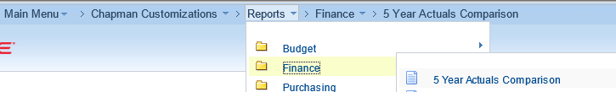

Run Control:
- You will be routed to the search page and prompted to enter a Run Control ID. This screen will appear when you select any of the Finance Reports.

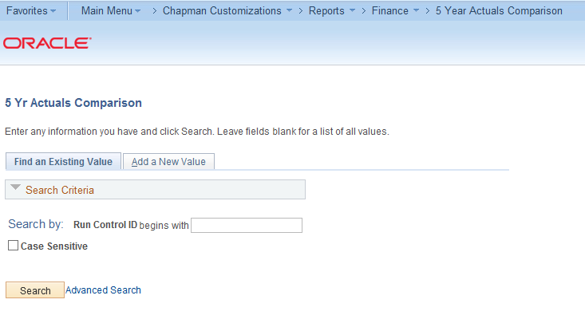
- A Run Control ID is created by the user and is unique to the user. A Run Control ID should be named to assist you in identifying the report. Report parameters can be saved to a Run Control ID for future processing. Here is a reminder of a few tips in establishing run controls:
  - Run Controls cannot contain spaces – use “underscore” if a space is needed
  - Run Controls can be up to 30 characters including numbers.
  - Create separate Run Controls for each report template ID. This will allow you to launch several reports without waiting for one to finish.
  - Include type of report in Run Control i.e. 5_YR_ACT_DIV or 5_YR_ACT_OFF_ACCT_SUMMARY

- Click on Add a New Value and create a Run Control ID and click Add.
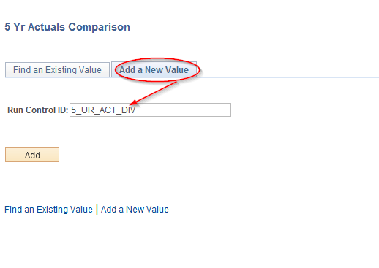
You will be routed to the Report Parameters screen.

Parameters & Budget Period:
- The 5 Year Actuals Comparison by Division template and Officer template are currently available. Select the magnifying glass to see the list of available options for selection.

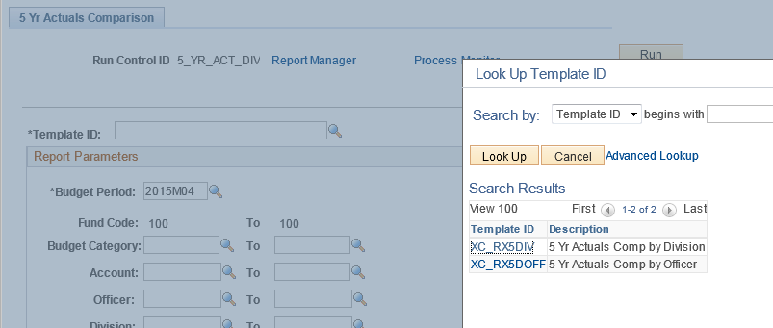
- The Budget Period is the identifier used in the report. If you select a period in an earlier year, the report output will only include data up to that period.
- Note this report defaults to the operating Fund, Fund Code: 100 as the report is only available for this fund at this time.

The screen shot below shows the available report parameters:
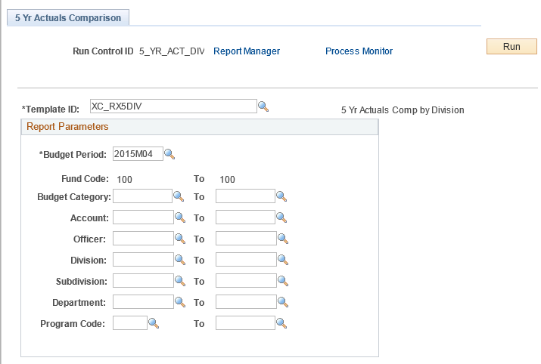

You can define your report by selecting parameters from the available options (Division, Subdivision, Budget Category, Account, Department, Program). Parameters should be selected from top to bottom. For example: If you select “Division” the “Departments” and “Program” selections are limited to the one in that division. If you select “Department” and then try and select a “Division”, the “Department” may disappear, otherwise if the department entered does not coincide with the division entered, the report may generate no output.

Other Uses for These Reports:
Suggestions for utilizing these reports for lower level data output –
Contingent upon Chart Field Security. Example: John Doe has access only to department 1234 under division 123. If John selects division 123 in his parameters, the output will only include that for department 1234, it will not include output for departments for which he does not have security.

- 5 year comparison by program – enter a specific program in both the program fields
- 5 year comparison by department – enter a specific department in both the department fields
- 5 year comparison by subdivision – enter a specific subdivision in both the subdivision fields

If this is a report you will be running throughout the year, click Save to retain these parameters as part of the Run Control ID. NOTE: Parameters will be saved once you click Run.

Run Formats:
- Click Run to begin report generation.

Like other reports, these are provided in three formats.
- PDF
- HTML
- Excel

Reminder -- Tips for Successful Report Generation

- Reports are currently available only for Fund 100 chartfields.

- Multiple reports can be generated simultaneously, HOWEVER, you cannot use the same Run Control, it must be a new/different Run Control.

- Once a Run Control is created it cannot be deleted. You can change the parameters for the Run Control and save it with new parameters, however there is not a process in place to delete Run Controls.

- Reports are purged after 7 days. To retain a report past 7 days: After you click Run, the Process Scheduler Request window opens – click Distribution.
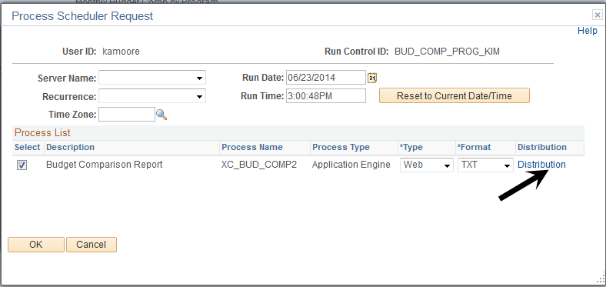
The Distribution window opens, change the number of Retention Days and click OK.
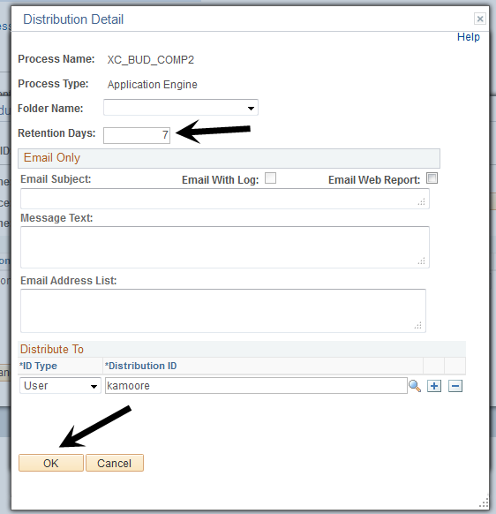

Run Controls – Suggestions For Naming Conventions

Budget To Actuals With Encumbrances
- Bud_to_Act_Enc_by_Dept

12 Month Budget Reports
- 12_mo_bud_prog
- 12_mo_bud_dept
- 12_mo_bud_acct

Budget Comparisons Reports
- Dept_(fill in main)
- Dept_(alternate)
- Mo_Compar_Dept_(main)
- Mo_Compar_Dept_(alternate)
- Program_(fill in main)
- Program_(alternate)
- Mo_Compar_Prog_(main)
- Mo_Compar_Prog_(alternate)

Budget Change Detail Reports
- Bud_Chg_Detail
- Bud_Chg_by_ref

Account Listing
- Account_Listing

Fund-Dept-Program Listing
- Dept_Prog_Listing

