

Accounts Payable Inquiry
Training Guide

PeopleSoft Financials

Chapman University
2015

Table of Contents – PO Activity Summary
Voucher Inquiry 3
Navigation & Inputs 3
Navigation & Inputs – Searching on supplier 4
Search Results 5
View Attachments 6
Review Accounting Entries 7
Review Payment Information 8
Scheduled Payments 9
Voucher Details 10

Voucher Inquiry
This page is available to search on AP transactions, payments, scheduled payments, accounting entries (g/l coding on invoices) and to view voucher details

Navigation & Inputs
- Main Menu > Accounts Payable > Review Accounts Payable Info > Vouchers > Voucher
- Based on input available such as the invoice number, supplier name, or date ranges, you can input the information you are searching on and click search to see results

- 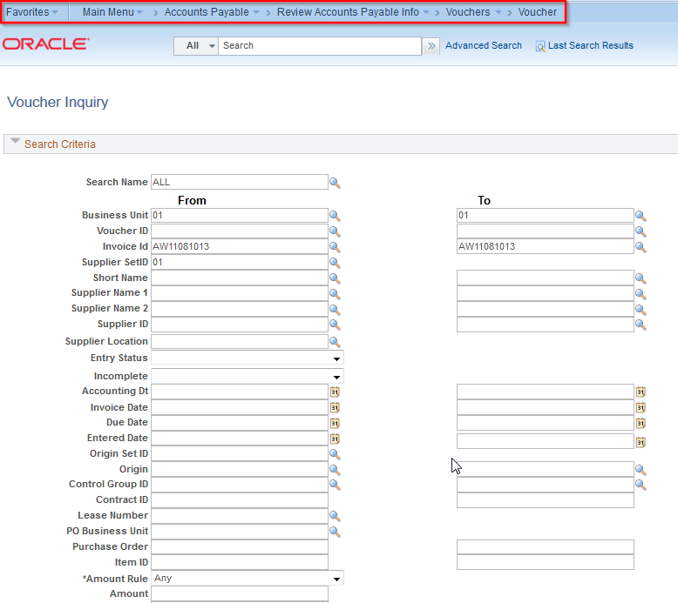


Navigation & Inputs – Searching on supplier
- Note the Supplier Short Name & Name1,2, search field has a bug. Please use the Supplier ID field to search on supplier number.
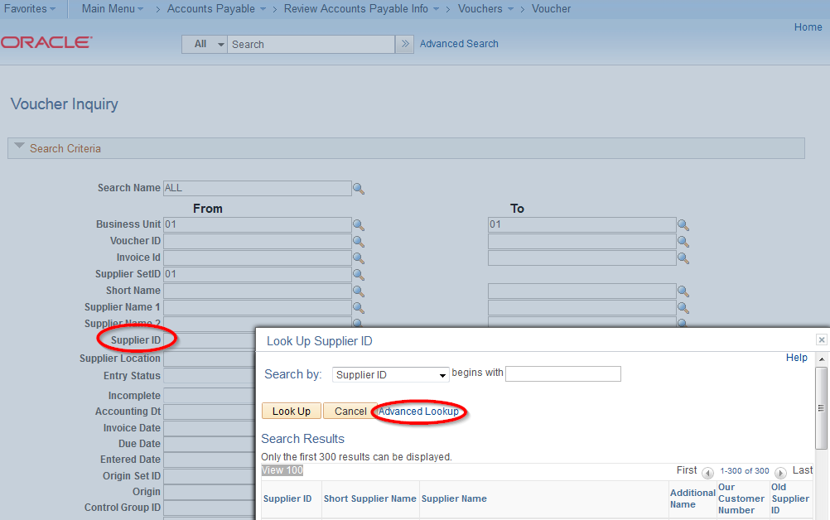
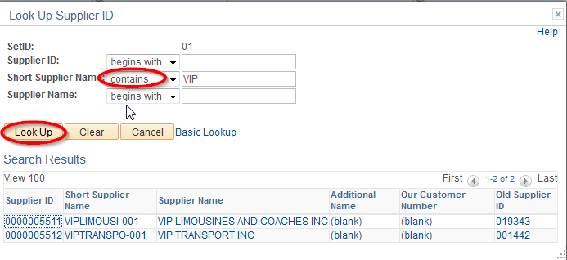

Search Results
The results will display on the bottom of the screen depending on the search criteria entered above.
- Click on the drop down arrow on the Actions, you can choose one of the following for more information.
  - View Attachments – this link is visible only if an attachment exists
  - Review Accounting Entries – this page shows where the invoice was changed to
  - Payment Information – this page shows the check number and check date
  - Scheduled Payments – this page shows when the voucher is scheduled to be paid
  - Voucher Details – this page shows the voucher line item detail by amount and chart fields
- You can also click on the other tabs to view additional voucher information
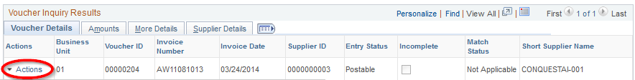

View Attachments
The system will take you to the Voucher Attachments Window. Click on the File Name hyperlink to view the invoice.
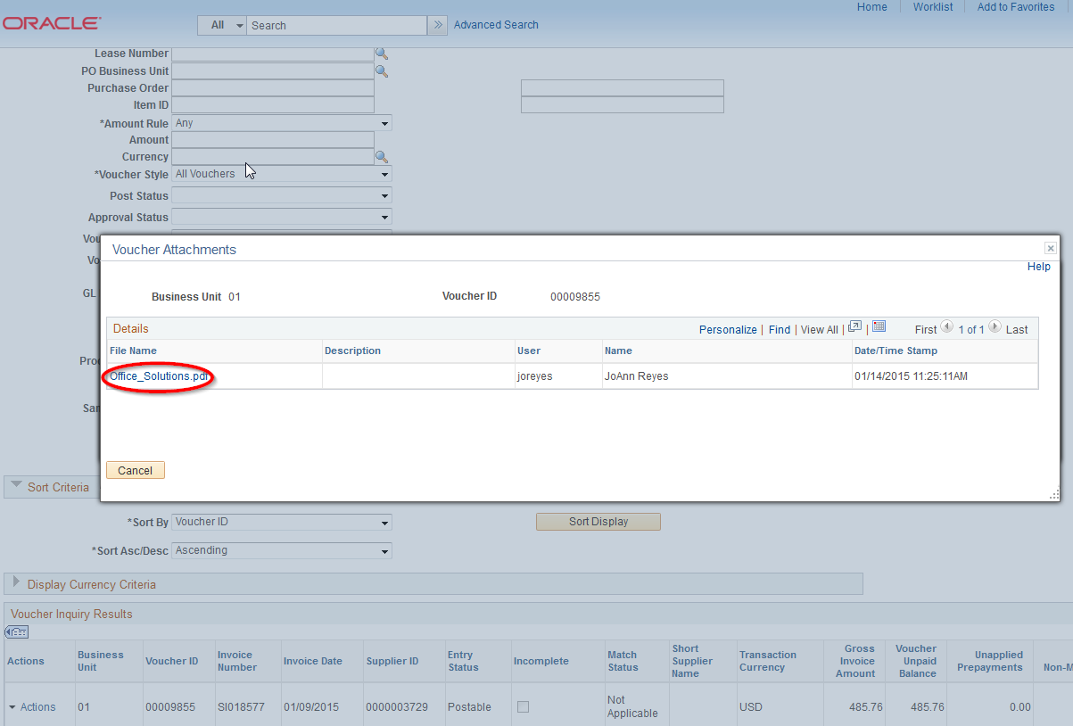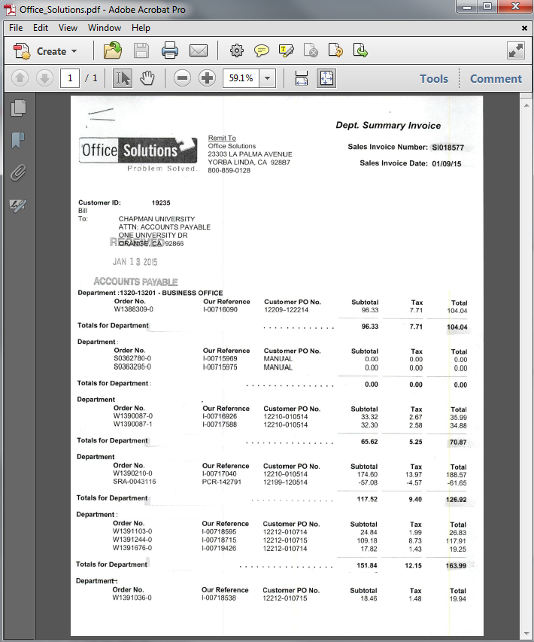

Review Accounting Entries
The system will take you to the Voucher Accounting Entries screen pre-populated with the VoucherID and Invoice number.
- Click the Search button to refresh the Accounting Information section of the page.
- Notice the 1 of 2. Item 1 shows that AP Accrual (expense accounting entries)
- Item 2 shows the accounting entries for payments
- You can use the arrow button next to the 1 of 2 or click the View All hyperlink
- You will also see voids and re-issues if applicable
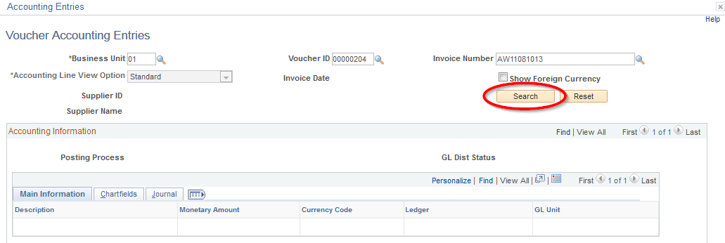

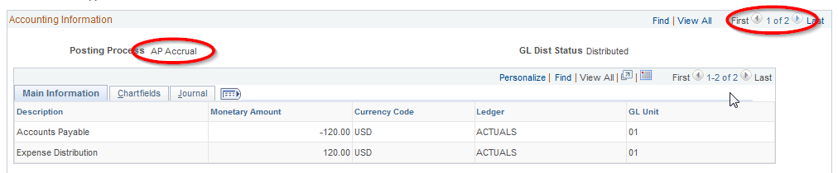

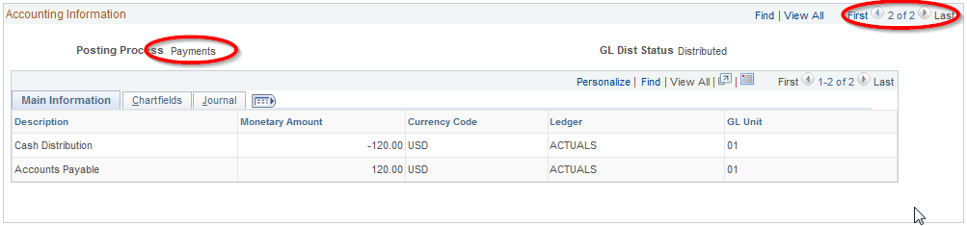

Review Payment Information

- From the Actions drop down, the Payment Information option takes you to the Voucher Payment Inquiry
- The check number is highlighted below
- You can click on the hyperlink for additional information and the system will take you to the Payment Inquiry page. You can see additional check details on this page such as reconciliation status after month-end reconciliation is complete.

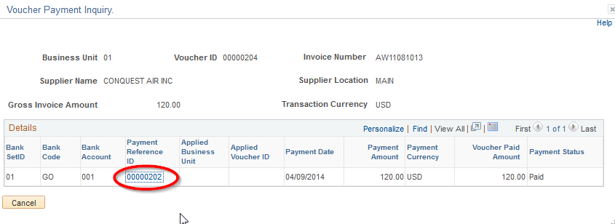

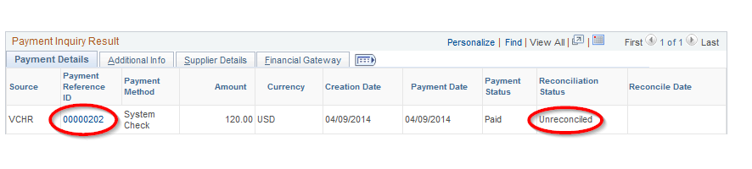

Scheduled Payments
- From the Actions drop down, the Scheduled Payment option takes you to the Scheduled Payment Inquiry screen. This page will only return information at the bottom of the screen when payment is scheduled. If the voucher is already paid, the results will be blank.
- The check number is highlighted below

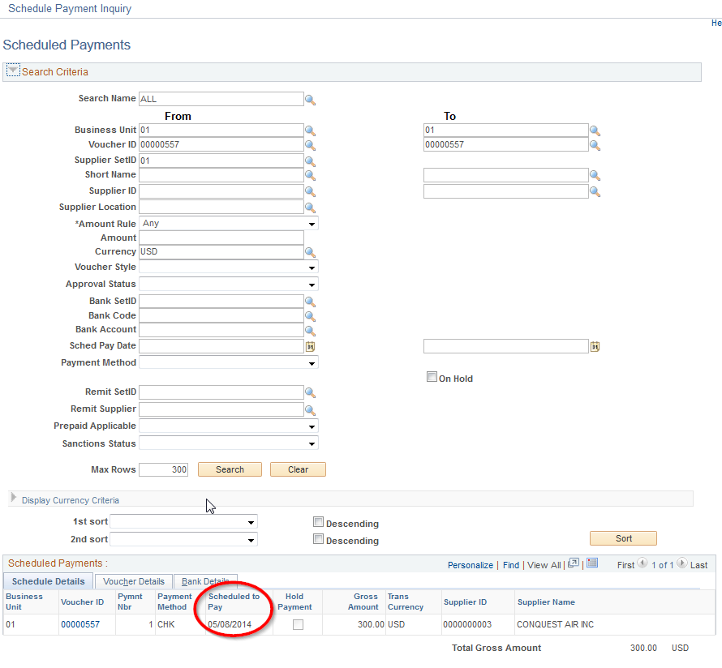

Voucher Details
This page shows the Voucher header information and detail line amounts and chartfields

