AP Transaction by Supplier

This report will provide a list of all AP activity by date range for a vendor, invoice number or specific chartfields.

- Establish a Run Control
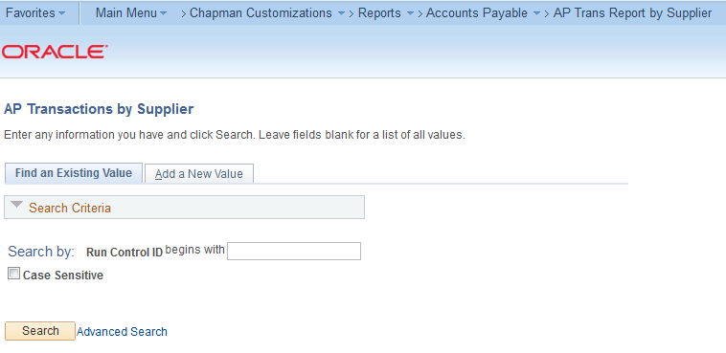

- Enter from/to date, supplier number or invoice number. Or enter parameters such as department or program range. Running the report with only the date from/to is not recommended.

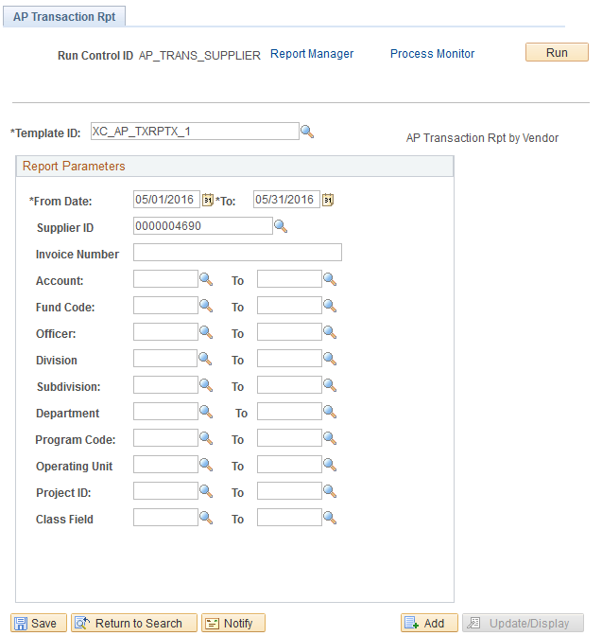

Sample AP Transaction Report
