
CREATING A REQUISITION

Components of a Requisition 2
Requisition and Purchase Order Process Flow 3
Types of Requisition & Purchase Orders 4
Standard PO 4
Blanket PO 4
Summary PO 4
Ingram Micro 5
Adding a Requisition 6
Adding Comments to the Requisition 8
Entering Lines on a Requisition 13
Saving the Requisition 21
Requisition Budget Checking & Budget Status 22
Requisition Approval Status 25
Deleting a Requisition 27
Cancelling a Requisition 28
Shortcuts to Entering Data – Using the Requisition Defaults 29
Non-Standard Requisition – Additional Input Instructions 33
Non-Taxable Items 33
Requisitions for Multiple Fiscal Years AND is $10,000 or Less 33
Requisitions For Multiple Fiscal Years and EXCEEDS $10,000 34
Blanket Requisitions 35
Blanket Requisitions – Adding to an Existing Blanket Purchase Order 36
Summary Requisition 36
Ingram Micro Requisition 36
Receiving items in Peoplesoft 37
Workflow Approvals 37
Requisition Entry Quick Reference 38

Components of a Requisition

Requisitions and Purchase Orders in PeopleSoft are line driven which means the Chartfield string (accounting information) is assigned at the line level of the order and not at the header level. This guide explains how to enter components of a requisition and how the components relate to each other.
In PeopleSoft requisitions consist of four components:
- Header - Defines the Business Unit, the Requestor, Date, and Statuses.
- Line - Contains the line item information. For each line item the quantity, category, UOM, description, vendor, and price.
- Schedule - Defines when (due date) and where you want the line items delivered.
- Distribution - Where accounting information (i.e. the general ledger Chartfield string) is entered. The Chartfield string includes the account, fund, department ID, program, class and project.

Each component of a requisition has a one-to-many relationship, starting with the header and ending with the distribution information. For example, every requisition has a header, but a header can have several lines. Each line can have several schedules and each schedule can have several lines of distribution information.

Requisition and Purchase Order Process Flow

Standard Requisition Process Flow
Requestor Submits Requisition via PS

IS&T Approval
No Approvals - Request Moved to Purchasing
Accounting Approval

Purchasing – Sources Requisition to P.O.

Workflow Approval
P.O. sent to Vendor for Fulfillment

In the standard requisition process, the workflow approvals take place on the purchase order after the requisition is sourced into a purchase order.
Ingram Micro (MD) Requisition Process Flow
Requestor Submits Requisition via PS

IS&T Approval
Accounting Approval
No Approvals

Requisition Workflow Approvals

Purchasing – Sources Requisition to P.O.

P.O. sent to Vendor for Fulfilment

For Ingram Micro purchases approval workflow will take place on the requisition. This step is required to consolidate multiple requisitions into one PO and independently route workflow by the requesting subdivision.
Entering the requisition is identical to the standard process, except for Origin needs to be changed from default value PO to MD.

Types of Requisition & Purchase Orders

There are four types of Purchase Orders issued through PeopleSoft by the submission of Requisitions. Here is a summary of the types and key points.
Standard PO
- Each Line on the Requisition includes item quantity, description, supplier item ID number and cost of each item. If pricing has been provided by the supplier, attach a copy of the quote.
Key Points:
- Enter each item on a separate line. Include the supplier item ID, if known.
- Do NOT include shipping amounts as a line item. If shipping amount is known include this in the Header Comments.
- Do NOT include sales tax. This will be calculated and added when the Requisition is sourced into a PO if the supplier is a taxable supplier.
- WORKFLOW approvals are done at the PO level. The PO is valid once it has been “fully approved”.
- RECEIVING – must be entered upon delivery of the order. If partial shipments are made by the supplier, enter the receipts into the system as the orders arrive.

Blanket PO
- Used when the same supplier is used for frequent purchases throughout a fiscal year. A purchase order is issued for a dollar amount. Use the same PO number throughout the fiscal year each time an order is placed with the supplier.
Key Points:
- Line 1 of the Requisition – the description is: FY14-15 Blanket PO for XXXXXX (example supplies for lab)
- Quantity should be a dollar value of requisition such as $1,800 which is 80% of the final PO amount.
- Price should be 1.00
- When PO is issued, sales tax and freight will be added. In this example the total amount encumbered is $2000
- RECEIVING – each invoice for a Blanket PO must be received by entering the sub total amount of the invoice as the receiving dollar amount in the quantity field. If you have multiple invoices, receive each one as a receipt. Do NOT combine invoice amounts when receiving, receive each one as a separate receipt.

Summary PO
- One line is used on the Requisition to describe the purchase of multiple items in a summary manner. Such as: Description: Assorted supplies per attached quote.
Key Points:
- Enter a single line with a description that summarizes the entire order.
- Quantity is 1.
- If non-taxable items are in the order such as “set up fee” ADD a line with Description: NONTAX with a brief description. This line Quantity is 1 also. Add the dollar amount that is nontaxable.
- Attributes tab – check the AMOUNT ONLY box
- RECEIVING - must be entered at time the order is delivered
Ingram Micro
- Requisitions for Ingram Micro must be entered using the PR Header Origin MD (not PO which is the default). This is because Purchasing combines multiple requests from the campus community for computer supplies onto a single Purchase Order. Other than changing the Origin to MD (from PO) items are entered on a Requisition in the same format for a Standard PO by listing quantity, description, supplier item ID and cost for each item. This vendor has a minimum order amount, which requires us to combine requests to meet the order minimum.
Key Points
- Change the Origin to MD
- WORKFLOW – approvals are done at the Requisition PRIOR to Purchasing combing it with other Requisitions. This is a change from the standard workflow process.
- RECEIVING – Do Not Receive. Receiving is done at the time items are delivered by the Purchasing/Receiving department.

Adding a Requisition

NAVIGATION: MAIN MENU > PURCHASING > REQUISITIONS > ADD/UPDATE REQUISITIONS

- To Add a new requisition – click on the Add button
  - Business Unit = 01 This is the default setting. 01 is Chapman University.
  - Requisition ID = NEXT This is the default setting. The ID will be the next available number.
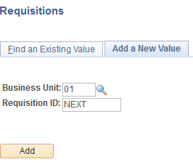

- This screen appears after clicking the Add button.
  - The Requisition Name field is optional, can be left blank. The field length is 30 characters. Special characters can be used.
  - Note the Status is Open and the Budget Status is Not Chk’d. These fields will update once the requisition is saved and budget checked.
  - Your ID appears in the *Requestor field by default
  - The *Requisition Date is the date you are entering the requisition and defaults to current date.
  - If entering a requisition for Ingram-Micro (computer accessories, toner, ink etc.) Select MD from the magnifying class in the Origin field.
  - The Accounting Date defaults to the current date.

IMPORTANT: When entering requisitions for future budget years you MUST update the Accounting Date field AND the *Requisition Date field to reflect the next fiscal year.
b
a
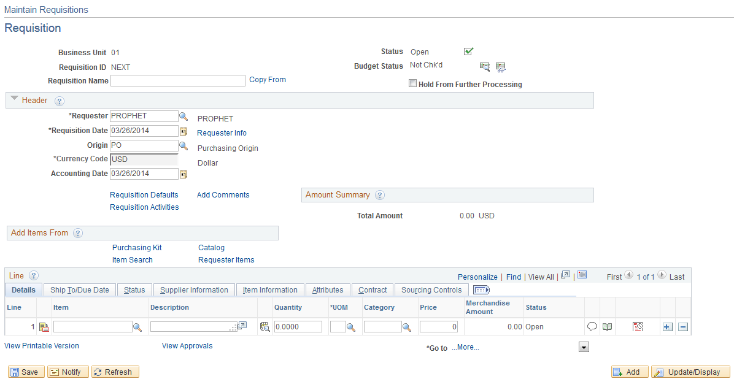
e
d
c
f

Adding Comments to the Requisition

- To communicate with Purchasing regarding the requisition click on the Add Comments link in the Header of the main requisition page.
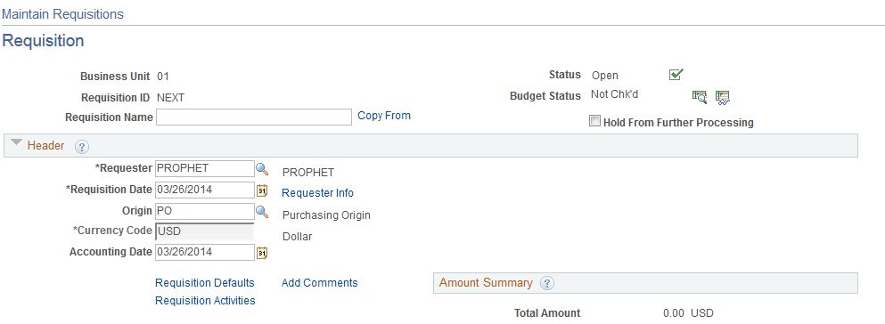
3

  - This is the comment window. Provide any details necessary to assist purchasing in handling your request. Quote numbers, shipping costs, etc. are to be included in this section.
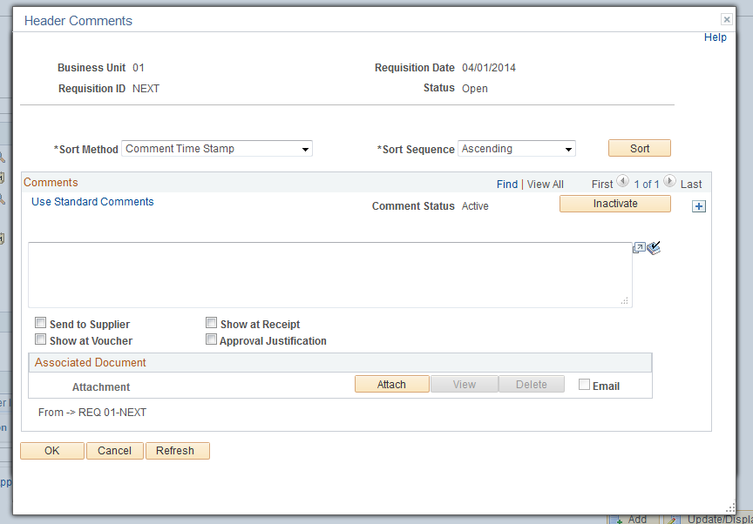
b
a

  - Click on the Standard Comments link to select a preformatted comment and append with additional information.

  - The Standard Comments box opens. Click on the magnifying glass next to Comment Type.
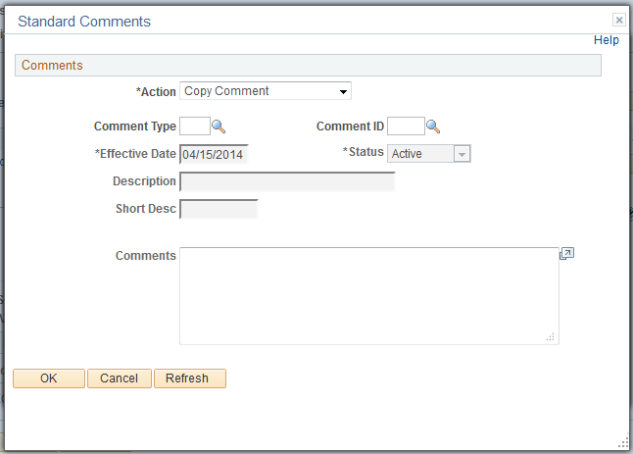
c
  - Click on STD – Standard Comments in the Look Up Comment Type window.
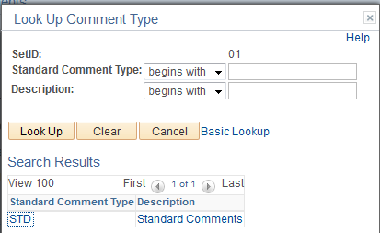
d

  - Click on the magnifying glass next to Comment ID
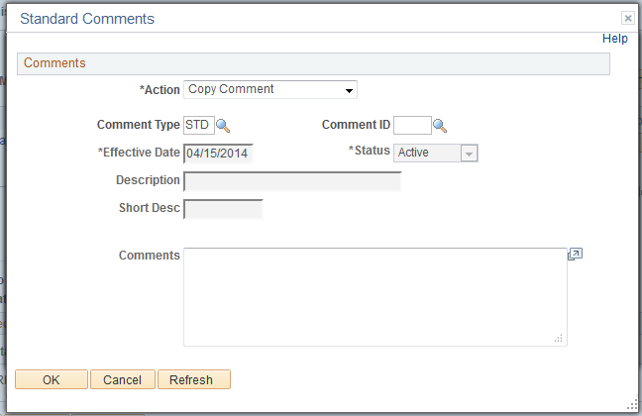
e

  - Select the most appropriate comment by clicking on either the Comment ID or Description.
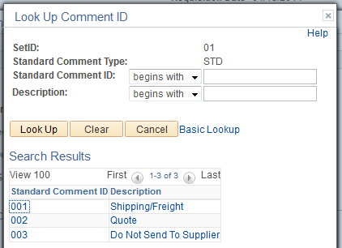
f

  - A brief comment will populate in the Comments section. Click OK. You will be returned to the Header Comments box.
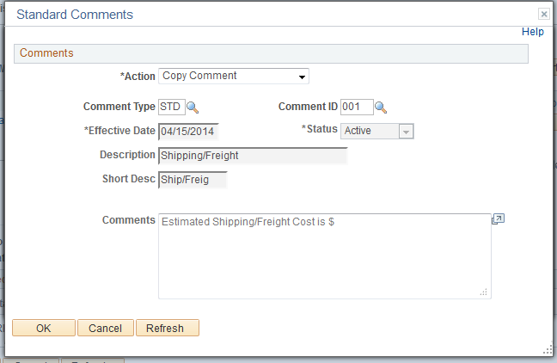
g

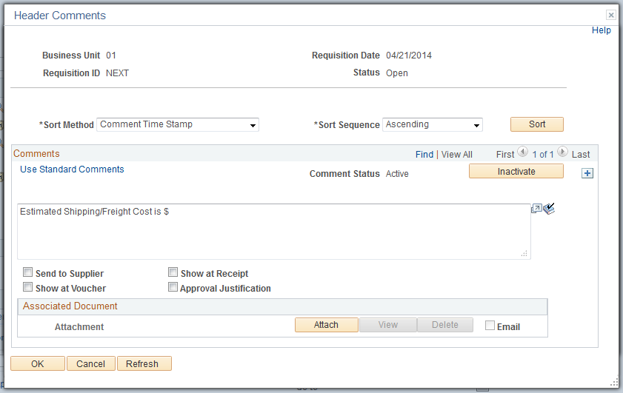
i
j
h
k
  - Add the remaining information following the pre-formed comment. Only use ONE Standard Comment. Include any additional information in the comment box.
  - The ONLY box used is the Approval Justification box. Check this box if you are entering comments that need to be see and reviewed by the Approvers of the Purchase Order as part of the Workflow approval process.
  - Attach any documentation (quotes etc.) by clicking the attach button. NOTE: documents must be electronic copies. If a quote has been provided you also need to provide the quote number on the final line item of the requisition. See # 4b.
  - Click OK to save your comments.
  - After clicking OK the Header page updates the link to Edit Comments.
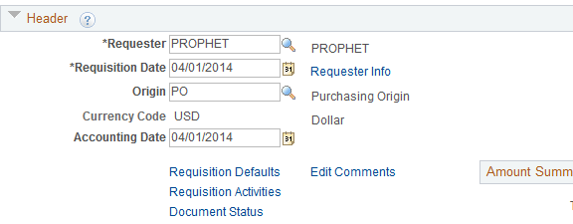
l

Entering Lines on a Requisition

- In the Line section Details tab enter the following information:
  - Description – A description of the item being ordered – this will be provided to vendor.
a
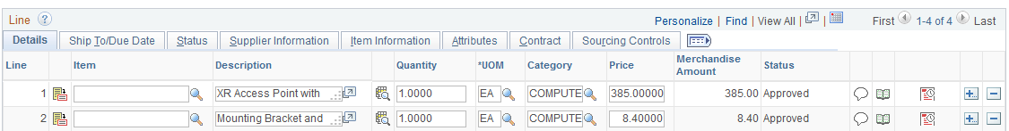

- If you are submitting a quote with the requisition, the final line item must include the quote number.
b
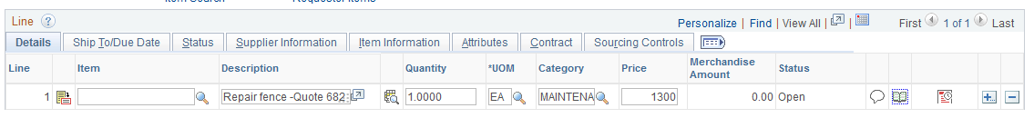
- To view the entire description click on the icon in the description line.
c
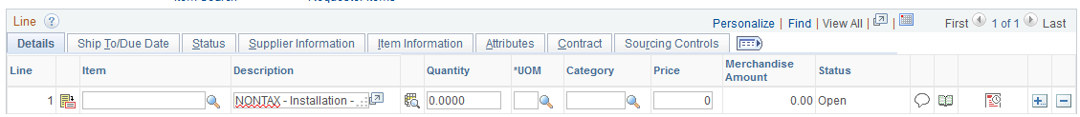

- This opens a window to display the entire Description. You can also compose your description in this box and then click Return.

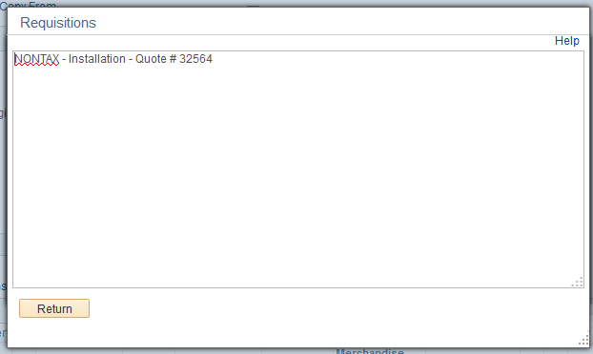
d

- Quantity – enter the number of items to be ordered.
e

- UOM – click the magnifying glass and select the appropriate Unit of Measure.
f
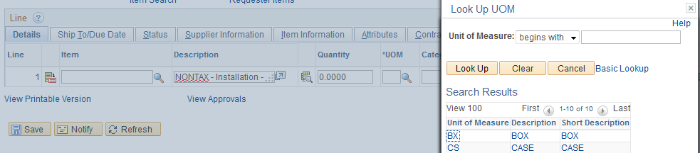
- Category - Selecting a “Category” is a new step in PeopleSoft and is a required field. If categories are not assigned, the requisition will be rejected. The use of categories saves the user from needing to remember individual account numbers. The Account # (formerly IFAS Object Code) is associated with the Category and entered into the requisition when the Category is selected. Click the magnifying glass icon to display the available categories. Click on the category to populate the field.
g
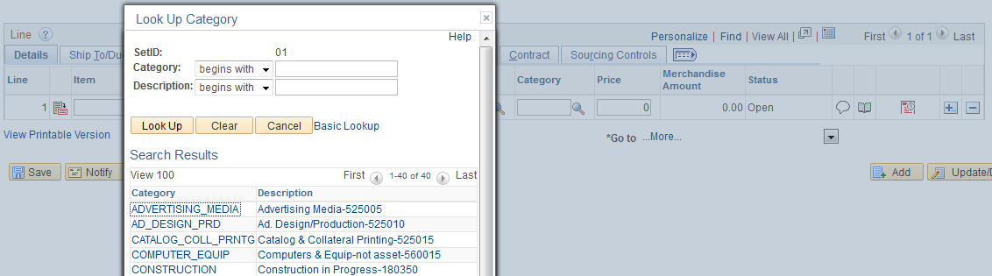

- There is an “Unlisted” Category if the menu items do not meet your needs. You MUST enter an Account # (in Step 7) when using the “Unlisted” Category.
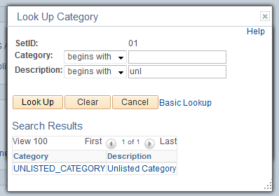
h

i
- Price – enter the price of the item

- Purchase requisitions may contain taxable and nontaxable items .Nontaxable items must have a description of NONTAX and a brief description of item/service
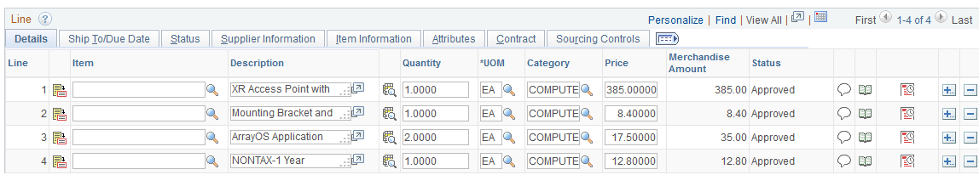
j
NOTE: Do NOT add lines for sales tax and freight. These amounts will be calculated by PeopleSoft during the Purchase Order processing. Budgets will be encumbered based on the amounts reflected on the requisition AND any appropriate sales tax and freight charges.

- Ship To/Due Date tab - the Ship To field automatically populates with the department tied to your login account. Click on the magnifying glass to view the options. The primary code for each department has the primary University shipping address as the location. Some departments have an alternate address identified by “A” after the location number, this ships items directly to the department address. Refer to the PeopleSoft Implementation Training tab of My Window to review the Location Codes document with physical locations associated with the Ship To Location code.

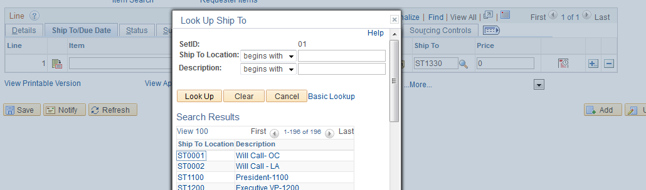
k

- Due Date is the date you expect the product/service to arrive in your department.
l
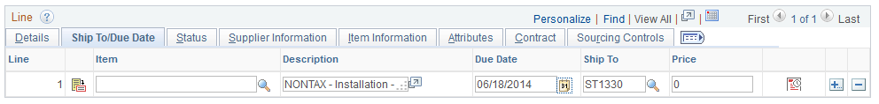

- Supplier Information tab - Requestors are required to enter a Supplier when submitting a requisition. Click on the magnifying glass to open the menu.
m
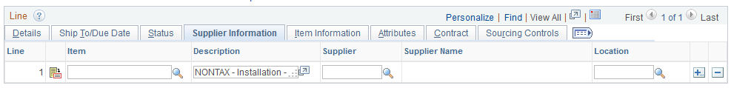

- Search by Supplier ID or Name to locate the vendor. If using the Short Supplier Name – you are limited to 10 characters. Click on the appropriate vendor name/ID to populate the field. If using “Unknown” as a supplier AND you want to add a NEW supplier, you must add the supplier information in the Header Comments field (see page 7). Purchasing will require a form to be submitted with additional details to add a new supplier to the PeopleSoft supplier menu.
NOTE: You can only submit one supplier/vendor on a requisition.

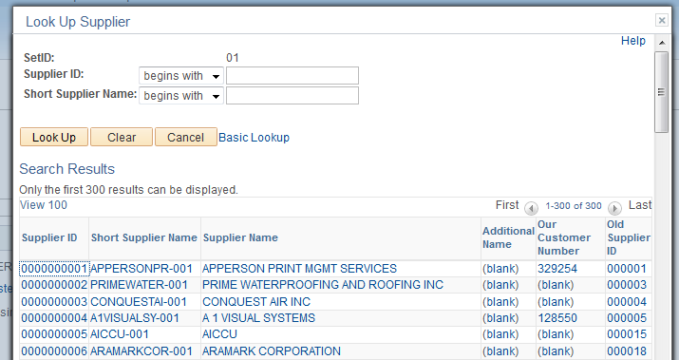
n

- Item Information tab, Supplier Item ID is completed to further identify the item requested. This field contains the catalog number or model number. Submit this information if known. It is not necessary to complete Supplier’s Catalog, Manufacturer ID etc.

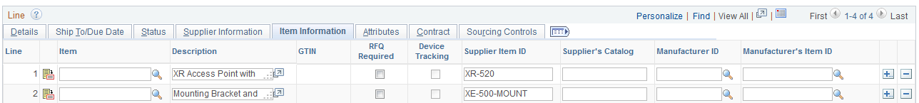
o

- The Attributes tab brings forward information entered in other tabs. The Amount Only box must be checked if the requisition is not for a specific item amount, but rather for a “lump sum” dollar amount and is used for “Summary” requisitions. EXAMPLE: Ordering 400 t-shirts in various sizes – rather than entering line items for each size - you attach a document in the Comment Section of all required items and request purchasing to handle the order. In this scenario click “amount only.”
p
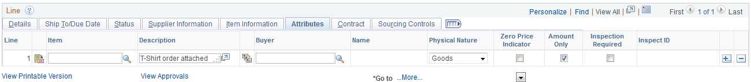

- Return to the Details tab. Click on the memo icon titled “Schedule” (5a). This will display the Schedule (for delivery of product) and the Distribution (chartfields – accounting “distribution”).
5

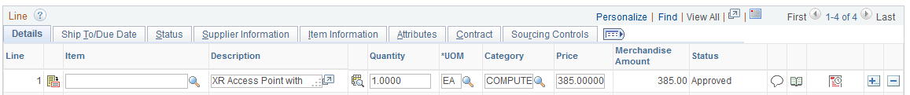
5a
- The Schedule screen appears. The Due Date and Ship To information is defaulted from the tabs you completed earlier. Click on the notepad icon to open a screen to enter chartfields.
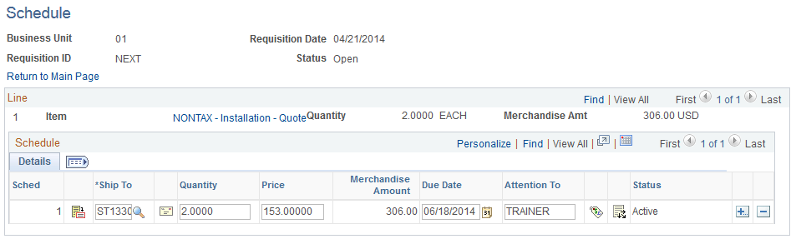
6

- The following screen appears with the Chartfields. Enter the Fund, Dept and Program numbers for your Department. If this is for a grant or construction project, you will also need to enter the PeopleSoft Project Number.
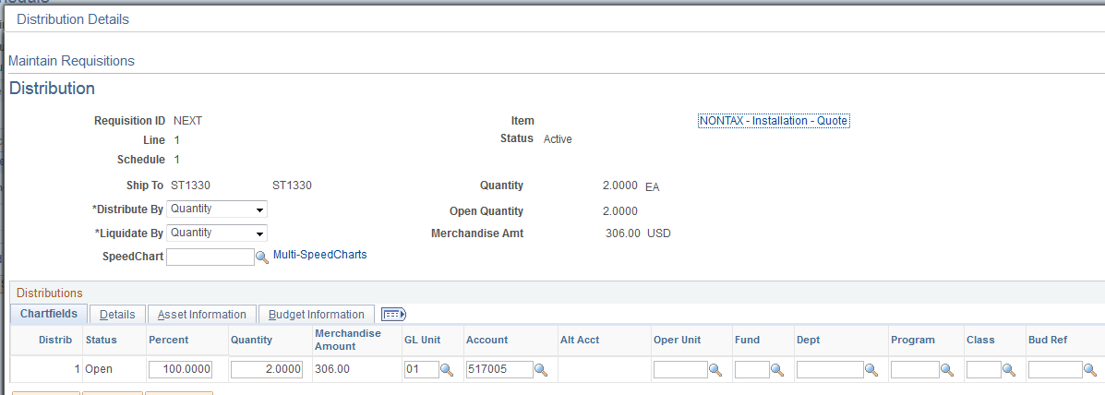
7
- SpeedCharts were created to assist users in completing requisitions by automatically populating the Fund/Dept/Program/Project fields on the requisition lines. Click on the magnifying glass for the menu of SpeedCharts.

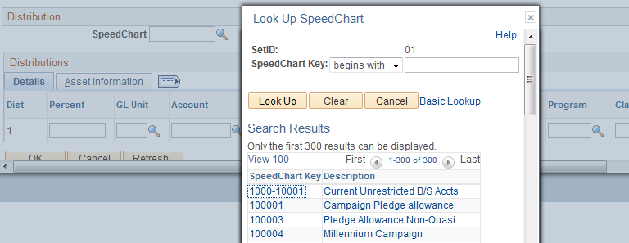
a

- After entering data on the Distribution screen – click OK to save the data and return to Schedule screen.
  - Note: You can click the Save button at the bottom of the screen at this point to save the information that has been entered. The Requisition ID will update from NEXT to the next available requisition number.
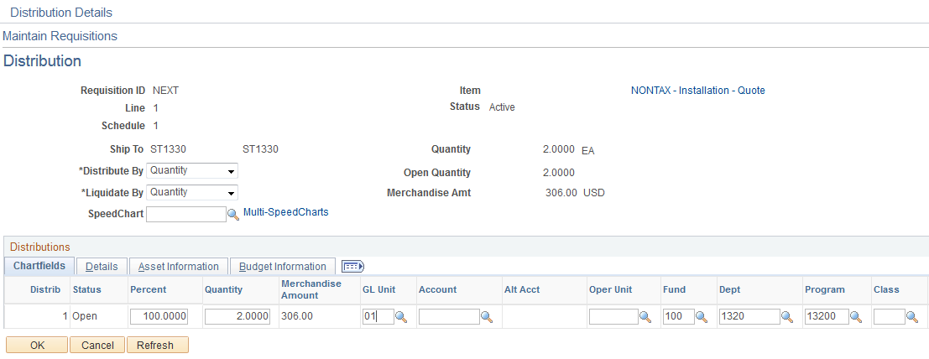
b

- Click on the link Return to Main Page
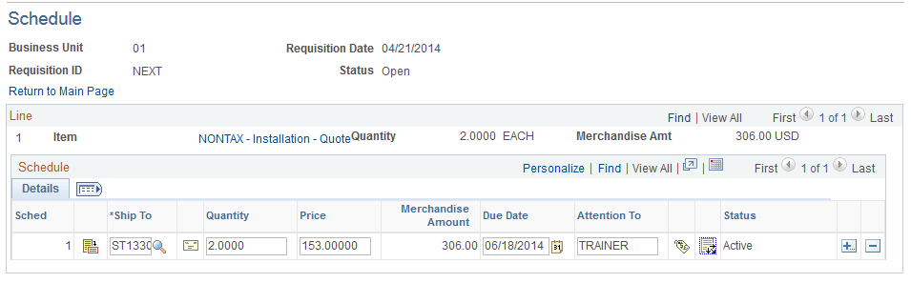
c

Saving the Requisition

- After adding all lines and necessary data click the Save button on the main page.
8
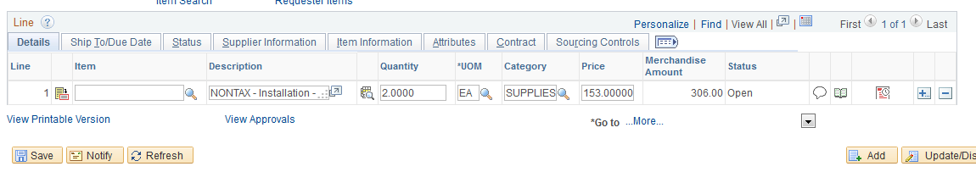

- At least one line item must be entered to save a requisition. A Requisition ID is assigned once the record is saved. The Requisition ID is 10 characters, “R” followed by 9 digits.
  - The “Hold From Further Processing” will allow you to save the requisition without completing the budget check process.

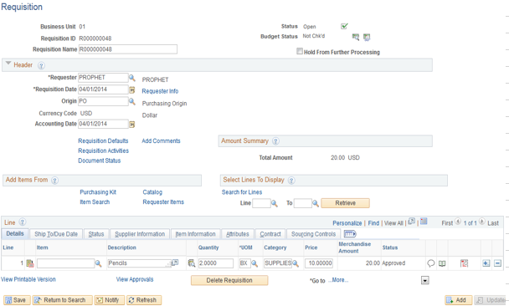
a
9

Requisition Budget Checking & Budget Status

- Click on the Budget Status icon to budget check the requisition AFTER saving the requisition.
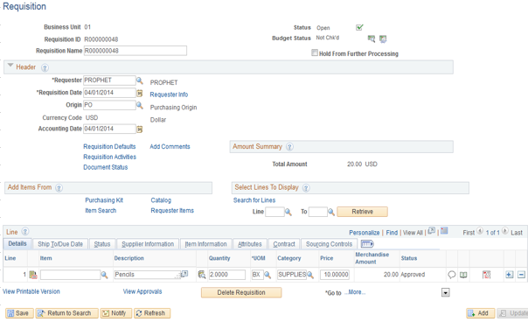
10

- If the system is unable to approve the requisition, the Budget Status will update to Error. Click on the word “Error” to open a window displaying the reason the requisition was not approved. The Error will result if you are over budget. A warning message will display if you are over the monthly budget, but not the annual budget. The Budget Manager is notified of all requisition errors.
11

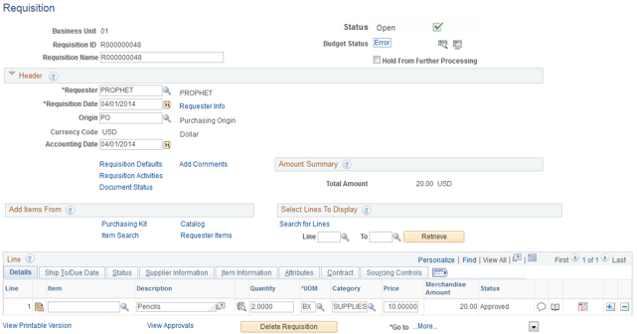

Review Exceptions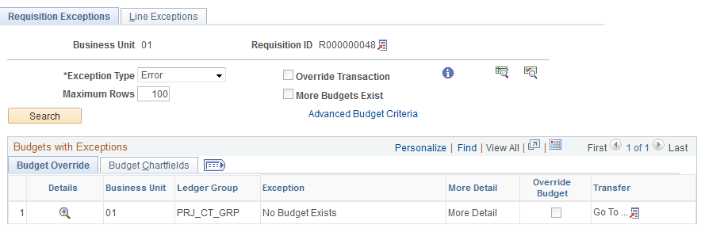

- If the budget check process is successful – the status updates to Valid.
  - Click on the Submit for Approval green checkbox icon to launch the requisition for approvals. The approvals will vary depending on the Origin and also if Accounting or IS&T approvals are required. The status will update to Pending or Approved.
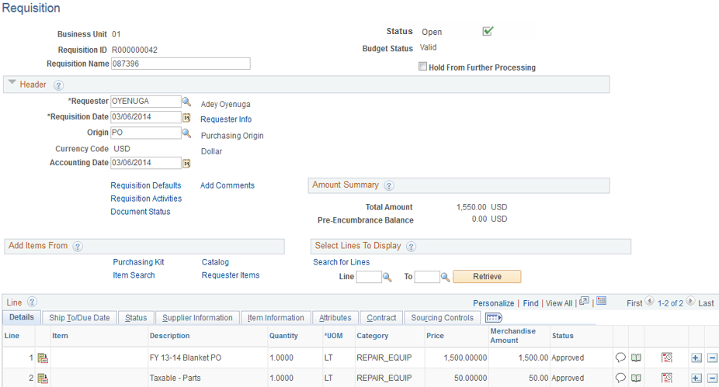
12a
12

Requisition Approval Status

- Requisitions for items that require additional approval through workflow will receive a “Valid” Budget Status but the Status of the requisition is Pending. The Approver will be notified through email with the Requisition # to Approve or Deny the requisition. This will occur for the following purchases:
  - Computer Purchases
  - Asset Purchases
  - Grants Funding
  - Restricted Funding
Once the Requisition is approved, the Status will update to Approved and the Requisition will be sourced to a Purchas Order.
13
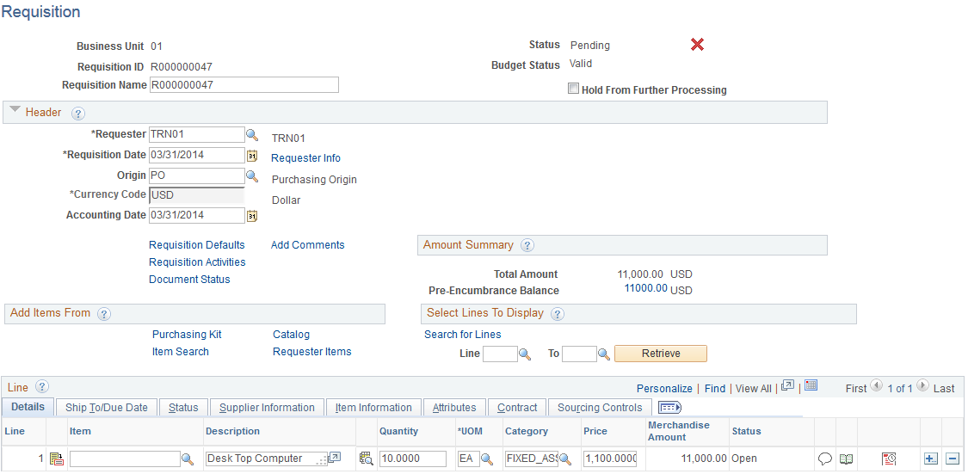

- To review Approvals, click on the View Approvals link.
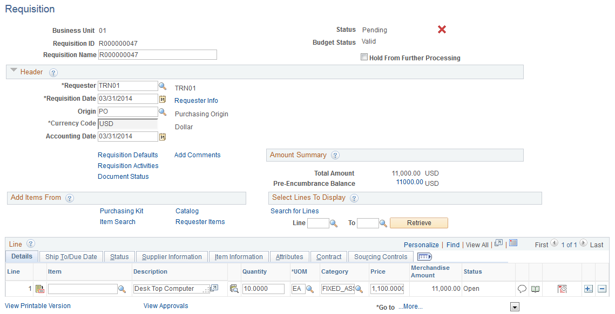
14
This screen provides the workflow approvers required for a requisition.
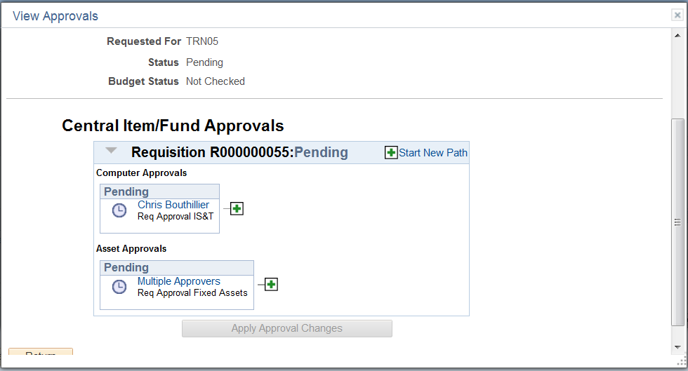

Deleting a Requisition

A requisition can be deleted or cancelled at two points during the process. If the requisition has been saved (Requisition ID has been added and Status = Approved) and NOT budget checked, line items can be deleted or the entire requisition can be deleted.
- To delete the requisition, click the Delete Requisition button at the bottom of the screen.
- To delete a line item click on the minus sign “-“and click Save.
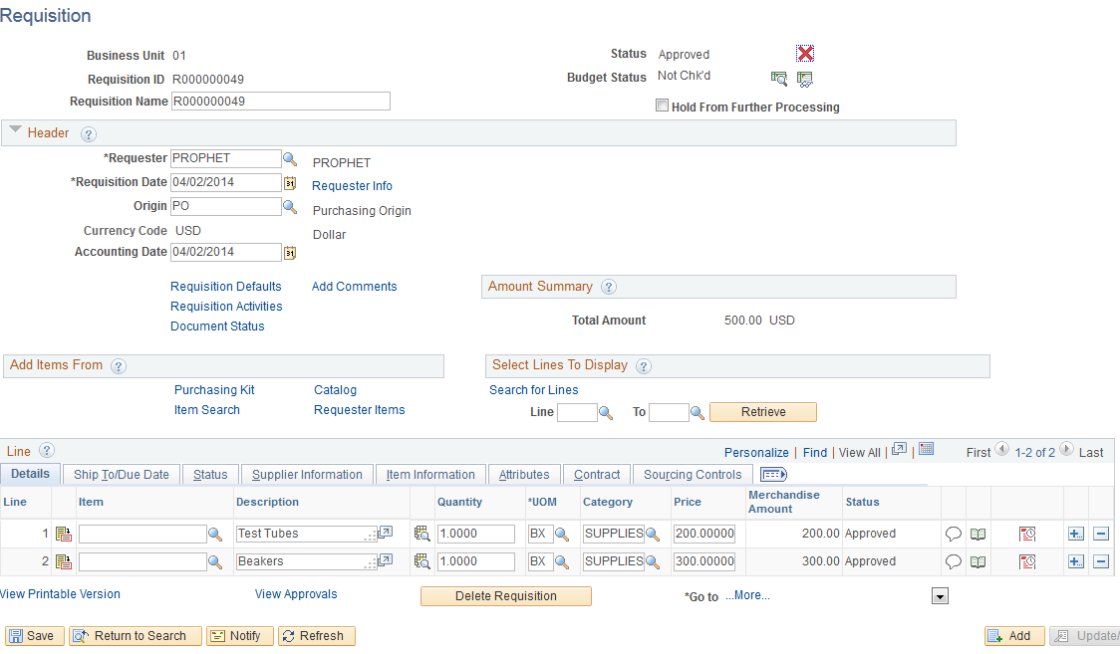
b
a

Cancelling a Requisition

If the requisition has been approved and there is a valid budget check, you cannot delete the requisition, you can only cancel the requisition. To cancel a requisition, click on the red X next to Status. A nightly batch process will run to reverse the budget pre-encumbrance lines. To reinstate the requisition you would need to repeat the Budget Check process. NOTE: Once a requisition has been sourced to a P.O. you will not be able to cancel a requisition or make any adjustments to the lines. You will receive an error message that the requisition has been sourced to a P.O. You would need to notify Purchasing to cancel the P.O.
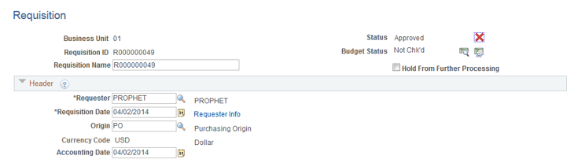

Shortcuts to Entering Data – Using the Requisition Defaults

Click the Requisition Defaults link to open the window. This is a useful tool if your requisition has multiple line items with similar categories, units of measure, schedule etc. Data entered in the Default Options window will populate other areas of the requisition.

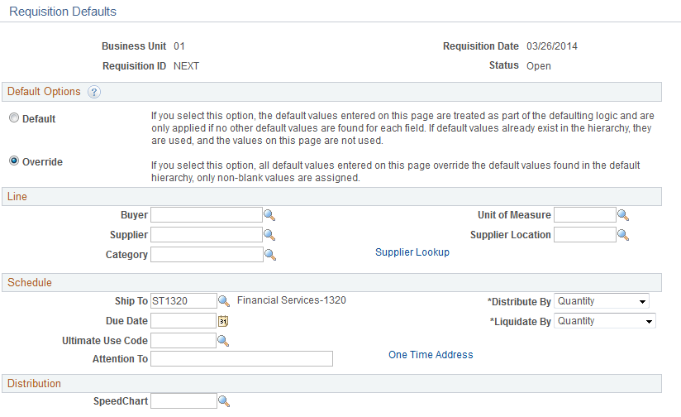
c
d
b
e
a
f

  - To use the default options click the Override radio button. Defaults will carry forward for all line items in the requisition. EXAMPLE: if most items are in the Category of “supplies” you can set that default and it will populate all lines. If a line item is not “supplies” you can update at the line level.
  - The Buyer field is left BLANK.
  - Clicking on the magnifying glass icon will display a menu of options for Unit of Measure.
  - The Supplier Location field defaults to MAIN and does not need to be changed.
  - Requestors are required to enter a Supplier when submitting a requisition. Click on the magnifying glass to open the menu OR click the Supplier Lookup link for additional search options.
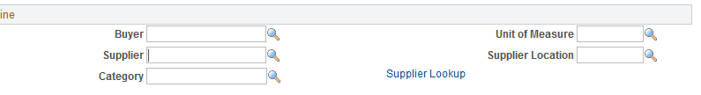
e
EXAMPLE: Enter partial name or city, etc. and click the Search button. Place a check in the Sel box and click OK.
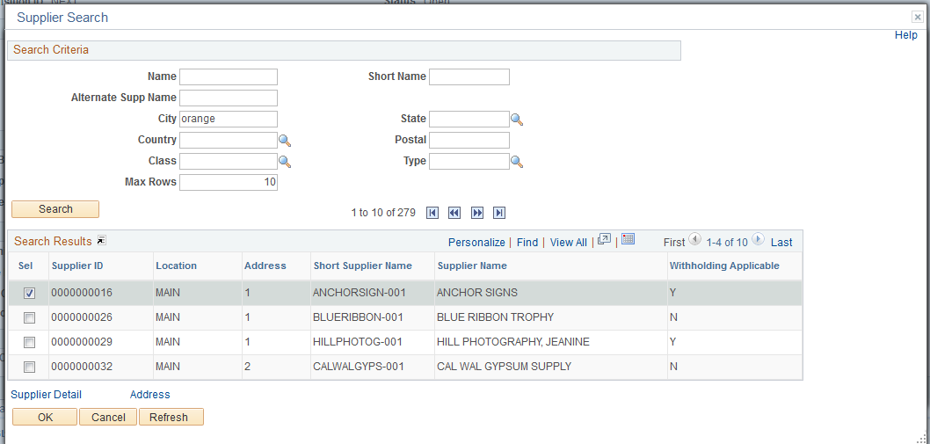

  - Selecting a “Category” is a required field. If categories are not assigned, the requisition will be rejected. The use of categories saves the user from needing to remember individual account numbers. The Account # (formerly IFAS Object Code) is associated with the Category and entered into the requisition when the Category is selected.

  - The Ship To field automatically populates with the department tied to your login account.
  - Due Date is the date you expect the product/service to arrive in your department.
g
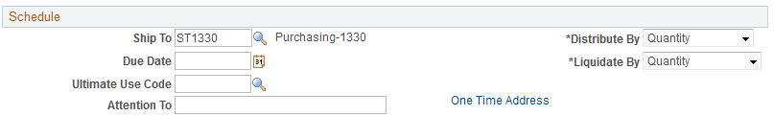
h

  - The SpeedChart field becomes active when the Override box is checked. Click on the magnifying glass for the menu of SpeedCharts.
i
  - Selecting a SpeedChart populates the applicable chartfields. NOTE: The SpeedChart number is not saved but the chartfields are populated.
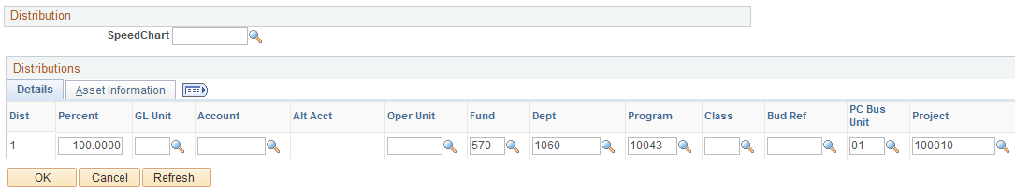
j
k
  - Click OK to save the default settings. Continue to the Line level and complete the necessary fields not completed with the Default settings.

Non-Standard Requisition – Additional Input Instructions

Non-Taxable Items
Line Item Description for Non-Taxable items must be entered using the following format
NONTAX - and brief description i.e. service contract, installation etc.

Requisitions for Multiple Fiscal Years AND is $10,000 or Less
If the requisition is for multiple fiscal years AND is $10,000 or less, you will need to add a chartfield line on the Distribution page and update the PS Account # 140210 (Prepaid Exp-Other Future Yrs) for the future fiscal year amount. See chart below for additional examples.
- Enter the description, total amount, and quantity in the Lines section on the Requisition main header page – Example $6000, Feb2015-Jan2016, $500 monthly
- Scroll to the right and click the Schedule Icon
- Scroll to the right and click the Distribution Icon
- Select Amount on the *Distribute By field (ref A)
- Scroll to the far right and click the “+” to add a row
- Update the amount to reflect the expense in the current fiscal year - Example $2000, 4 months (ref B)
- Update the amount to reflect the expense in the future fiscal year and change the PS Account # to 140210 – Example $4000, 8 months, Account 140210 (ref C)

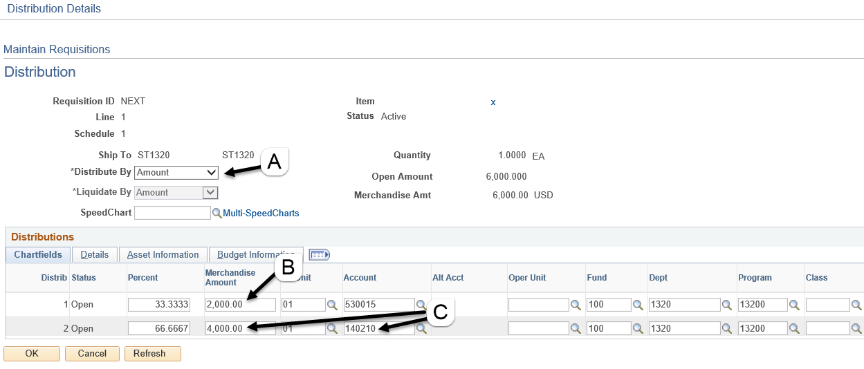

Requisitions For Multiple Fiscal Years and EXCEEDS $10,000
If the requisition is for multiple fiscal years and EXCEEDS $10,000, you will need three lines on the chartfield Distribution page– one for the current & prior period (if applicable) expense, one for current fiscal year prepaid PS Account # 140220 (Preapid Expenses – Other) and the last for the future fiscal year prepaid PS Account # 140210 (Prepaid Exp-Other Future Yrs). See chart below for additional examples.
- Enter the description, total amount, and quantity in the Lines section on the Requisition main header page – Example $12000, Jan2015-Dec2015, $1000 monthly
- Scroll to the right and click the Schedule Icon
- Scroll to the right and click the Distribution Icon
- Select Amount on the *Distribute By field (ref A)
- Scroll to the far right and click the “+” to add two rows
- Update the amount to reflect the expense in the current fiscal year - Example $1000, 1 month, assume today is January 2015 (ref B)
- Update the amount to reflect the expense in the prepaid current year and change the PS Account # to 140220 – Example $4000, 4 months, Account 140220 (ref C)
- Update the amount to reflect the expense in the prepaid future fiscal year and change the PS Account # to 140210 – Example $7000, 7 months, Account 140210 (ref D)

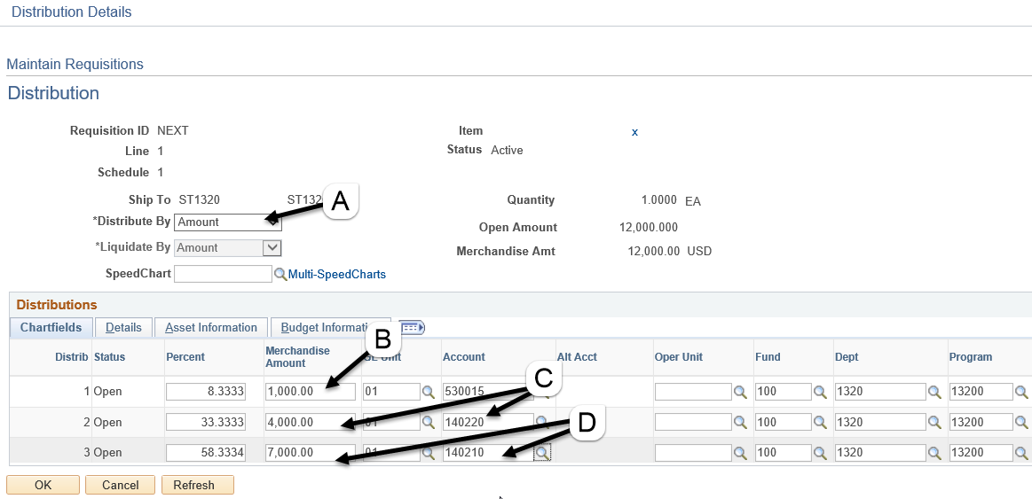

Other Prepaid examples
Type | Today’s Date | Period/Amount | Expense | CY Prepaid 140220 | FY Prepaid 140210
$10k or Less | Jun2015 | Feb2015-Mar2016 $6000 | 4 months $2000 | n/a | 8 months $4000
$10k or Less | Mar2015 | Feb2015-Mar2017 $6000 | 4 months $1000 | n/a | 20 months $5000
Exceed $10k | Jan2015 | Jan2015-Dec2015 $12000 | 1 month $1000 | 4 months $4000 | 7 months $7000
Exceed $10k | Mar2015 | Jan2015-Dec2015 $12000 | 3 months $3000 | 2 months $2000 | 7 months $7000

Blanket Requisitions
When entering Blanket requisitions some fields will have specific differences from “regular” requisitions. Here are critical points to remember when completing a requisition for Blanket PO.
Header – Comments
- Be as detailed as possible in Comments
- Identify in Comments if there are NO shipping charges

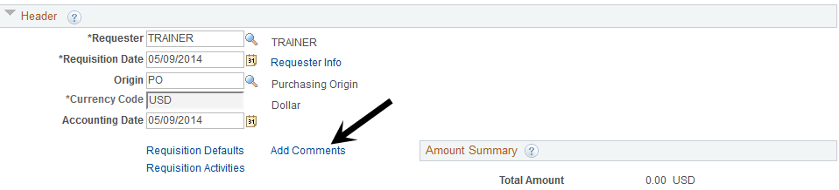
Line
- Description: FY 14-15 Blanket PO – followed by brief description
- Quantity: Dollar amount of Blanket*
- Unit of Measure: LT (Lot)
- Category: Select appropriate Category from drop down menu
- Price: 1.00
- Description: Nontaxable Item: NONTAX and brief description i.e. service contract etc.
Adding line to existing Blanket: ADD to P.O. and 9 digit PO number
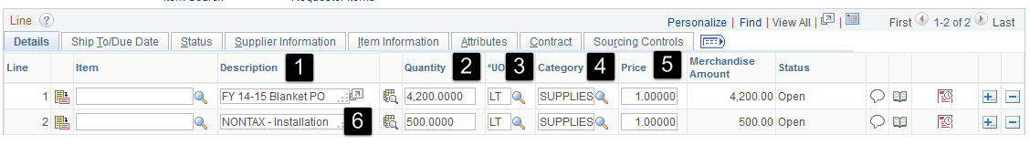
*When determining amount of blanket – subtract 20% for sales tax and shipping. Example: If you anticipate total purchase/expense will be $10,000 (including sales tax & shipping), set the blanket amount for $8,000. The PO total amount encumbered will increase when sales tax and shipping are added through the purchasing process. NOTE: Encumbered amount will be close to the anticipated amount. You can calculate the amount to enter for the requisition by multiplying your anticipated maximum expenditure by .80 or 80%.

NOTE: Return to Page 18 and continue with Step 5 to enter the Schedule and Distribution.

Blanket Requisitions – Adding to an Existing Blanket Purchase Order
Line item Description for Adding to a Blanket PO must be entered using the following format
Add to P.O. and include the 9 digit number and the current date (example Add to P.O. P000001234 3/1/2015)

Summary Requisition
Line item should be entered as amount only

Ingram Micro Requisition
PO Origin should be entered as MD

Receiving items in Peoplesoft

After goods & services are received, you will need to create/enter a receipt into Peoplesoft. Items must
be received and matched in accounts payable before a payment can be issued to the vendor.

Please see the receiving training document for detailed instructions.

Workflow Approvals

Workflow is the approval process for requisitions and purchase orders. When a requisition has been submitted that needs review/approval an email is generated by the system to the reviewer/approver based on the department on the requisition distribution & workflow approval report (Main Menu/Chapman Customizations/Reports/WF PO Approval Assignment)
Requisition Approvals
- Computers, Fixed Assets, Grants & Restricted Account purchase requisitions require workflow approvals on the requisition from the accounting and/or IS&T approvers.
- Ingram Micro (MD PO Origin) will route for management workflow approvals on the requisition
Purchase Order Approvals
- All purchase orders except Ingram Micro type with MD PO Origin

Approvers Actions
- Approve – approve the Requisition. When all levels are approved, the requisition can be sourced into a PO
- Deny - If a requisition is denied, it can not be sourced into PO and must be cancelled
- Hold - Approvers must call/email the requestor to inform of errors and request correction

Requisition Entry Quick Reference

- Navigation – Main Menu/Purchasing/Requisitions/Add-Update Requisitions – Click Add
- Enter a Requisition name (brief description, can be used to search on)
- Origin = PO or for Ingram Micro Origin = MD
- Click on Requisition Defaults and enter the following:
  - Click the Override radio button
  - Enter a Supplier number
  - Enter a Category (account number shortcut)
  - Enter the Unit of Measure
  - Enter Attention To (optional)
  - Enter the chartfields Fund/Dept/Program/(PCBU)(Project)/(Class) (optional)
- Lines section
  - Enter Line Description
  - Enter Quantity
  - Enter Price
  - Reminder taxable & non-taxable items must be split into separate lines
  - For non-standard requisitions, please follow the detailed input guidelines (see pages 4-5 for details)
- Click on Add Comments link to add comments or attach quotes (see pages 8-12 for details)
- Save
- Budget Check
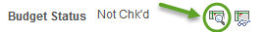
- Submit for Approval
