
ENTERING RECEIPTS

Entering Receipts 2
Summary – Receiving Entry Guidelines by PO Type 2
Navigation 3
Entering the PO Number 3
Searching for the PO Number 5
Changing the Receipt Date to a Prior Date 6
Entering Quantity Received – Regular PO 7
Entering Quantity Received – Blanket PO 8
Entering Optional Input – Vendor Invoice Number 11
Viewing Prior Receipts 12
Cancel a Receipt 14
Notification of Missing Receipt – Match Exception Email 15
PO Number from Match Exception Workbench 16
PO Number from Voucher Inquiry Page 16

Entering Receipts

After goods/services are received you will need to create the receipt.

IMPORTANT: You can only receive ONE invoice at a time. If you have multiple invoices you CANNOT combine them and receive one amount. Each invoice MUST be received separately.

Summary – Receiving Entry Guidelines by PO Type

Standard PO – Enter Receipt Quantity
Each invoice/shipment must be received as a separate receipt. If partial/multiple shipments are made by the supplier, Do Not combine invoice/shipment amounts when receiving, receive each one as a separate receipt.

Blanket PO – Enter Dollar Amount in the Receipt Quantity Field
Each invoice for a Blanket PO must be received by entering the only the sub total amount of the invoice (excluding freight, tax, misc charges) as the receiving dollar amount in the Receipt Qty field. If you have multiple invoices, Do Not combine invoice amounts when receiving, receive each one as a separate receipt.

Summary PO – Enter the Dollar Amount in the Receipt Price field
Each invoice for a Summary PO must be received by entering the sub total amount of the invoice (excluding freight, tax, misc charges) in the Receipt Price field. If you have multiple invoices, receive each one as a receipt. Do Not combine invoice amounts when receiving, receive each one as a separate receipt.

Ingram Micro PO – Do Not Receive
Do not receive Ingram Micro purchase orders.

Amazon PO – Do Not Receive
Do not receive Amazon purchase orders.

Credit Card PO – Do Not Receive
Do not receive Visa/Credit Card purchase orders.

Navigation
NAVGATION: MAIN MENU > PURCHASING > RECEIPTS > ADD/UPDATE RECEIPTS
- Click the Add button to display the Search Criteria screen. You are “adding” a new receipt.
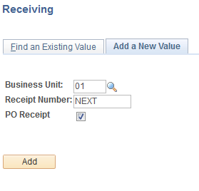

Entering the PO Number

- Enter the PO number in the ID field (if known). A PO number is ten characters, “P” followed by 9 digits. Click Search.
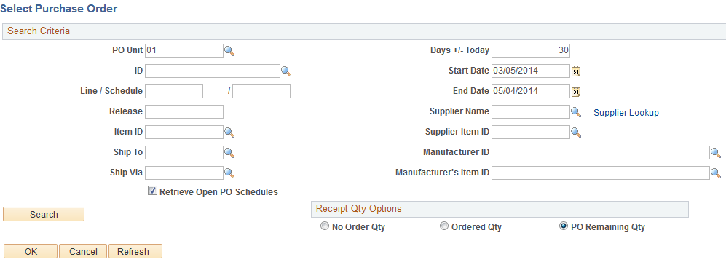
2

  - The items included in the purchase order will appear in a list below. Click the Select All box to select all items to be received.
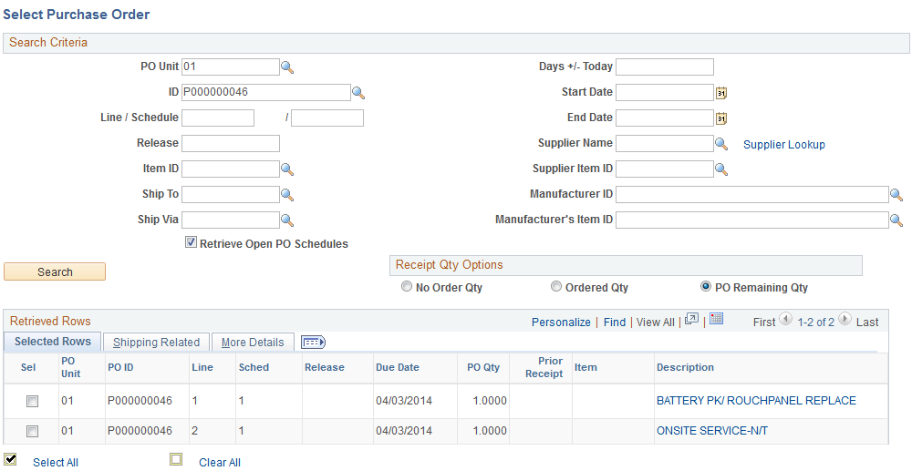
a

  - If you are not receiving all lines/items, click the Sel box on the items you want to receive.
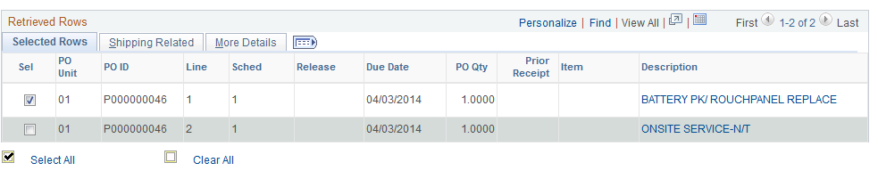
b

Searching for the PO Number

- If the PO # is unknown, click the Search button to display ALL POs with items to receive, not just the POs based on your requisitions. You can narrow the search by Date or Supplier.
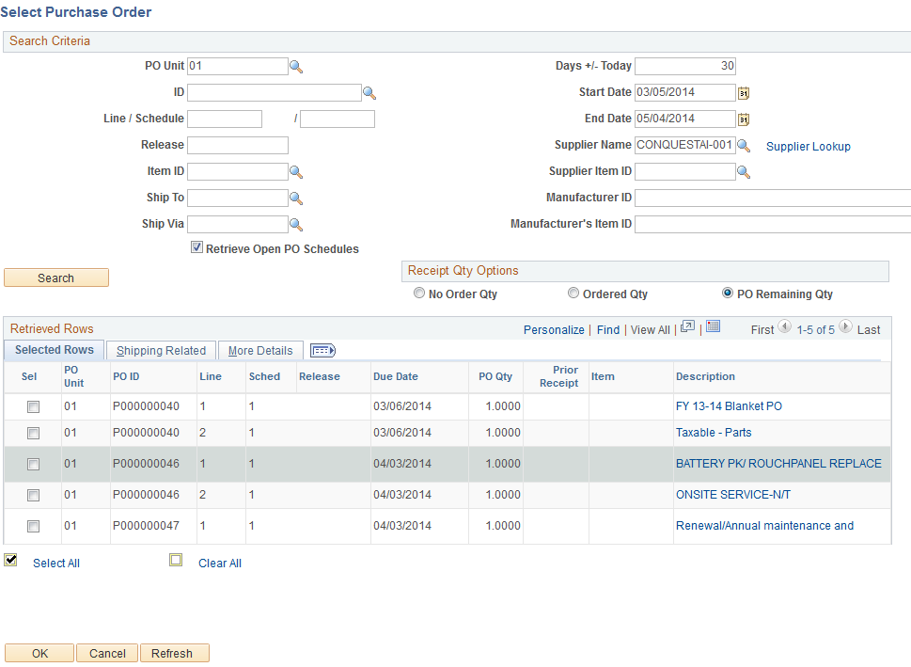
3
  - Click the Sel box next to the PO ID of item(s) you want to receive. And click OK.
a
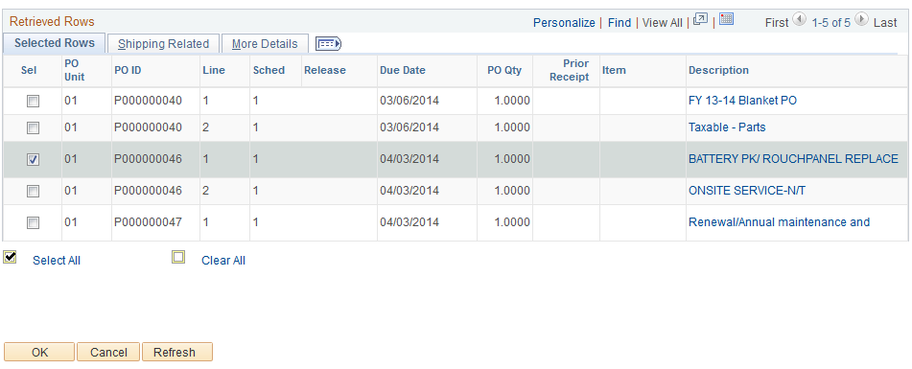

Changing the Receipt Date to a Prior Date

- If you are receiving an item that arrived PRIOR to the date you are entering the date in PeopleSoft – click on the Header Details link to open the window.

  - Update the Receipt Date to reflect the actual date received. NOTE: This is critical near fiscal year end to ensure that the payment is charged to the year in which the items were received. For month end it will assist in accrual. Click the “x” to close the box.
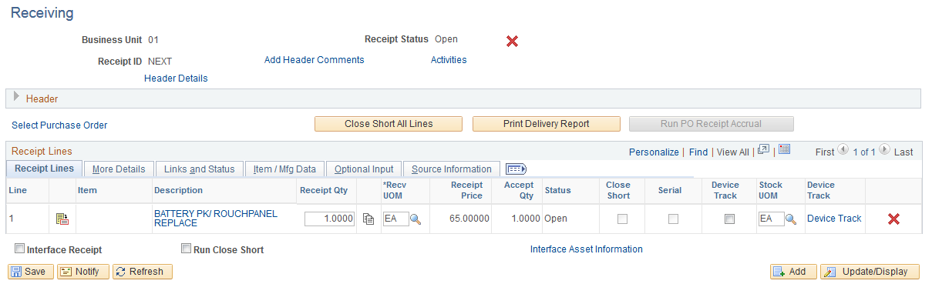
4
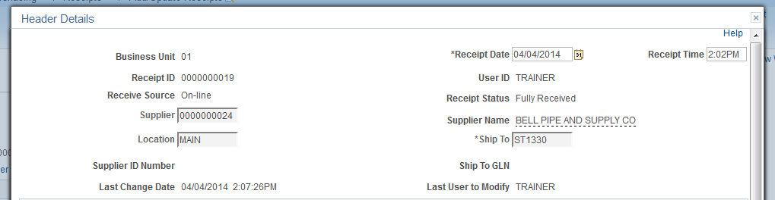
a

Entering Quantity Received – Regular PO

- For regular requisitions enter the quantity received (system defaults to amount ordered and not yet received). NOTE: Status is Open.

- Click Save.

b
a

- Status is now Received. NOTE: Receipt Status at top of screen is Fully Received.
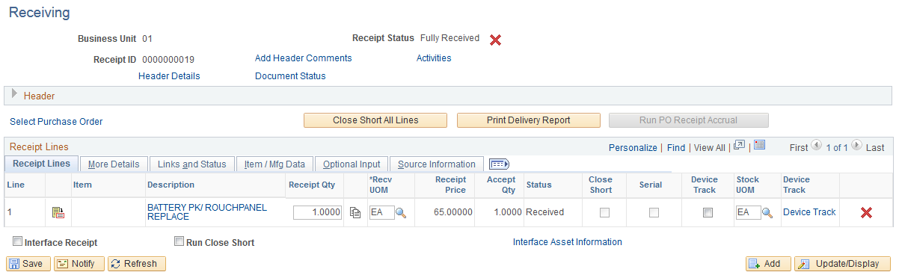
4

Entering Quantity Received – Blanket PO

The process for receiving Blanket POs is slightly different from regular POs. Follow steps 1 through 4 to select the Blanket PO and update received date if necessary. Here is a screen print of selecting a Blanket PO.

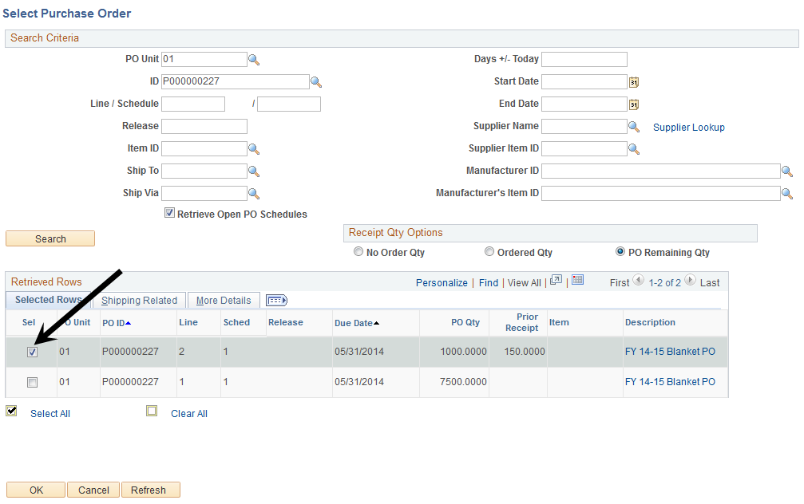

    - Blanket POs are received by the dollar amount. However, it is the Receipt Qty field you will update. Enter invoice subtotal in the Receipt Qty field.

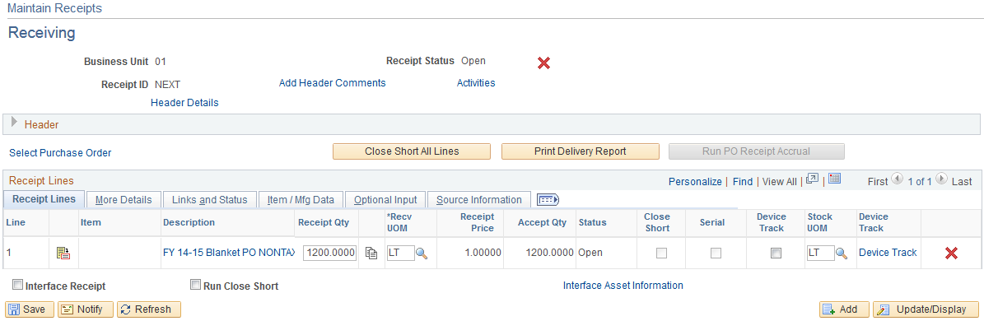
1

    - Review the invoice. You will receive the SUB TOTAL amount reflected on the invoice. Remember: You do not add tax and shipping at the requisition level, so you do not need to receive tax and shipping. EXAMPLE: Receive $725.00 of the total amount of the Blanket PO.

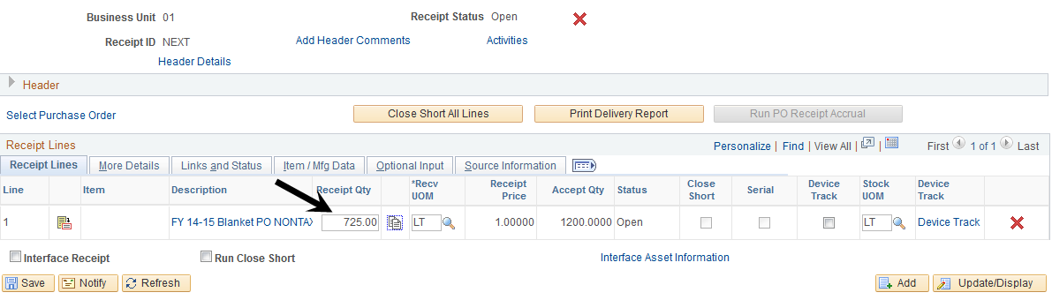
2

    - Click Save to update the receipt. The Receipt Status will change to “Fully Received”. The system has “fully received” the amount of THIS invoice.

Note: The system may show a warning message indicating the line is xxx days early after you click the Save button. Click OK and proceed.

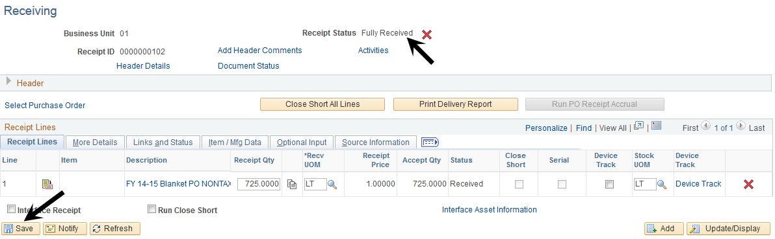
3

    - As you receive future invoices, you will repeat Blanket PO Receiving Steps 1 – 3 and update the Receipt Price. When searching for POs to receive, the search window will show a portion of the Blanket has already been received. The screen shot below is an example of a Blanket PO where two invoices have been “received”.

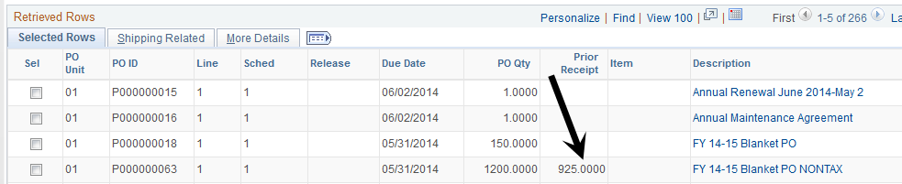
4

Entering Optional Input – Vendor Invoice Number

The receiving page allows you to save the invoice number with the receipt for reference. Click on the Optional Input tab. Field are available to enter the Invoice Number, Packing Slip, Lading and Pro Number for reference.

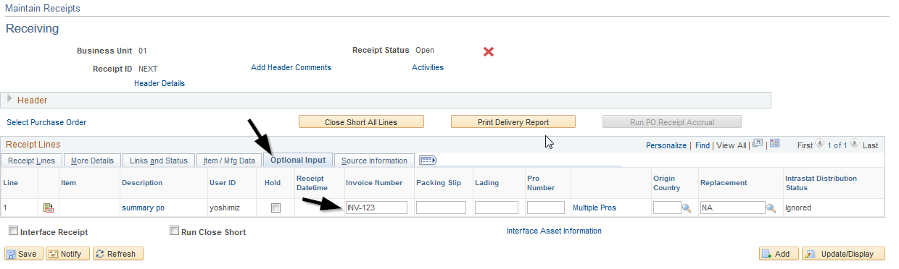

Viewing Prior Receipts

      - To review prior amounts received, search on the PO number. All receipts against that PO will appear. Click the Find an Existing Value tab.
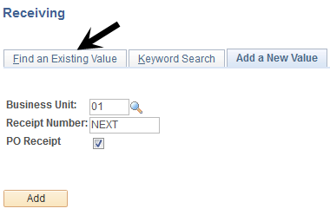

      - Enter the PO # (you can use the Wild Card key % to replace 0s) and click Search. A list of prior receipts appears. Click on one to see the receipt details.
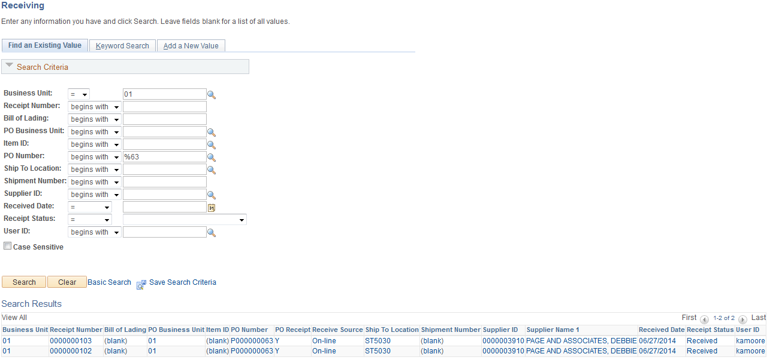

3. Click on the smallest Receipt Number to retrieve the first invoice received. You can compare this information to the initial invoice. Click on Previous in List to look at additional receipts.

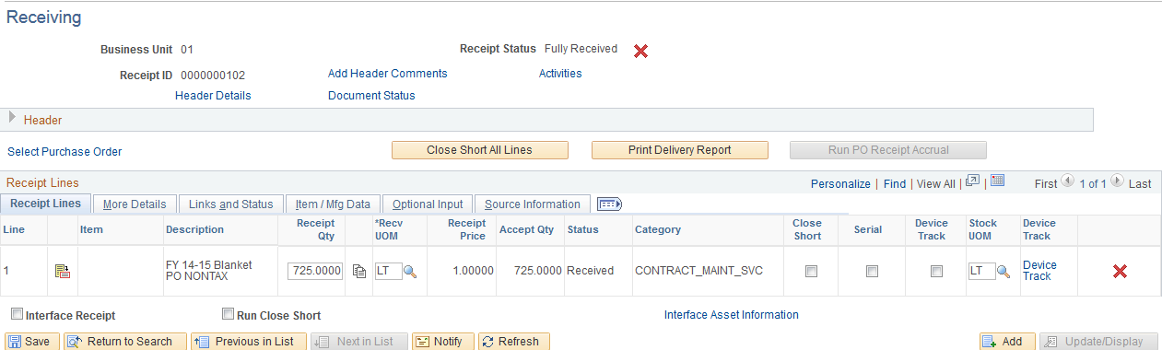

Cancel a Receipt

- The “red X” allows you to cancel the receipt. Simply click either to delete the receipt.

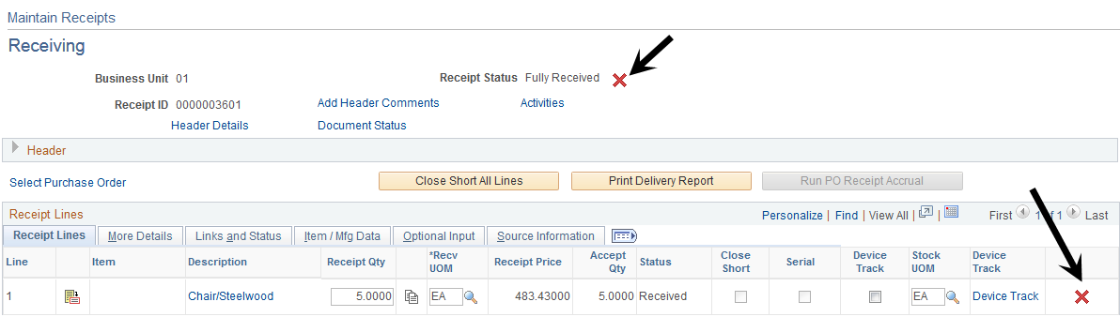

You will receive a warning message – click Yes to cancel or No to stop the cancellation.

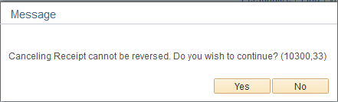

Notification of Missing Receipt – Match Exception Email

Purchase orders must be received in PeopleSoft for Accounts Payable to create a voucher and print a check. If the necessary receiving does not occur in a timely manner, PeopleSoft will generate an email every time a match exception is caused by the lack of receiving.
Sample Email
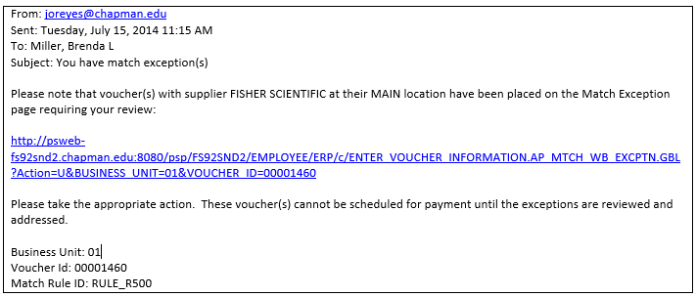
1
2
- Click the link in the email and sign into PeopleSoft to view the match exception details to find the PO number. Depending on your security roles, the link may not work.
- You can also find the PO number by using the voucher inquiry pages to view the voucher. The voucher ID is located at the bottom of the email.
  - Voucher Inquiry Navigation: Main Menu/Accounts Payable/Review Accounts Payable Info/Vouchers/Voucher, search for the voucher, click on the Actions at the bottom of the page -Voucher Details to see the PO Number
  - Note: Match Rule ID: RULE_500 is a system generated ID indicating the receipt is missing.
- Make note of the PO Number and follow the steps for receiving in this Guide.
  - See PO number options below from the Match Exception Workbench with access to the hyperlink on the email

PO Number from Match Exception Workbench
Available if you have security role for this page
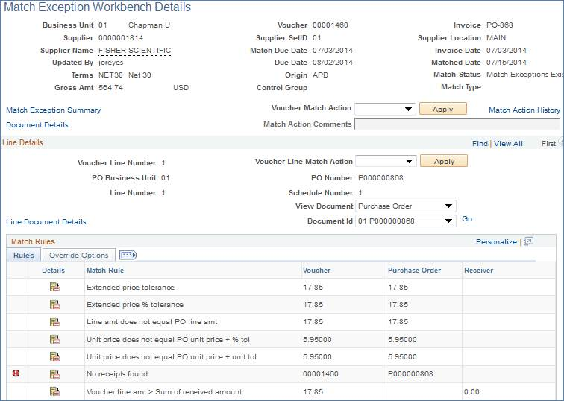
3

PO Number from Voucher Inquiry Page
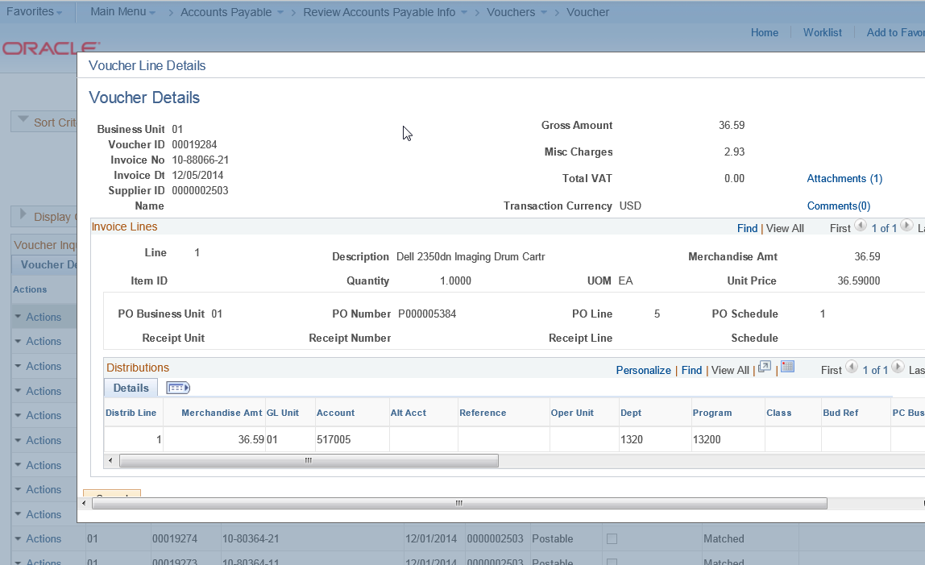
3

