Payment Request Center
End User Status Page & create new Payment Request 2
Payment Request Center Page 2
Summary Information Tab 3
Supplier Information Tab 4
Invoice Details Tab – Example A – all lines have the same taxability 5
Invoice Details Tab – Example B – invoice lines have taxable and non-taxable amounts 7
Review & Submit Tab 9
Voucher Status and Tracking 10
Tracking the Voucher 10
Voucher Processing Issues 10
Approval Emails 10

End User Status Page & create new Payment Request

Payment Request will take the place of the manual Non-PO Payment request pdf form.
- The Payment request page will track all requests and you can see when a voucher is created
- Once a voucher is created, you can use the voucher inquiry pages to track the progress of the voucher
- If the payee is a Chapman employee please contact AP or Payroll to determine how to process the reimbursement/payment.
- You will need to scan and attach invoices to the payment request
- If the supplier is not setup in the system, you will need to follow the current process to request new supplier setup before you can proceed

Payment Request Center Page
- Create new Payment Request – click on the Create button

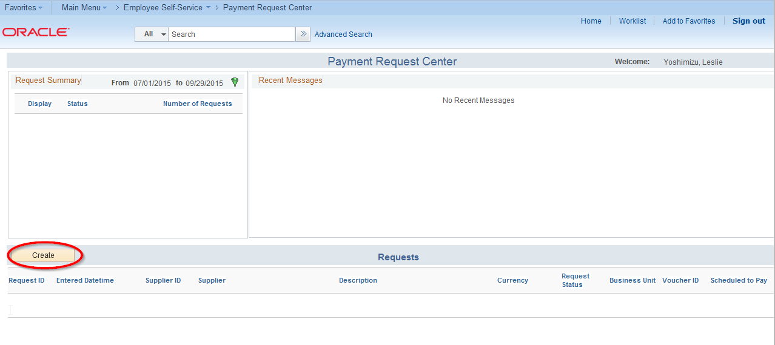

Summary Information Tab
- Enter the invoice date & number
  - If the vendor did not provide an invoice number please use the invoice number creation guidelines below
- Enter a description
- Enter amounts, note tax, freight & Misc charges must be entered in the appropriate field
- Attachments are required – invoice must be attached
- Notes/Comments – this field is used for AP handing instructions, please do not enter miscellaneous comments.
  - Please review the questions & change to YES if applicable. Enter extension number if pickup is required

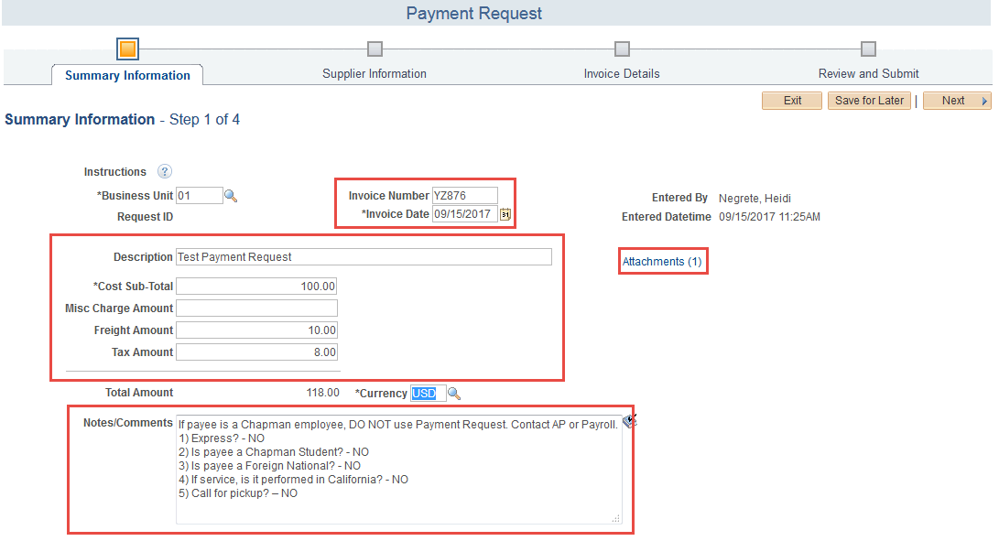
Invoice number creation guidelines
Used when the vendor does not provide an invoice number
- Date conversion format
      - Month – 1 digits for months 1-9, 2 digits for months 10-12
      - Day – 2 digits
      - Year – 2 digits
    - Single date of service example
      - Michael Brown 2/12/2017 service date. Invoice number = MB21217
      - World Affairs Council of Orange County 2/22/17 service date. Invoice number = WACOC22217
    - Multiple date of service (travel) example
      - Michael Brown 2/1/2017 thru 2/12/2017. Invoice number = MB2011217

Supplier Information Tab

- On the supplier information tab, enter the partial supplier name in the Supplier Name field & click Search
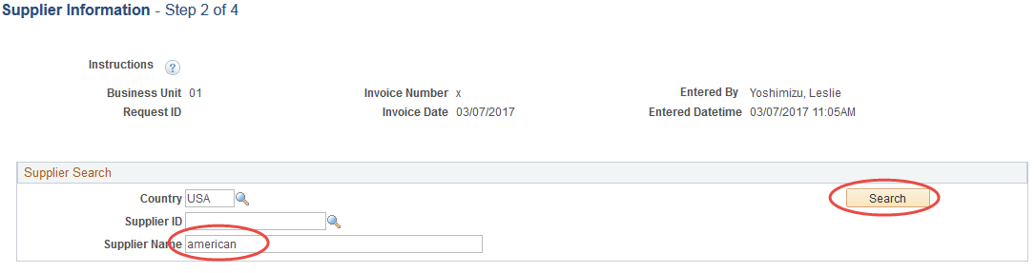

- A list of suppliers meeting the criteria will display
- Select the supplier by clicking the radio button
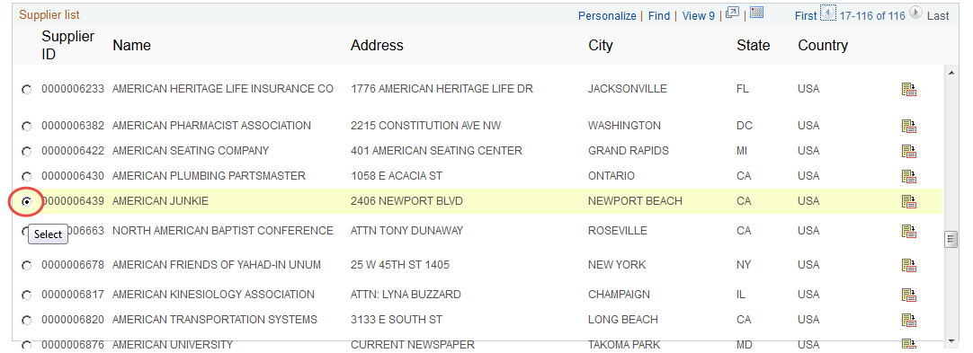

- The supplier information will display in the Supplier Address
- Note that the remit to address may not match the invoice. AP staff verifies and updates as required once the payment request become a voucher
- Click Next to proceed to the next page
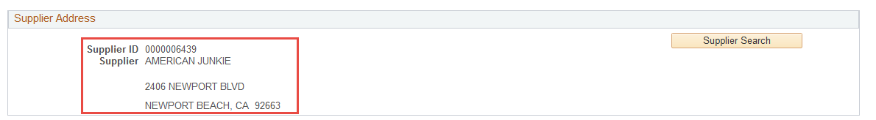

Invoice Details Tab – Example A – all lines have the same taxability
- Click on the Add Lines button to enter chartfield information
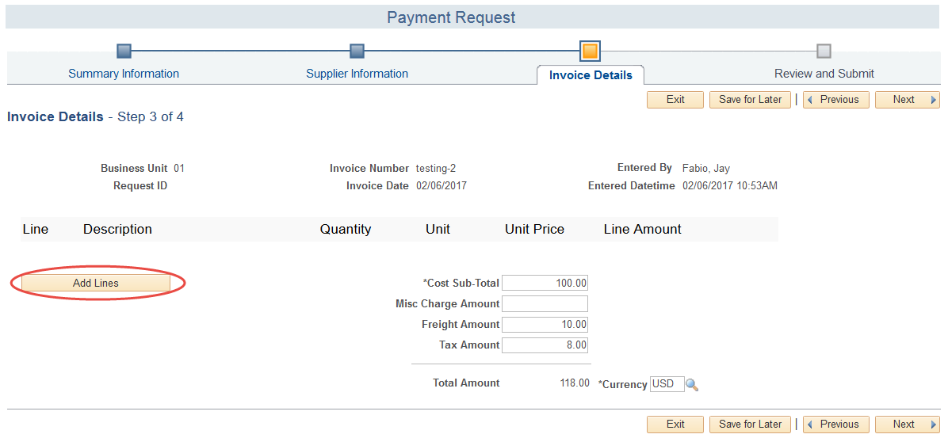
- Enter the chart-field information for the Merchandise Cost Sub-Total (exclude tax, freight, misc charges). Click the Add Lines button.
- All fields marked with an * are required
- The Description field is not a required field, but this field will display on the manager approval page. It is recommended that this field is not left blank.
- Accounting Details section required fields are Account, Fund, Dept, Program are required. GL Business Unit and Amount will default. Project Bus Unit, Project and Class are optional fields.
- +/- is available to breakout the lines into separate distributions

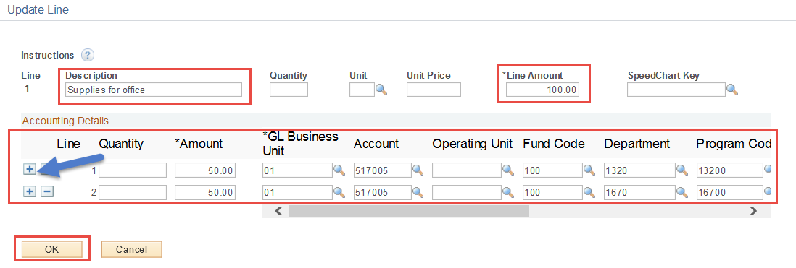

- The line total amount will display
- Click Next
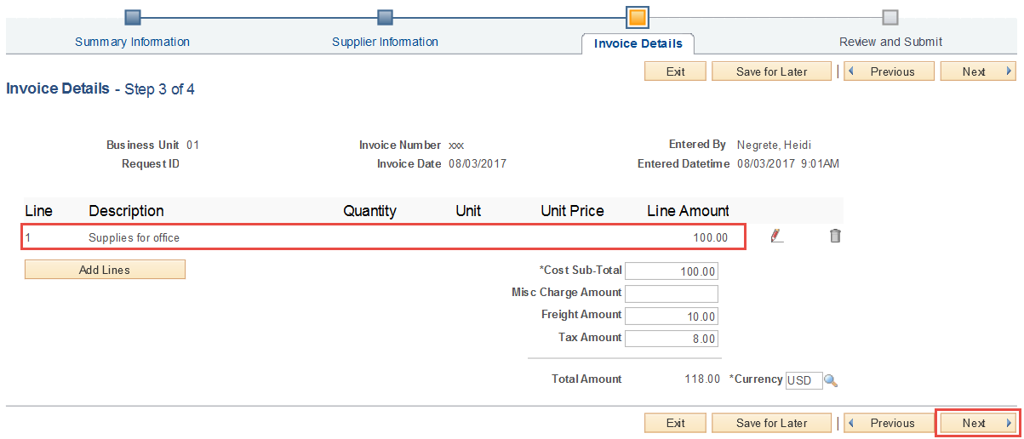

Invoice Details Tab – Example B – invoice lines have taxable and non-taxable amounts
- Click on the Add Lines button to enter chartfield information

- Enter the chart-field information for the Merchandise Cost Sub-Total (exclude tax, freight, misc charges)
- All fields marked with an * are required
- Enter description TAXABLE xxxxxxxxxxxxxxxx
- Accounting Details section required fields are Account, Fund, Dept, Program are required. GL Business Unit and Amount will default. Project Bus Unit, Project and Class are optional fields.
- +/- is available to breakout the lines into separate distributions

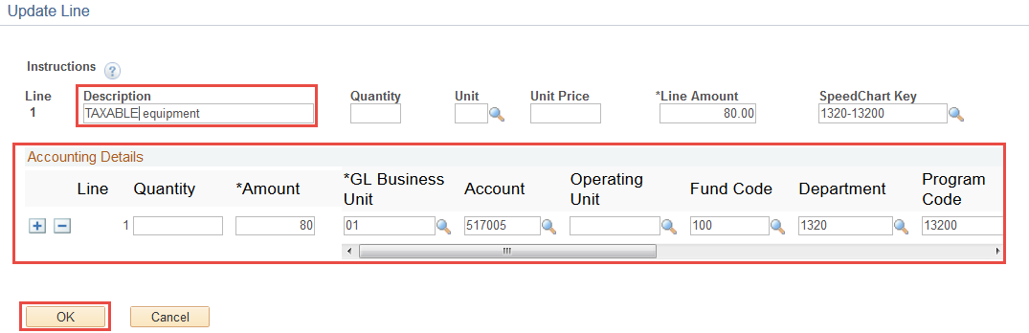

- The line amount entered will display
- Click Add Lines button to add the NON-TAX line
- Repeat above and specify NON-TAX xxxxxxxxxxxxx in the description

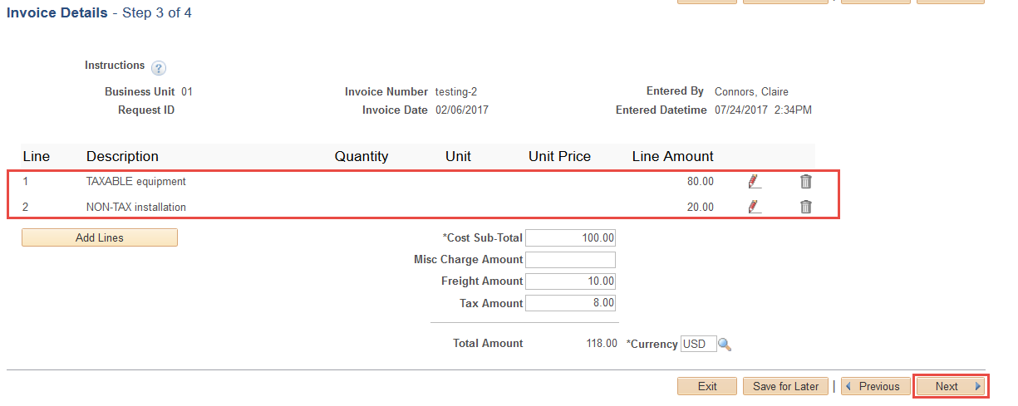

- Click Next to continue

Review & Submit Tab
- Review & Submit the invoice
- View status on Payment Request homepage
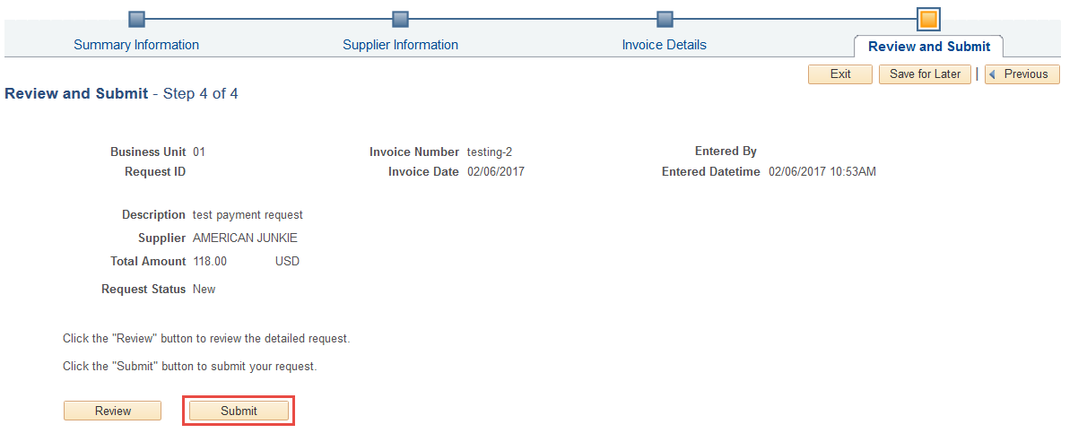

- Payment Request Center homepage will show the status of the request
  - The voucher number is shown once the Payment Request has been processed into a voucher.
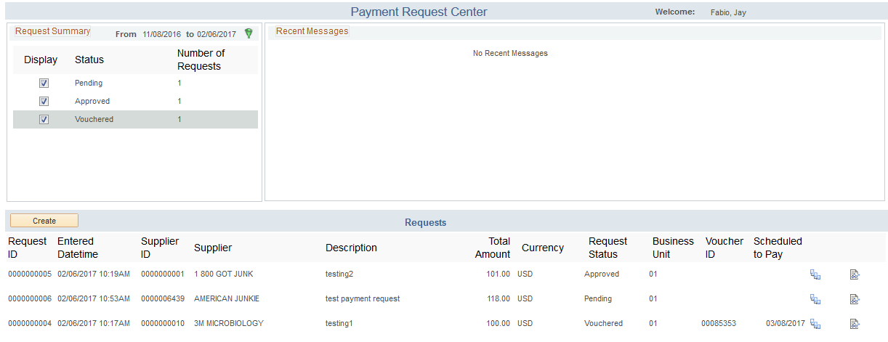

Voucher Status and Tracking

Tracking the Voucher
Once the voucher is created, the voucher will follow the standard workflow approval and posting process. Voucher review is done using the navigation Main Menu/AccountsPayable/Review Accounts Payable Info/Vouchers/Voucher

Voucher Processing Issues
During the voucher processing stage various errors can occur as they do today with the Non-PO Payment Request form. Some examples are budget blocks and workflow Deny or Sendback. These types of processing issues are handled manually and are not linked back to the payment request at this time to generate an automated email. The AP department will following the current process and contact the end user with any processing issues.

Approval Emails
Note the system send out an approval email when the Payment Request is approved to be processed into a voucher. Once the voucher is created, the voucher will follow the regular business process for budget checking and workflow approvals. This can take anywhere from 1 to several days. Upon approval, the Payment Request originator does not receive an email.
Voucher tracking is available using the voucher inquiry screens. Main Menu/Accounts Payable/Review Accounts Payable Info/Vouchers/Voucher

