Using the Assigned Remote Work (ARW) Form
Navigation 1
Landing Page 2
Adding a form 4
Change/Update/Withdraw a Submitted Unapproved Form 5
View forms 5
Approve Forms 6

Navigation

The Assigned Remote Work (ARW) form can be found on the Employee/Manager Self-Service page
Working@Chapman – Your One-Stop Employee Resource Center

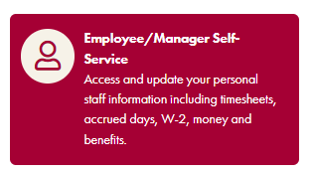
Non-supervisory employees land on the Employee Self Service Homepage where one can find the eForms tile
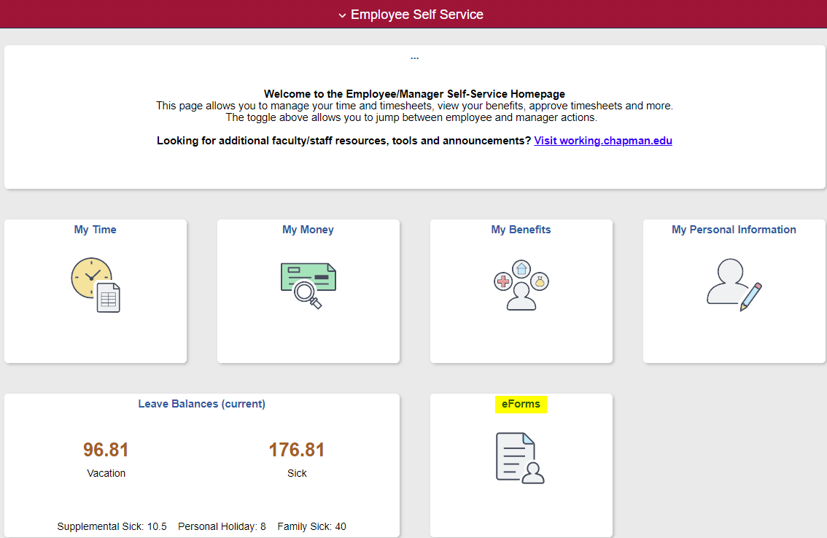

Managers who land on the Manager Self-Service page should click on the Manager Self Service drop down menu at the top to select the eForms Homepage
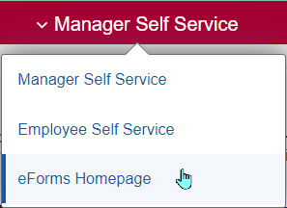
Click on the ARW tile.
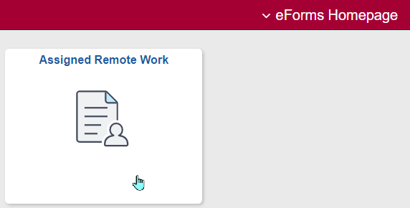

Assigned Remote Work Landing Page
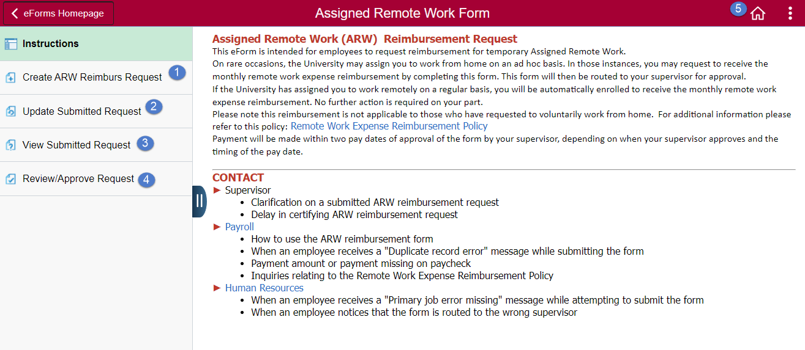

The landing page displays the general instructions and key contacts
- Create ARW Reimburs Request – Add a new request form
- Update Sumbitted Request – Update your existing request form
- View Submitted Request – View your existing request forms and managers can view requests submitted by their direct reports
- Review/Approve Request – Approve request forms route to manager
- Home – Select the Home button to return to the Manager Self Service page

Adding a form
- Click on Create ARW Reimburs Request
- The employee ID, Name and Supervisor will display on the Employee Information section. The form will route to the supervisor listed for approval
- Select the period the remote work occurred. A separate form is required for each month remote work occurred.
- Provide the details explaining the remote work assignment
- Click the Submit button
- The Results window will display a confirmation page
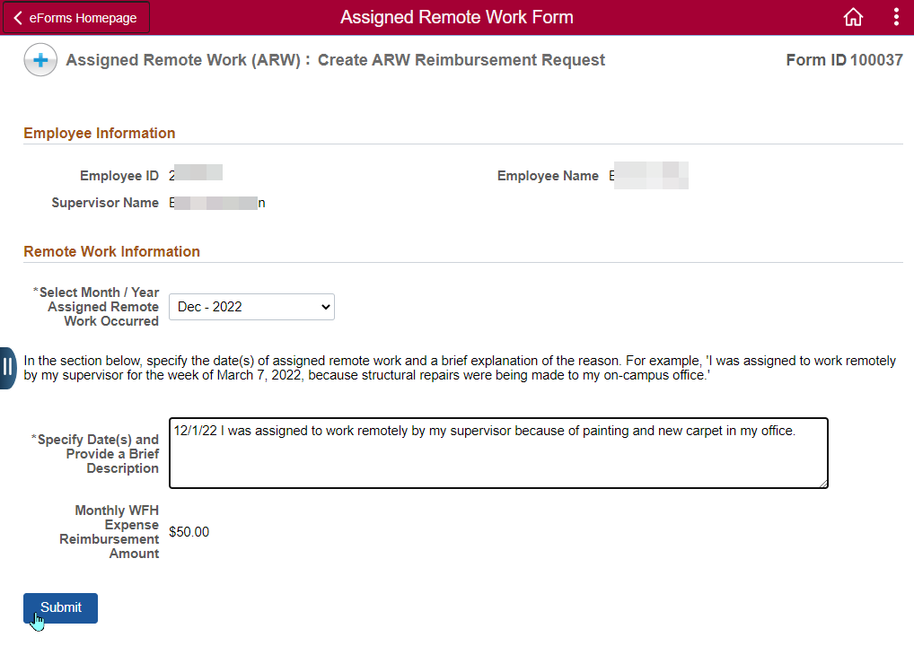
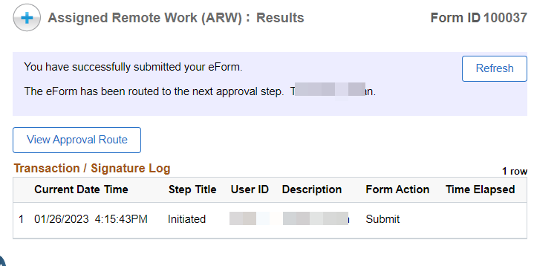

Change/Update/Withdraw a Submitted Unapproved Form
- Click on Update a Submitted Request
- Click Search or enter additional search criteria to narrow down the results
- Select the form
- Make the appropriate changes and click Resubmit or click Withdraw to withdraw the request
- The Results window will display a confirmation page

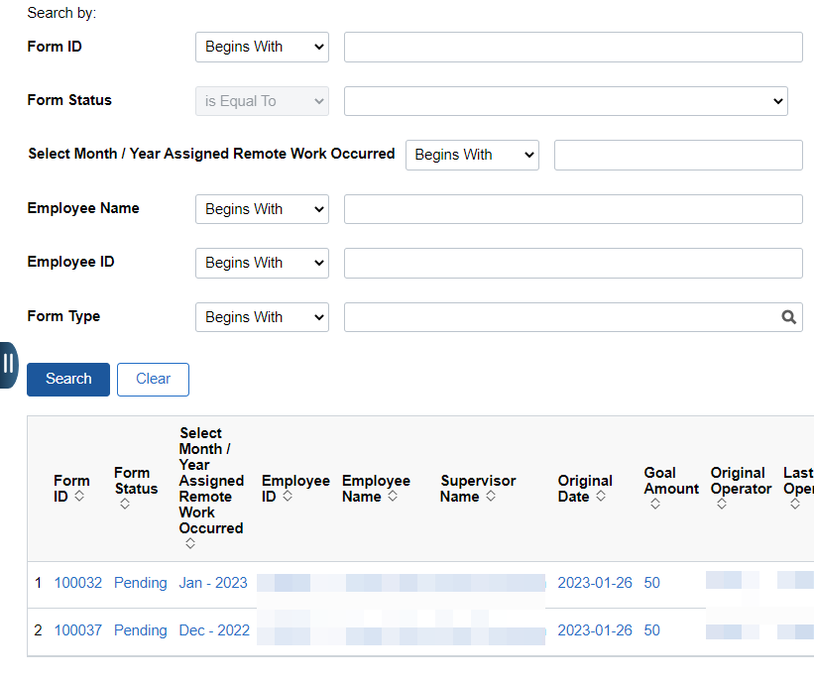

View forms
- Click on View Submitted Request
- This page displays forms in all statuses created by you and forms created by your direct reports
- Click Search or enter additional search criteria to narrow down the results

Approve Forms
- Click on Review/Approve Request
- Click Search or enter additional search criteria to narrow down the results
- Select the form
- Review the information
- Enter Supervisor Comments (optional) but highly recommended for Deny and Pushback
- Choose one of the following options
  - Deny – denies the form and user is no longer able to resubmit the form
  - Pushback – sends the form back to user for additional information and the ability to resubmit the form
  - Hold – holds the form in the manager/supervisor’s queue
  - Approve – approves the form for payroll processing and payment on the next payrun
- The Results window will display a confirmation page
