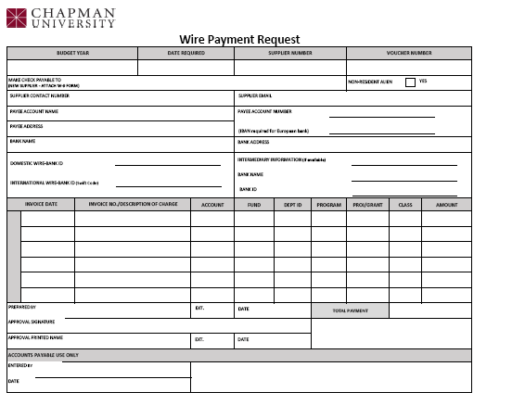
Wire Payment Requests are used for ACH requests only

Header fields
Budget Year | The fiscal year of the expense. For 2014-15, the budget year will be 2014. It is always the first year listed.
Date Check Required | The date the check needs to be mailed or picked up.
Supplier Number | Used by Accounts Payable only
Voucher Number | Used by Accounts Payable only
Make Wire Payable To | The name of the vendor or supplier. If this is a new vendor/supplier, please attach the Chapman University Substitute W-9 Supplier Information Form.
Nonresident Alien | Check this box if the payee is a nonresident alien. A nonresident alien is any person who is not a U.S. citizen; a lawful permanent resident (green card holder), or able to pass the Substantial Presence Test.
Supplier Contact Number | A phone number for the supplier in case there are any questions about this request.
Supplier Email | An email address for the supplier in case there are any questions about this request.
Payee Account Name | The name of the beneficiary on the bank account

Payee Account Number | The beneficiary bank account number if the bank where the wire is to be sent is in the US.  For a European bank, use the IBAN which contains long alpha and numeric characters.
Payee Address | The address of the beneficiary.
Bank Name | The name of the bank where the wire is to be sent.
Bank Address | The address of the bank
Domestic Wire Bank ID  International Wire – Bank ID (Swift Code) | The bank’s nine digit routing number if the bank where the wire is to be sent is in the U.S.  The Swift Code contains both alpha and numeric characters and can be obtained from the beneficiary bank
Intermediary Information | This is only for international wires and provides the information about the middle bank. If available, enter the middle bank’s name and routing number.

Item Fields
This section is divided into two sections, one for charges and one for credits.
Inv. Date | The date of the invoice or date of service. If not known, use today’s date.
Invoice No./Description | The invoice number if available and a brief description of the charge/credit.
The following fields indicate the where the item is to be charged or credited.

Account | Six digit field indicating the line item to be charged.
Fund | Three digit field indicating the source of funds being used.
Department | Four digit field indicating the department being charged
Program | Five digit field indicating what portion of the department is being charged.
Proj/Grant | Six digit field indicating the grant or capital project being charged.
Class | Optional four digit field used by the department for tracking items such as an event, film project or faculty grant.
Amount | The dollar amount for this item.

Footer fields
Total Payment | The total of the itemized items above.
Prepared by | The name of the person preparing the request, their extension and the date.
Approval Signature | The signature of the person approving the request.
Approver Printed Name | The name of the person whose signature appears above, their extension and date.
Special Instructions | Enter any special instructions or additional explanations in this box.

