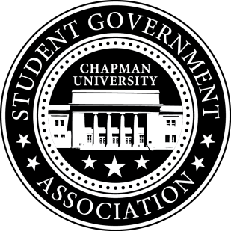
Senate Minutes | Feb. 8, 2013

- Call to Order
  - Roll Call
    - Excused: Lizardo, Summers, Thompson, Rabago
  - Approval of Minutes
    - Motion to approve by Zach Rice
    - Second by Chris Im
    - Unanimous approval
  - Approval of Agenda
    - Motion to approve by Kyle Chattleton
    - Second by Chris Im
    - Unanimous approval

- Committee Reports
  - Student Life Committee
    - Pizano working on vans from residence halls, Philip working on wireless printing in the dorms
  - Campus Inclusion Committee
    - Horna speaking with Psi Chi and Active Minds to bring speaker to campus- Chattleton working with Student and Campus Life and Black Student Union
  - Academic Affairs Committee
    - Osgouei working to bring ASBE groups together- Smith working on improving Finals schedule
  - Allocations Committee

- Old Business
  - Delta Tau Delta - Student Org Conference Scholarship
    - Motion to approve $1440 by Anthony Jacobsmeyer
    - Second by Chris Im
    - Approve: 15, Opposed: 1, Abstain: 1

- New Business
  - Snow Club
    - Motion to approve $2000 by Chris Im
    - Second by Zach Rice
    - Approve: 17, Opposed: 0, Abstain: 1
  - American Medical Student Association
    - Motion to approve $500 by Kyle Chattleton
    - Second by Anthony Jacobsmeyer
    - Approve: 12, Opposed: 1, Abstain: 4
  - Chapman Men's Crew
    - Motion to approve $0 by Brandon Tracey
    - Second by Chris Im
    - Approve: 16, Opposed: 0, Abstain: 2
  - Chapman on Broadway
    - Motion to approve $1314.62 by Brandon Tracey
    - Second by Sally Horna
    - Approve: 16, Opposed: 0, Abstain: 1
  - John Demshki- Outlets on the AF Walkway
  - Chris Im- proposed Trolley Route

- Open Forum

- Announcements
Fall in Love with Reading Campaign to promote Colligate Readership Program

- Adjournment
  - Motion to adjourn by Kyle Chattleton
  - Second by Zach Rice
  - Unanimous Approval

