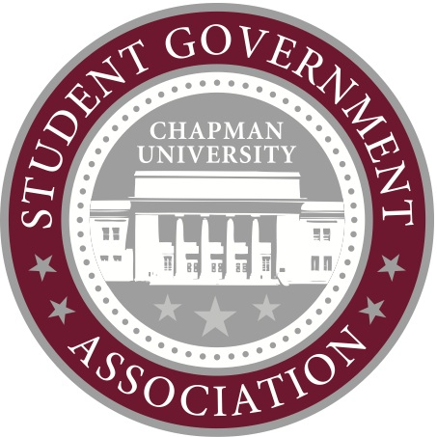Contact:

Ashley Kaplan

Director of Public Relations

[sgapr@chapman.edu](mailto:sgapr@chapman.edu)

Chad Rabago

Director of Elections

[sgaelections@chapman.edu](mailto:sgaelections@chapman.edu)

FOR IMMEADIATE RELEASE

Orange, Calif. – Chapman University Student Government Association is excited to welcome the new president and vice president for the 2015-2016 academic year.

Students voted the first week of March with a total voter turnout of 18.31 percent. The SGA presidential candidates included Josh Nudelman and, write-in candidate, Gagan Sandhu. Vice presidential candidates were Jaycie Rowe and Ryan Rodriguez. Nudelman received 55 percent of the votes, winning him the presidential race. Rowe received 54 percent, placing her as the new vice president. The two new executive members ran on a ticket together, but students could vote for them separately.

Both newly elected officers have previous SGA experience serving as senators. Rowe is currently the Allocations Committee Chair and Nudelman serves of various outside committees on campus.

John Demshki and Kelsey Dalzell will join Nudelman and Rowe to complete the executive council. Demshki will be returning as the director of finance for a second year. Dalzell, a current senator, will step into the role of director of public relations. Nudelman and Rowe also appointed Kendall DeVries as the director of elections. DeVries is the current freshman class senator.

For additional information, please contact Director of Elections, Chad Rabago, or Director of Public Relations, Ashley Kaplan.

###

Student Government Association is the most influential leadership organization on campus. Our mission is to advocate for student’s rights, make a positive change on campus and improve your Chapman experience.