Hazardous Communication Program

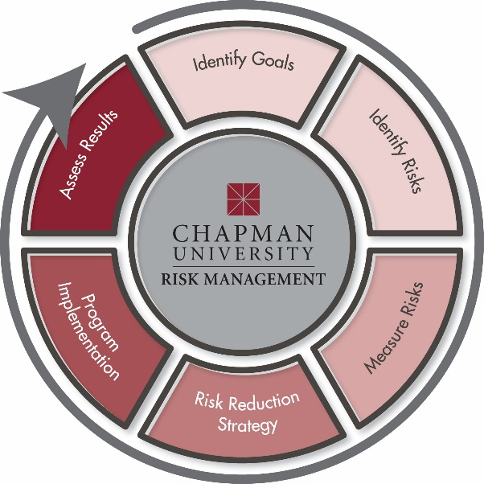

Chapman University Environmental Health & Safety – (714) 628-2888
Chapman University Risk Management – (714) 532-7794
Chapman University Fire Safety - (714) 744-7875
Chapman University Public Safety – (714) 997-6763

Table of Contents
1.0 PURPOSE 3
2.0 APPLICABILITY AND SCOPE 3
3.0 REGULATIONS AND STANDARDS 3
4.0 DEFINITIONS 4
5.0 RESPONSIBILITIES 4
5.1 Chapman University Responsibilities 4
5.2 Manager/Supervisor Responsibilities 5
5.3 University Personnel Responsibilities 5
6.0 ACCESS TO THE WRITTEN PROGRAM 6
7.0 TRAINING COMPONENTS 6
7.1 Training 6
7.2 Hazard Identification, Reduction and Controls 6
7.3 Globaly Harmonized System, Safety Data Sheets 7
7.4 Labels 8
7.5 Globally Harmonized System (Pictograms) 9
7.6 Emergency Response Awareness 9
7.7 Record Keeping 9
8.0 PROGRAM APPROVAL AND REVIEW 10
Appendix: Hazardous Communication Program Related Documents and Sources ...………11
Hazard Communication Program Training Log …………………………………………….12

Chapman University Hazardous Communication Program

1.0 PURPOSE AND POLICY
Chapman University has developed this Hazard Communication Program to augment our standard safety procedures so as to enhance our concern for employees' health and safety. By law, workers have the right to know what hazards/ toxic substances are present in the workplace and how to protect themselves, this is also known as the Right-to-Know law. Thus, the purpose of the Hazardous Communication Program is to provide Chapman University personnel, students, and volunteers with information about the hazardous chemicals that they are working with and to provide guidance on how to work safely when using these materials. This program includes safety warnings and labeling requirements. In addition, the required materials shall be distributed to any employee that are, or will be, working with hazardous chemicals.
This program will be evaluated yearly to ensure the intent of the program is followed and the program is effective.

2.0 APPLICABILITY AND SCOPE
This program applies to all Chapman University personnel, students, volunteers, and employees who are or will be working in environments that contain hazardous chemicals.

REGULATIONS AND STANDARDS
California Code of Regulations, Title 8 Section 5194 (https://www.dir.ca.gov/title8/5194.html)

Related Standards and Guidelines:
- The Hazardous Substances List (CCR, Title 8, §339)
- Hazard Communication Standard (HCS) (29 CFR 1910.1200(g))
- Toxic and Hazardous Substances List (29 CFR, Part 1910, Subpart Z)
- California Air Contaminates List (CCR, Title 7, §5155)
- Threshold Limit Values for Chemical Substances and Physical Agents in the Work Environment, American Conference of Governmental
- Industrial Hygienist
- National Toxicology Program, Annual Report on Carcinogens
- International Agency for Research on Cancer Monographs
- Safety Data Sheets (SDSs) of reproductive toxicants or cancer-producing substances
- Chemicals Known to the State of California to Cause Cancer or Reproductive Toxicity (Prop 65 – CCR, Title 22, §12000)
- Any other chemicals or materials that present a personal hazard

4.0 DEFINITIONS
Administrative controls: methods in which the exposure of a hazard is limited or reduced by modifying the process in which a certain task is performed. Implementing written safety policies, rules, supervision, schedules, and training will attain the goal of reducing the duration, frequency, and severity of exposure to hazardous chemicals or situations.
Employee: a research staff member, technician, or student worker working with hazardous materials or chemicals, employed by the University and in a position reporting to a designated supervisor.

Engineering controls: methods that are built into the design of a plant, equipment or process to minimize the hazard.
Personal Protective Equipment (PPE): is equipment worn to minimize exposure to a variety of hazards.
Student: a University student and is herein defined to include any person enrolled in a research or other university course, receiving academic credit for participation in laboratory operations, or otherwise providing support in an environment that involves working with or near chemical hazards, under the direction of the University, who is not otherwise remunerated in connection with such services.

Supervisor: a University principal investigator, lab manager, senior researcher, administrative officer, or associate in charge of a laboratory, school unit, operation, or clinic where hazardous materials are used and/or stored.
Volunteer: an individual that provides services related to hazardous materials use to the University without remuneration or compensation. This may include research assistants.

5.0 RESPONSIBILITIES

5.1 Chapman University Responsibilities
It is the responsibility of Chapman University, through the Environmental Health and Safety office, to:
- Institute and maintain the Hazardous Communication Program
- Review the program annually and notify constituents of any changes
- Assist in identifying operational hazards/ hazardous chemicals in the workplace
- Recommend appropriate engineering controls, administrative controls and PPE
- Assist with training needs and record keeping
- Maintain university-wide chemical inventory
- Ensure that Safety Data Sheets are easily accessible, up-to-date and available at all times
- Post Cal/OSHA notices informing university personnel formally of their right to see the following:
  - Their medical records and records of exposure to toxic substances or harmful physical agents
  - Provide information (Safety Data Sheets) for chemicals or substances used in the workplace, or to which employees may be exposed

5.2 Supervisor Responsibilities
Each member of management is responsible for understanding and assisting in the program's implementation. It is the responsibility of the department manager and supervisor to:
- Become familiar with the Hazardous Communication Program
- Identify hazardous chemicals/materials in the workplace
- Conduct annual chemical inventory
- Ensure that all hazardous materials are properly labeled and compliant
- Ensure that Safety Data Sheets (SDSs) are easily accessible and available
- Implement recommendations provided by EH&S Staff
- Minimize, or, eliminate hazardous exposures via engineering and administrative controls; this includes the use of personal protective equipment (PPE)
- Monitor workplace conditions, exposure and physical stress to minimize detrimental conditions of the user
- Providing training to employees on the hazards that they may be exposed to, including physical hazards, health hazards, safe handling procedures, and emergency procedures for hazardous materials
- Informing all personnel when introducing a hazardous material into a workplace

5.3 University Personnel Responsibilities
It is the responsibility of the university personnel to:
- Obtain and maintain training on hazardous communication; provided by Chapman University’s Environmental Health and Safety Office
- Obtain and maintain training on all other safety related topics before working with hazardous materials
- Follow the guidelines outlined in the Program
- Adhere to the information on hazardous materials, container labels, SDSs, departmental procedures and other identified safety concerns
- Follow recommendations given by EH&S, such as wearing the appropriate PPE
- Notify EH&S personnel and supervisor/ manager when hazardous conditions in the workplace changes or if any questions arise regarding hazardous communication
- ACCESS TO THE WRITTEN PROGRAM
This written Hazardous Communication Program is available to all University personnel and other users and their representatives. Copies of this program are available from EH&S.

TRAINING COMPONENTS

7.1 Training
Training is mandatory for any university personnel, employee, student, and volunteer who is working in an environment in which hazardous chemicals and materials are present. Training shall be conducted initially and thereafter on an annual basis or when there are changes in job tasks that create additional hazards for the worker. In conjunction with familiarization of the written Program, workers are required to complete the online Hazardous Communication Training course administered by Risk Management/ EH&S. If you have any questions about how to receive the appropriate online training, contact the Risk Management Office.
The Hazardous Communication Program includes, but is not limited to:
- Departmental operations where hazardous materials are present
- Accessibility of Hazard Communication Program
- Hazardous materials/chemical awareness and identification
- Hazard reduction and control
- Safety Data Sheets (SDS)
- Globally Harmonized System (GHS)
- Container and labeling requirements
- Emergency response awareness

7.2 Hazard Identification, Reduction, and Controls
- Managers and supervisors shall assess the workplace to determine the types of hazards/ hazardous materials that are present. This will dictate what precautions shall be taken in order to reduce the risk for exposure.
- The goal is to eliminate the hazard. If this is not possible, try substituting the hazardous material for something less hazardous. For example, substituting an oil-based paint for one
that is less hazardous for the environment.
- When hazards cannot be eliminated or reduced below acceptable exposure limits, engineering controls shall be implemented. For example, an engineering control would be the use of laboratory fume hood to draw airborne contaminants away from a worker’s breathing zone.
- If the hazard cannot be reduced or eliminated via substitution or engineering controls, then administrative controls shall be implemented. An example of an administrative control would be task rotation for the purpose of reducing one’s exposure to hazardous materials.
- If engineering and administrative controls are not feasible, then the use of PPE is required. PPE is the last line of defense against workplace hazards. An example of PPE would be wearing a lab coat, gloves, goggles, face shield, air purifying respirator, etc.

7.3 Globally Harmonized System (GHS)
The Globally Harmonized System (GHS) is a universal system that is used for classifying chemicals according to their health, physical, and environmental hazards. It makes it easier to interpret labels from American & foreign manufacturers. GHS includes: Safety Data Sheets (SDS), hazardous pictograms, and labeling requirements

Safety Data Sheets (SDS)
The SDS includes information such as the properties of each chemical; the physical, health, and environmental health hazards; protective measures; and safety precautions for handling, storing, and transporting the chemical. The information contained in the SDS must be in English (although it may be in other languages) and contains the same content as the MSDS, except now the SDSs are required to be presented in a consistent user-friendly, 16-section format. SDSs shall be made available for each hazardous material in the workplace. The most current SDS supplied by the chemical manufacturer or distributor shall be kept on file, and made accessible to all employees, their representatives, and contractors for viewing or copying during each work shift. Paper or electronic copies of SDSs shall be maintained either in individual workspaces or centrally within the department.
Safety Data Sheets (SDS)
Section 1 | Identification
Section 2 | Hazards(s) Identification
Section 3 | Composition/Information on Ingredients
Section 4 | First-Aid Measures
Section 5 | Fire-Fighting Measures
Section 6 | Accidental Release Measures
Section 7 | Handling and Storage
Section 8 | Exposure Controls/Personal Protection
Section 9 | Physical and Chemical Properties
Section 10 | Stability and Reactivity
Section 11 | Toxicological Information
Section 12 | Ecological Information (non-mandatory)
Section 13 | Disposal Considerations (non-mandatory)
Section 14 | Transport Information (non-mandatory)
Section 15 | Regulatory Information (non-mandatory)
Section 16 | Other Information

EH&S offers an online resource for Chapman students, staff, and faculty to download SDSs for chemicals used or stored at (https://chimeracloud.org/sds/).
For more information: https://www.osha.gov/Publications/OSHA3514.html

7.4 Labels

Labels provide important safety information about the contents in the bottle such as the hazard associated with the material, proper personal protective equipment (PPE) required when working with the material and how to handle and store the material. Labels shall be legible, in English and prominently displayed on the container.

Primary (original) containers are the original containers that you receive from the manufacturer.

Primary container labels need to have six items:

Signal word- reflects the severity of the hazard

GHS symbols

Manufacturer information- Name, address, and telephone number of the chemical manufacturer or other responsible party

Precautionary statement/first aid- describes the various measures that should be taken to protect health and safety

Hazard statements- describe the nature of the chemical’s hazard(s)

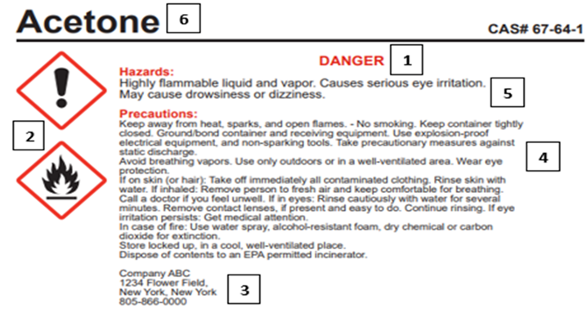
Product name or identifiers- trade, product, or chemical name

Secondary containers are the containers that contain chemicals that are transferred from a primary container (e.g. bottle). All secondary container labels need to include the full chemical name and need to include the GHS pictogram(s) associated with the hazardous material.

7.5 Globally Harmonized System (GHS) Pictograms

Flammable  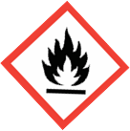 | 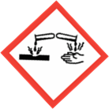  Corrosive | 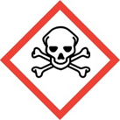  Toxic
Oxidizer | Health Hazard | Harmful/Irritant
Dangerous for the Environment | Explosive | Compressed Gas

7.6 Emergency Response Awareness
Do not attempt to clean up or mediate a spill unless authorized or certified to do so. Refer to the Chemical Hygiene plan for general guidelines regarding accidental hazardous spills and exposure control.

If a spill, accident, or incident occurs involving hazardous materials, immediately contact:

Public Safety: (714) 997-6763
Karen Swift, EH&S Manager: (714) 628-2888
Allan Brooks, Director of Risk Management: (714) 532-7794

7.7 Record Keeping
Record keeping will be monitored and managed closely by Risk Management/ EH&S staff as well as by the department of the worker’s employment. This includes:

  - Hazardous Communication Program
  - Training records
  - Chemical inventory
  - Job Safety Analysis
EH&S conducts evaluations of the workplace as necessary to ensure that the provisions of the current written program are being implemented and that it continues to be effective to ensure the safety of all University personnel.

8.0 PROGRAM APPROVAL AND REVIEW
EH&S approves and reviews the Program on an annual basis, and the most recent review and modification was completed as on May 1, 2021.

Appendix

Related Documents and Sources
- Chemical Hygiene Plan
  - https://www.chapman.edu/faculty-staff/environmental/_files/chapman-university-chemical-hygiene-plan.pdf
- Globally Harmonized System (GHS)
  - https://www.chapman.edu/faculty-staff/environmental/_files/globally-harmonized-system.pdf
- Guidelines for Chemical Storage
  - https://www.chapman.edu/faculty-staff/environmental/_files/guidelines-for-chemical-storage.pdf
- Safety Data Sheets Search
  - https://chimeracloud.org/sds/

Hazard Communication Program
Training Log

The Chapman University Hazard Communication Program has been reviewed with me, and I understand completely.

- Name: _______________________________ Signature: ____________________________
Date: ________________________________
- Name: _______________________________ Signature: ____________________________
Date: ________________________________
- Name: _______________________________ Signature: ____________________________
Date: ________________________________
- Name: _______________________________ Signature: ____________________________
Date: ________________________________
- Name: _______________________________ Signature: ____________________________
Date: ________________________________
- Name: _______________________________ Signature: ____________________________
Date: ________________________________
- Name: _______________________________ Signature: ____________________________
Date: ________________________________

Supervisor/ Manager’s name: _________________________
Supervisor/ Manager’s signature: ______________________

